Practical Workbook

Fundamentals of Information Technology



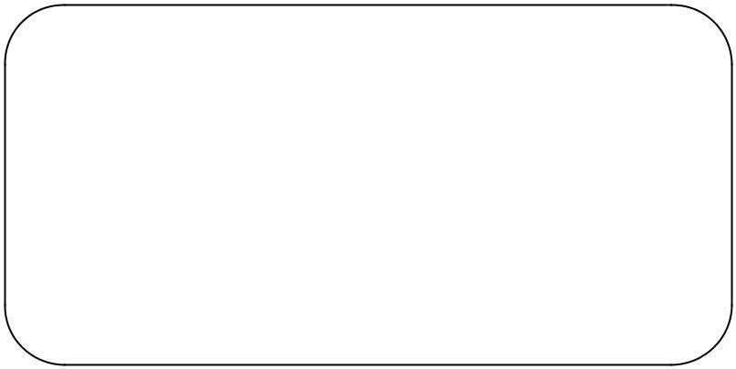

Name : RAAZIA
Year : 2024
Batch : 2024
Roll No : 240XX
Department: SOFTWARE ENGINEERING

Department of Software Engineering

NED University of Engineering & Technology, Karachi – 75270, Pakistan

Workbook

Fundamentals of Engineering and Technology (CT-174)

Prepared by

Dr. Kashif Mehboob Khan

Approved by Chairperson

Department of Software Engineering

INDEX

Lab No. | Object | Signature
1. | Familiarization with DOS environment and its important commands
2. | Learning some configuration commands & creating batch files in DOS
 | environment
3. | Understanding network sharing and working with Windows 10,11
4. | Learning and Exploring the features of Microsoft Word
5. | To learn the basics of Microsoft excel
6. | Working with Formulas conditions, logical &Trigonometric functions in  Microsoft Excel
7. | Data Analysis with MS Excel , Working with Pivot Tables and Pivot Charts.  To learn how to depict data graphically
8. | Learn about Relational Database Management Systems, Creating Database,  Relationships ,Queries in Microsoft Access
9. | Creating queries, forms and reports in Microsoft Access (OPEN ENDED LAB)
10 | To Familiarization with the environment of Microsoft Power Point
11. | Introduction to Assembly Language Tools Number System & Flags
12. | Demonstrating various components of a PC and their interconnection
13. | Experimenting with logic gates, implementing the circuit on bread board  and observing output for various combinations of inputs

FIT Lab Session 01
NED University of Engineering & Technology – Department of Software Engineering

Lab Session 01
OBJECT
Familiarization with DOS environment and its important commands.

WORKING WITH DOS

Understanding DOS
DOS, the acronym for Disk Operating System, is an operating system with a command-line interface used on personal computers. It provides a set of commands that enables the users to access or manipulate information on their disks, as well as simply interact with their computer.
DOS
A DOS, or disk operating system, is an operating system that runs from a disk drive. The term can also refer to a particular family of disk operating systems, most commonly MS-DOS, an acronym for Microsoft DOS. It has four functional units.

Command Interpreter
The command interpreter (command.com) is an interactive interface used to execute DOS commands.

System Files
The system files define the hardware to the software. When the computer
is booted these system files provide a unified set of routines for controlling the computer operation.

Basic Input Output System (BIOS)
The system files or hidden files interact with special read-only memory
on the motherboard. The special ROM is called Basic Input Output System (BIOS).

DOS Utilities
The DOS utilities carry out useful tasks such as preparing disks, comparing files, finding free space on a disk and printing.

Dos Commands
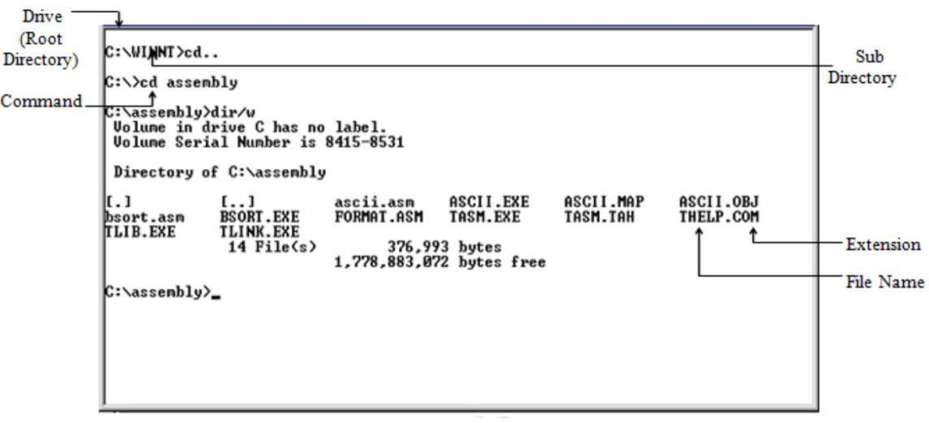
Figure 1.1: DOS environment

DOS commands are of two types namely internal commands and external commands.
- Internal commands are those which are built into command.com.
- External commands are those that must be located from a file loaded by command.com before it can be executed.
A brief description of important DOS commands is given below:

Changing drive
Type drive letter of the drive to which you want to switch to, on the command prompt followed by ‘:’
Example: c:>d: This will change the current drive from C to D. Result: d:>

Wild Cards
DOS recognizes two wild cards:
- The asterisk (*) represents one or more characters that a group of files has in common.
- The question mark (?) represents a single character that a group of files has in common.

Working with Directories
- dir to view the contents of a directory Prompt on screen: drive:>
Syntax: dir
Example: c:>dir This will list all the files and subdirectories on drive C, which is being prompted on screen. If another drive needs to be accessed, first change the drive, as previously explained and then enter the dir command.
Use wild cards to display selected lists. For example:
- dir *.* Displays all files and subdirectories on the drive
- dir ?????.comDisplays all files having names up to five characters and extension ‘com’
dir command can be modified using these wild cards and other switches as follows so that only one screen of selected information is displayed at a time.
- Cd to change from one directory to another Prompt on screen: drive:>
Syntax: cd drive:\path
Example: c:>cd dos This will change the current directory from the root directory to
‘dos’ directory on the prompted drive C.
Result: c:\dos>
- md to create a new directory Prompt on screen: drive:>
Syntax: md drive:\path\dirname
Example: c:>md neduetThis will create a new directory, named ‘neduet’ on the
drive being prompted, in this case drive C.
- cd.. to switch back one level up in the directory structure Prompt on screen: drive:>
Syntax: cd..

- cd\ to switch back to the root drive directory Prompt on screen: drive:>
Syntax: cd\
Example: c:\dos\subdos>cd\ This will switch back to the root drive, C
Result: c:\>
- rd to remove a directory Prompt on screen: drive:>
Syntax: rd drive:\path\dirname
Example: c:\>rd neduetThis will delete the directory, named ‘neduet’ from the prompted drive C.
- tree to view directory listing in a hierarchical structure. Prompt on screen: drive:>
Syntax: tree drive:\path
Example: tree d:This will display the hierarchical directory structure of drive D.
Use /f to display the names of the folders as well as the files in each folder, in a hierarchical manner.

Working with Files
- copy to copy a file from one directory or drive to another Prompt on screen: drive:>
Syntax: copy drive:\source path\filename drive:\destination path\ filename
Example: copy c:\neduet\cfile.exe c:\windows
This will copy the file, named ‘cfile.exe’ from ‘neduet’ directory to
‘windows’ directory with the same name for the new file.
- ren to rename a file Prompt on screen: drive:>
Syntax: ren drive:\path\old filename drive:\path\new filename
Example: c:\>ren cfile.exe edit.exe
This will rename the file ‘cfile.exe’ to ‘edit.exe’ in the prompted drive C.
- del to delete a file Prompt on screen: drive:>
Syntax: del drive:\path\filename
Example: c:\>del cfile.exe This will delete the file, ‘cfile.exe’ present in the
prompted drive C.

Wild cards can also be used with any of the above commands to work with group of files.
- Type to view a file on the screen. Only text based files can be viewed, as DOS supports only such files.
Prompt on screen: drive:>
Syntax: type drive:\path\filename

Files longer than one screen scroll off to the top. To avoid this, use |more suffix following the command.
Example: c:\>type cfile.txt |more
3

Disk Management
- format to format a disk Prompt on screen: drive:> Syntax: format drive:
Example: c:\>format Z: This will format Flash memory stick in drive Z.
- chkdsk to get a report on statistics of the disk Prompt on screen: drive:>
Syntax: chkdsk drive:
Example: c:\>chkdsk c: This will generate a report on statistics of drive C.
- vol to view a disk’s volume label and it’s serial number
Prompt on screen: drive:>
Syntax: vol drive:
Example: c:\>vol d: This will display volume label of drive d.
- ver to find current version of DOS installed on your system Prompt on screen: drive:>
Syntax: ver
Example: c:\>ver This will display the current version of DOS on your system.
ver
There are many versions of DOS and ver command is used to find the exact version.
cls
Used to clear the screen.
label
Displays the volume label of the disk. Also allows the user to add, modify, or delete the volume label of a disk.
vol
Displays the volume label of the disk.
dir
Displays a list of a directory's files and subdirectories. Supports multiple parameters.
md
Creates a directory or subdirectory. The name of the new directory is provided right after the command.
cd
Displays the name of the current directory or changes the current directory. To change directory, provide the name of the directory right after the command.
rd
Deletes a directory.
tree
Displays the directory structure of a path or of the disk in a drive graphically.
copy con
Makes a new file in the current directory. A file extension must be provided along with the file name. Once the file is created, an editor opens. To exit the editor, press
Ctrl+Z, then Enter.
ren
Renames files or directories.
del
Deletes one or more files. If a directory name is provided, then all files in the directory are deleted.
type
Displays the contents of a text file.
copy
Copies one or more files from one location to another.

Lab Session 01

OBJECT
Familiarization with DOS environment and its important commands.

Exercise:

Perform the following operations on DOS and present your output. Attach relevant screenshots.
- Open an MS-DOS window by typing cmd in the Start Menu.

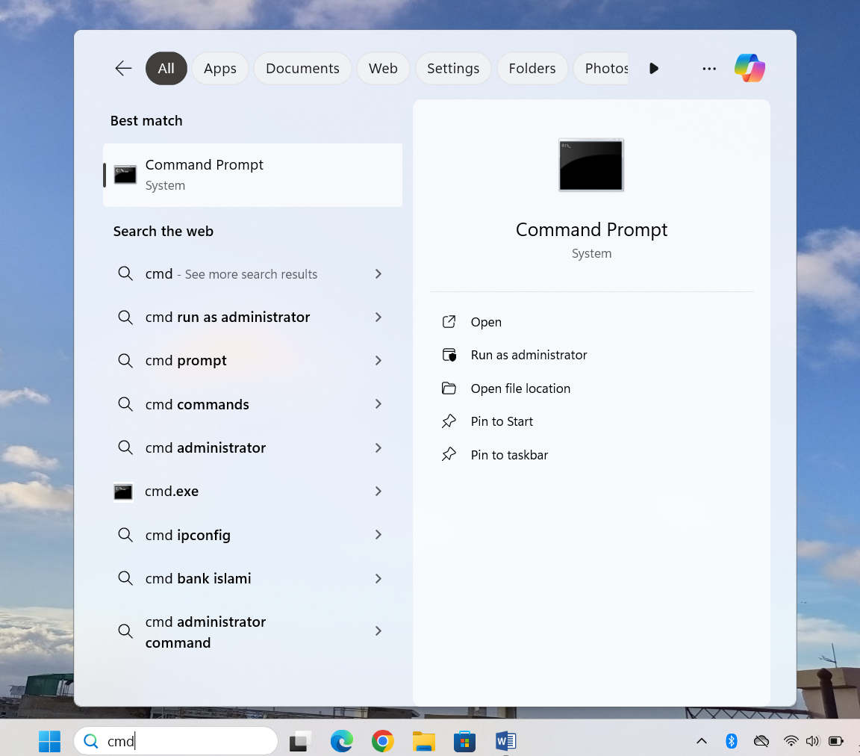

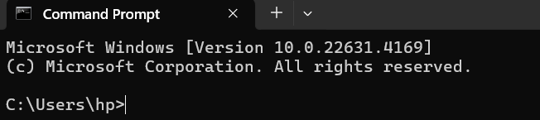

- Change the current drive to C:\>

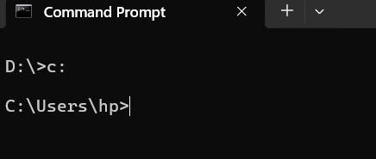

- Create a new directory with your name.

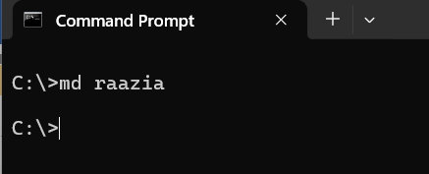

- Change to the newly created directory in .
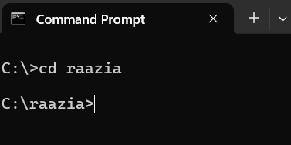

- Create a new text file and fill it with text.

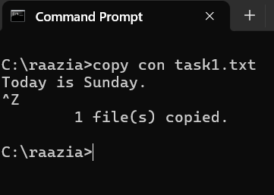

- Display the contents of the file created in

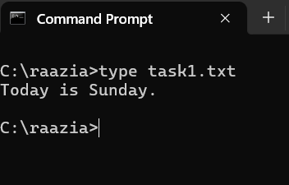

- Make a new copy of the file created in

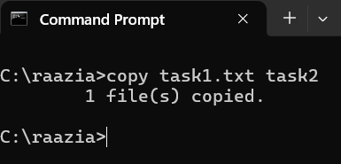

- List all the files in the current directory.

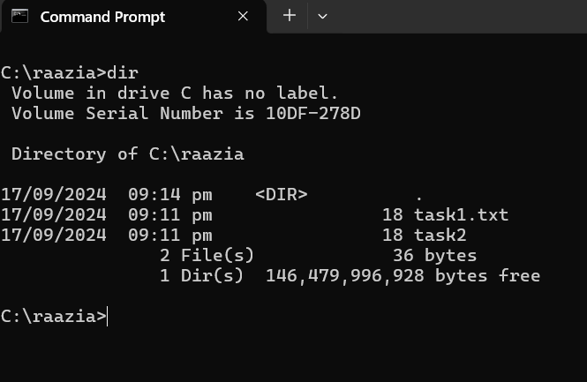

- Delete the file created in .

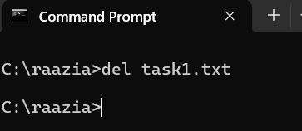

- Exit the directory and delete it.
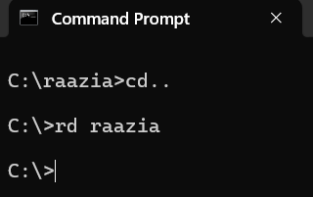

- Write command to display all files having extension ‘docx’.

dir\*.docx/s

- Write command to display all files of all types starting with letter ‘s’.

dir /s s*

- Write a command to copy the file assignment of type docx from the directory ‘ITC’ of drive D to drive F.

copy d:\ITC\assignment.docx F:\

- Write a command to delete the directory as well as the files of the directory ‘world’ on drive E.

Rd/s E:\world

- Write command to copy all the files beginning with ‘m’ and whose file names has a ‘txt’ extension from drive A to the ‘\document’ directory on drive C.

copy A:\*m.txt C: \document

- Write set of commands to create a directory ‘practical’ on drive F, and then move into it. Now list all files present in it, then go back to root drive F.

F:
md practical
cd practical
dir
cd\

FIT Lab Session 02
NED University of Engineering & Technology – Department of Software Engineering

OBJECT

Lab Session 02

Learning some configuration commands and creating Batch files in DOS environment.

CONFIGURATION COMMANDS
- doskeyto recall previously generated DOS commands, first it should be enabled, which is done by using doskey command.
Prompt on screen: drive:>
Syntax: doskey
Example: c:\>doskey This will install doskey.
Now use UP and DOWN ARROWS to recall commands;
ESC clears command line;
F7 displays command history; ALT+F7 clears command history; F8 searches command history;
F9 selects a command by number.

- date to set date of the system Prompt on screen: drive:>
Syntax: date mm/dd/yy (or use ‘-’ in place of ‘/’)
Example: c:\>date 5-16-2011 This will set date to May 16, 2011.

- time to set time of the system using the 24 hour clock representation Prompt on screen: drive:>
Syntax: time hh:mm:ss
Example: c:\>time 14:33 This will set current time to 2:33 pm.

- cls to clear the screen Prompt on screen: drive:> Syntax: cls
Example: c:\>cls This will clear the screen and bring the cursor to the top.

- prompt to set system prompt Prompt on screen: drive:> Syntax: prompt prompt name
Example: c:\>prompt neduet: This will set the current prompt to neduet: Result: neduet:

To get back to standard default system prompt, type prompt without parameters. Use the following switches anywhere in the prompt command to incorporate special information:
  - $tto get the current time
  - $dto get the current date
  - $pto get both the active drive and directory
  - $n to get the active drive only

FIT Lab Session 02
NED University of Engineering & Technology – Department of Software Engineering
  - $g to represent the character ‘>’
  - $l to represent the character ‘<’
  - $b to represent the character ‘|’
Example: c:\>prompt time is $t$g
Result: time is 14:02:10>

- exit to exit from DOS shell Prompt on screen: drive:> Syntax: exit
Example: c:\>exit This will close the DOS window

DOS HELP
- Type help at the command prompt to display DOS Help table of contents.
- Type help followed by the command name to view information about a command. For example: c:\>help copy This will display information about the ‘copy’ command. The command name can also be followed by /? to view information about a command. For example: c:\>copy/?This will display information about the copy command.

MAKING BATCH FILES
A batch program of a batch file is a text file that contains a series of commands that DOS carries out when its name is typed at the command prompt.

AUTOEXEC.BAT file is an example of such files. It is a special batch program that runs every time you start your computer. It starts necessary programs and does settings at the startup. To make a batch file, apply the following steps:


Open a new text file in (notepad editor).
Type DOS commands, which are to be included in the batch program in this text file. Each command is typed on a different line.
 Save the file with suitable name provided that its extension is bat. For example, mybatch.bat
Use copy con command to create batch file with extension .bat.
BATCH FILE COMMANDS

echoThis command directs DOS whether or not to display the commands in a batch file or not.
Syntax: echo on/off
An alternate is to insert @ sign before the command.

Example: @dir This command, if included in the batch file will prevent dir command from displaying on the command prompt.
call This command calls one batch program from another. Syntax: call [drive:][path]filename
Example: Create a batch file named one.bat with command md. Then make another batch file named two.bat with the following two commands:
call one.bat
copy/?
From DOS prompt run two.bat Syntax: two.bat
Result: This will display the directory listing, page wise, and then the help file.


pauseThis command suspends processing of a batch program and displays the message:Press any key to continue...
Syntax: pause
Example: Create a batch file named one.bat with command dir/p. Then make another batch file named two.bat with the following two commands:
call one.bat pause
help
From DOS prompt run two.bat Syntax: two.bat
Result: This will display the directory listing page wise, then pause and wait for a key from the user and on receiving a key, it will display the help file.


rem This command records comments <remarks> in a batch file Syntax: rem [comments]
Example: Create a batch file named remark.bat with the following commands: dir/p rem moving to root directory cd\
From DOS prompt run remark.bat Syntax: remark.bat
Result: This will display the directory listing page wise, it will then print the remark “moving to root directory” and will then move to the root directory.

Result: The echo command will be skipped.

FIT Lab Session 02
NED University of Engineering & Technology – Department of Software Engineering

OBJECT

Lab Session 02

Learning some configuration commands and creating Batch files in DOS environment.

EXERCISE:

Write set of commands ad attach screen shots associated to each task

- Write a command to change the command prompt to ‘Good Morning:\>’. Write another command using ‘$’ to switch back to the standard C prompt (C:\>).

First Command:

ANSWER

prompt Good Morning:\$G

Second Command:
ANSWER

prompt $P$G

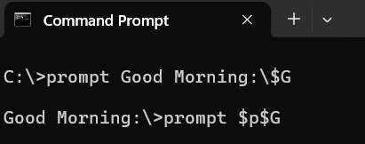

- Write a command to set the system date to Oct 24^{h}, 2023
ANSWER
10-24-2023

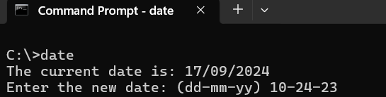

- Make a batch file called first.bat, which includes commands to display directory listings of drive F, then remove a directory called “new” from the same drive. Do not switch into the drive.

ANSWER

@echo on
dir F:\
pause
rd F:\new
pause
exit

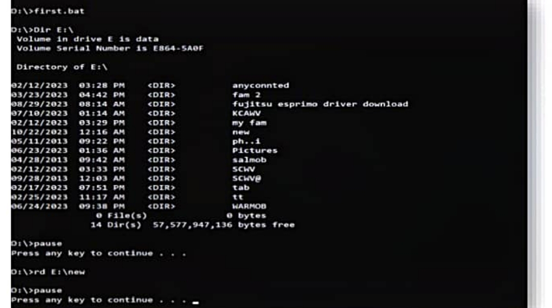
FIT Lab Session 03
NED University of Engineering & Technology – Department of Software Engineering

OBJECT

Lab Session 03

Understanding network sharing and working with Windows 10,11

THEORY

COMPUTER MANAGEMENT OVERVIEW

Computer Management is a collection of administrative tools that you can use to manage a single local or remote computer. It combines several administration utilities into a console tree, and it provides easy access to administrative properties and tools. You can use Computer Management to:

- Monitor system events, such as logon times and application errors.
- Create and manage shared resources.
- View a list of users connected to a local or remote computer.
- Start and stop system services, such as Scheduled Tasks and Indexing Service.
- View device configurations and add new device drivers.
- Manage applications and services.

OPENING THE COMPUTER MANAGEMENT CONSOLE
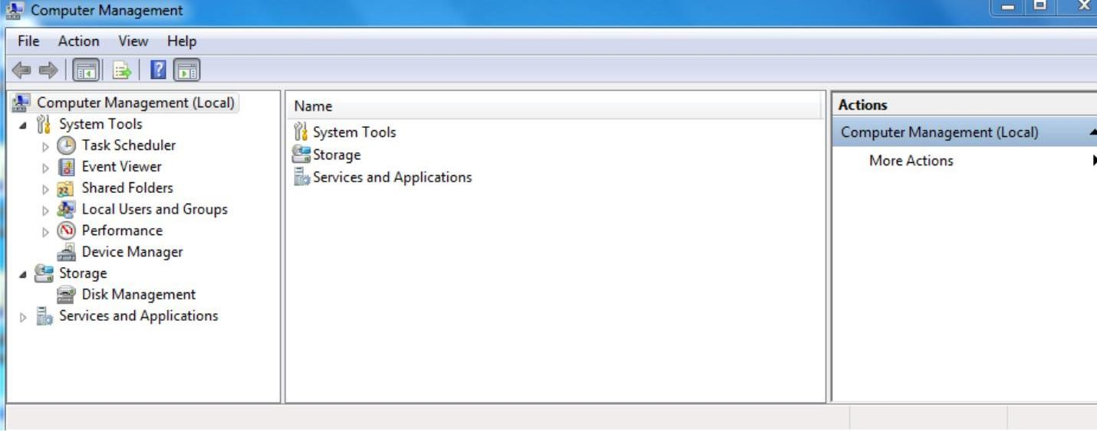
Fig 3.1 Computer Management

- To open Computer Management, click Start, and then click Control Panel^{-→}System and Security^{-→} Administrative Tools→Computer Management Or

- Go to start Run and write “compmgmt.msc “and click OK. Computer Management contains three items:
  - System Tools
  - Storage
  - Services and Applications (not to be discussed in this course)

FIT Lab Session 03
NED University of Engineering & Technology – Department of Software Engineering

- SYSTEM TOOLS

Systems Tools is the first item in the Computer Management console tree. You can use the following default tools to manage system events and performance on the target computer

  - Task Scheduler
  - Event Viewer
  - Shared Folders
  - Local Users and Groups
  - Performance (Logs and Alerts)
  - Device Manager
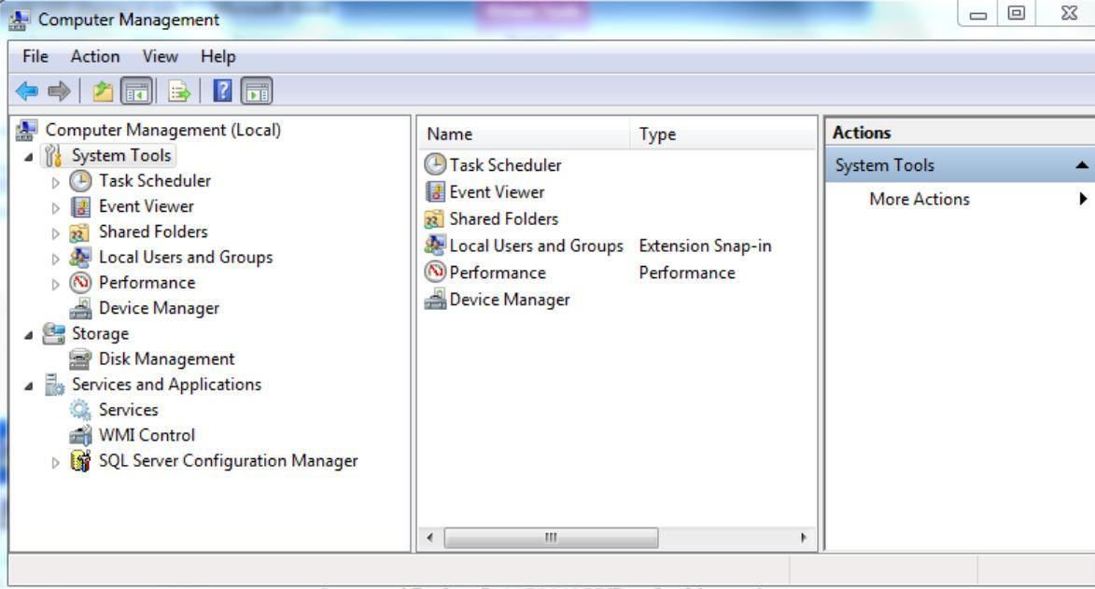
Figure 3.2 System Tools

USING TASK SCHEDULER
You can use task scheduler to create and manage common tasks that your computer will carry out automatically at the times you specify. To begin, click a command in the Action menu. Tasks are stored in in folders in the Task Scheduler Library. To view or perform an operation on an individual task, select the task in the Task Scheduler Library and click on a command in the Action menu.
USING EVENT VIEWER
It can be used to view events that have occurred on your computer, select the appropriate source, log or custom view mode in the console tree. The administrative Events custom view contains all the administrative events regardless of source. An aggregate view of all the logs of some machine is shown in figure 3.3

FIT Lab Session 03
NED University of Engineering & Technology – Department of Software Engineering
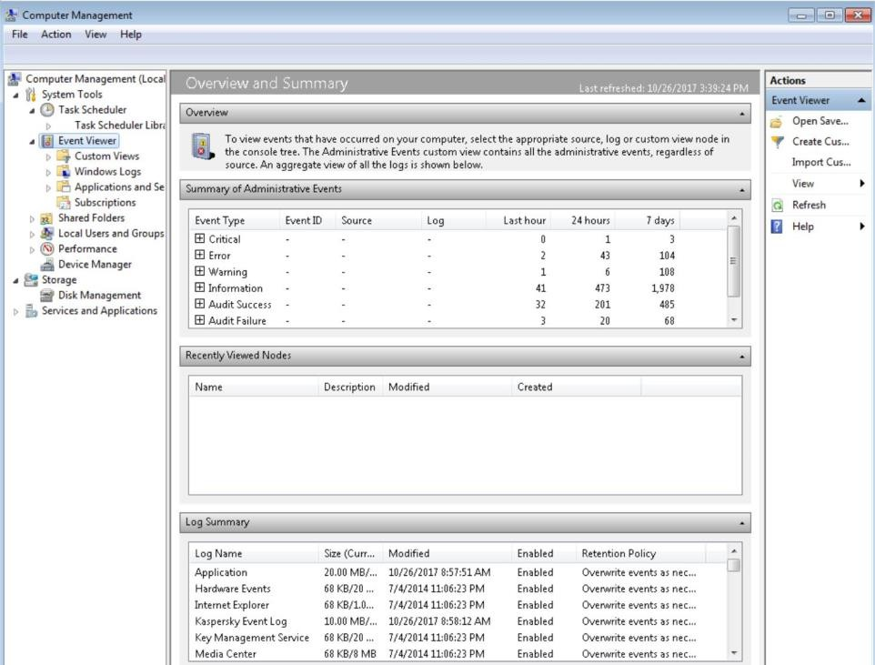
Figure 3.3 Event Viewer

USING SHARED FOLDER
You can use Shared Folders to manage shared resources on both local and remote computers. Windows Explorer and the command line allow you to manage shared resources on your local computer only.
To share a folder or drive

- In the console tree, click Shares.

[ Computer Management→
→
On the Action menu, click More Actions
New Share…
→
System Tools
→
Shared Folders
Shares ]

- Follow the steps in Create A Shared Folder Wizard.
- You will be prompted to select a folder or drive, type a new share name and description of the shared resource, and set permissions. After you provide this information, click Finish. [Note: A shared folder is available to a particular user(s) on entire network.]
To set permissions on a shared resource
- Right-click the shared resource for which you want to set permissions, and then click
Properties.
- On the Share Permissions tab, select the following options that you want, and then click
OK:
  - Click Add to grant a user or group permission for a shared resource. In the Select
Users, Computers, or Groups dialog box, look for or type the user, computer, or group name, and then click OK.
  - Click Remove to revoke access to a shared resource.
  - In Permissions for <group or user>, select the Allow or Deny check boxes to set individual permissions for the selected user or group.

To stop sharing a resource
In the details pane, right-click the folder that you want to stop sharing, and then click Stop Sharing.

You can directly right click on a file or folder name and then select share with to share it among users at same computer

FIT Lab Session 03
NED University of Engineering & Technology – Department of Software Engineering

LOCAL USERS AND GROUPS OVERVIEW
Local Users and Groups is a tool you can use to manage local users and groups by
- Create a new user account / group
- Modify a user account / group
- Change the password for a user
- Disable or activate a user account / group
- Identify members of local groups

- Delete a user account / group
- Rename a user account
To create a new user account
- On the Action menu, click New User.
- Type the appropriate information in the dialog box.
- Select or clear the check boxes for:
  - User must change password at next logon
  - User cannot change password
- Password never expires
  - Account is disabled

- Click Create, and then click Close.
To modify a user account / group
- Right-click the / group you want to modify, and then click Properties.
- Make the changes you want, and then click O

Change the name of computer
    - Settings →System → About
  - Add a user using CMD
    - Net user : No. of users
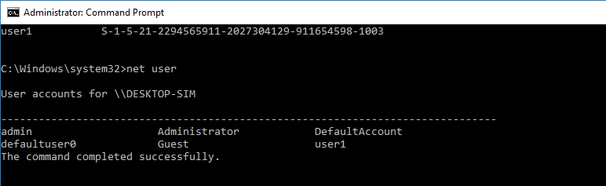
    - Net user username / add
    - Wmic useraccoubt get name,SID
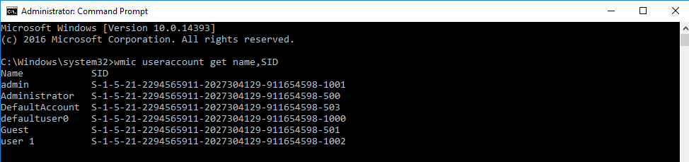

  - CHANGE THE NAME OF ADMIN
Regedit → local user- → software-→ Microsoft → windows nt → current version → profilelist-→ profile image path
Now at C:→USERS -→Change Name
SEARCH →netplwiz and change name there also At cmd→ NET USER to check the users
This pc –right click system protection
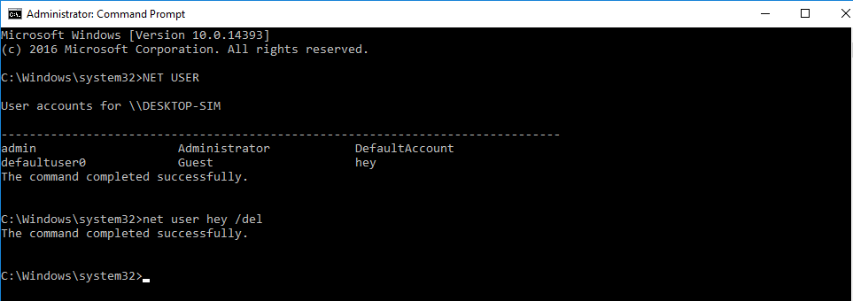

  - Delete a user
at cmd →net user newuser /del
Right click → this pc → properties -→ advance system protection-→User Profile → delete unknown account

PERFORMANCE

With Performance Monitor you can collect performance data automatically from local or remote computers. You can view logged counter data using System Monitor or export the data to spreadsheet programs or databases for analysis and report generation. Performance Monitor offers the following operations:
- Counter data collected by performance Logs and Alerts can be viewed during collection as well as after collection has stopped.
- Because logging runs as a service, data collection occurs regardless of whether any user is logged on to the computer being monitored.
- You can define start and stop times, file names, file sizes, and other parameters for automatic log generation.
- You can manage multiple logging sessions from a single console window.
- You can set an alert on a counter, specifying that a message be sent, a program be run, an entry be made to the application event log, or a log be started when the selected counter’s value exceeds or falls below a specified setting.

Logs and Alerts also offers other options related to recording performance data. These include:
- Start and stop logging either manually on demand, or automatically based on a user defined schedule.
- Configure additional settings for automatic logging, such as automatic file renaming, and set parameters for stopping and starting a log based on the elapsed time or the file
size.
- Create trace logs. It traces logs record detailed system application events when certain activities such as a disk input/output (I/O) operation or a page fault occurs.

DEVICE MANAGER

Device Manager provides you with a graphical view of the hardware that is installed on your computer. (See figure 3.4) You can use Device Manager to update the drivers (or software) for hardware devices, modify hardware settings, and troubleshoot problems. Device Manager is typically used to check the status of your hardware and update device drivers on your computer. Advanced users who have a thorough understanding of computer hardware might also use Device Manager’s diagnostic features to resolve device conflicts and change resource settings.

You can use Device Manager to:
- Determine whether the hardware on your computer is working properly.
- Change hardware configuration settings.
- Identify the device drivers that are loaded for each device, and obtain information about each device driver.
- Change advanced setting and properties for devices.
- Install updated device drivers.
- Disable, enable, and uninstall devices.
- Roll back to the previous version of a driver.

View the status of a device
- Click Device Manager.
- Double-click the type of device you want to view.
- Right-click the specific device you want, and then click Properties.
- On the General tab, under Device status is a description of the device status.

Enable / Disable device
- Open Device Manager.
- Double-click the type of device that you want to Enable / Disable

- Right-click the specific device you want, and then click Enable / disable.

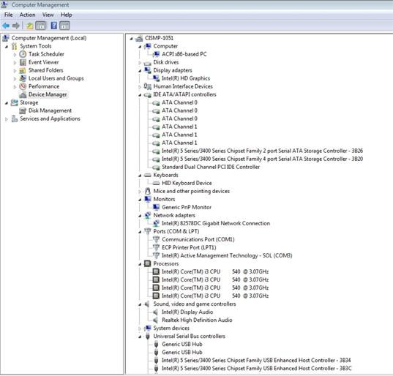
Fig. 3.4 Device Manager

Uninstall a device
- Open Device Manager.
- Double-click the type of device that you want to uninstall.
- Right-click the specific device you want to uninstall, and then click Uninstall.
- In the Confirm Device Removal dialog box, click OK.
- When you are done uninstalling the device, turn off your computer, and remove the device from the computer.

​STORAGE
Storage displays storage device that are installed on the computer that you are managing. You can use the default following tools to manage the properties of storage devices.
Disk Management
You use Disk Management (See fig. 3.5) to perform disk-related tasks, such as creating partitions and volumes, formatting them, and assigning drive letters.
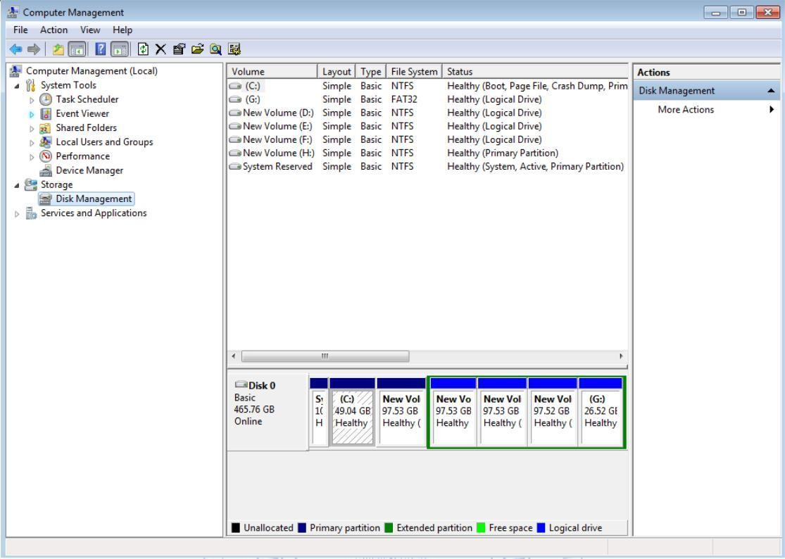
Fig 3.5 Disk Management
On different operating systems, you can also use Disk Management to perform advanced tasks, such as configuring software RAID. Other operations are;

  - Simplified tasks and intuitive user interface: Disk Management is easy to use. Menus that are accessible from the right mouse button display the tasks you can perform on the selected object, and wizards guide you through creating partitions or volumes and initializing or converting disks.
  - Basic and dynamic disk storage: Basic disks contain basic volumes, such as primary partitions, extended partitions, and logical drives. Use basic disks on portable computers or when you plan to install multiple operating systems in different partitions on the same disk.
Dynamic disks contain dynamic volumes that offer features not available in basic disks, such as the ability to create fault-tolerant volumes (RAID).
  - Local and remote disk management: By using Disk Management, you can manage any remote computer running a compatible Windows OS, on which you are a member of the Administrators group.

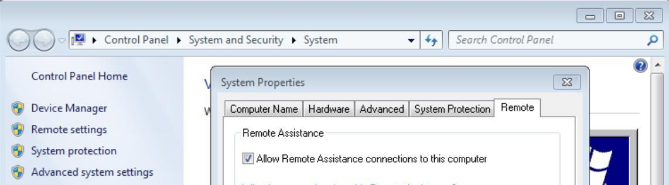
For example, if you want to allow your system to be remotely accessed, go to My Computer, then Select Properties by right clicking anywhere on this window. Now Select Remote Settings Tab (See fig. 3.6) and select appropriate radio button (middle one is preferred).

Fig. 3.6 Allowing Remote Desktop Access

In order to remotely access a desktop, type Remote Desktop Connection in search bar or mstsc.exe in Run, a window will appear, just give name of the computer, to which you want to get connected, followed by the password. Now a Desktop of that computer will appear on your monitor.
  - Mounted drives: You can use Disk Management to connect, or mount, a local drive at any empty folder on a local NTFS-formatted volume. Mounted drives make data more accessible and give you the flexibility to manage data storage based on your work environment and system usage. Mounted drives to access more than 26 drives on your computer.

  - Logical Disk Manager Service: The Logical Disk Manager Service uses disk groups to maintain information about the current state of disks in your computer.
Manage basic volumes:

Viewing the properties of a volume
ι. In Disk Management, right-click the partition, logical drive, or other basic volume, and then click Properties.
ii. Assign, changing or remove a drive letter
  - Right-click a partition, logical drive, or volume, and then click Change Drive Letter and Paths
  - Do one of the following:
    - To assign a drive letter, click Add, click the drive letter you want to use, and then click OK.
    - To modify a drive letter, click it, click Change, click the drive letter you want to use, and then click OK
    - To remove a drive letter, click it, and then click Remove.

Create a mounted drive
  - Right-click the partition or volume you want to mount, and then click Change Drive Letter and Paths.
  - Do one of the following:
- To mount a volume, click Add. Click Mount in the following empty NTFS
- folder, type the path to an empty folder on an volume, or click Browse to locate it
- then click OK.
- To dismount a volume, click it and then click Remove.

Mark a partition as active
  - Right-click the primary partition you want to mark as active, and then click Mark Partition as Active.
Format a basic volume
  - Right-click the partition, logical drive, or basic volume you want to format (or reformat), and then click Format.
  - Select the options you want, and then click OK.
Create a partition or logical drive
  - Right-click an unallocated region of a basic disk, and then click New Partition, or right click in an extended partition, and then click New Logical Drive.
  - In the New Partition Wizard, click Next, click Primary partition, Extended partition, or Logical drive, and then follow the instructions on your screen.
Note: first create Primary Partition then extended. Logical Volumes are created with in the extended partition
Delete a partition or logical drive
  - Right-click the partition, logical drive, or volume you want to delete, and then click
Delete Partition

Note: First delete all Logical Partition and then Extended and Primary Partitions

Disk Defragmenter

Disk Defragmenter analyzes local volumes and consolidates fragmented files and folders so that each occupies a single, contiguous space on the volume. As a result, your system can access files and folders and save new ones more efficiently. By consolidating your files and folders, Disk Defragmenter also consolidates a volume’s free space, making it less likely that new files will be fragmented. The process of consolidating fragmented files and folders is called defragmentation.
To defragment a particular disk or partition, select and right click on it, then select Properties and go to tab Tools, here you can find options for Disk Defragmentation. (See fig. 3.7)

These days a scheduled task of Disk fragmentation is already present. So you will not find your disk defragmented.
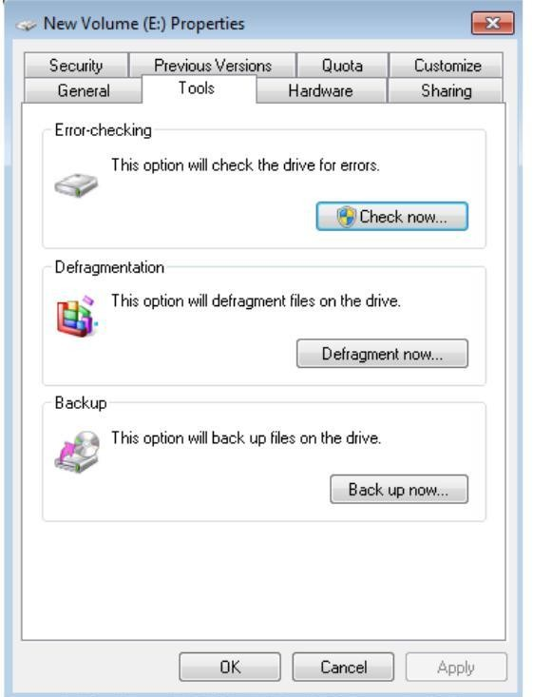
Fig 3.7 Disk Defragmentation

OBJECT

Lab Session 03

Understanding network sharing and working with Windows 10,11

EXERCISE

- Use Task Scheduler utility to daily prompt a Good Morning message on your screen at 9 a.m. List steps of accomplishing the above task.
ANSWER
1. open task scheduler
2. click on Create a Basic task
3. enter name and description
4. click on next
5. now select daily on when do you want to start the task options
6. click on next
7. now set the time to 9:00 am and recur every to 1 days
8. click on next
9. now select Display a message from what actions do you want the task to perform options
10. click on next
11. now type the title in the title bar and Good Morning in the message bar
12. click on finish

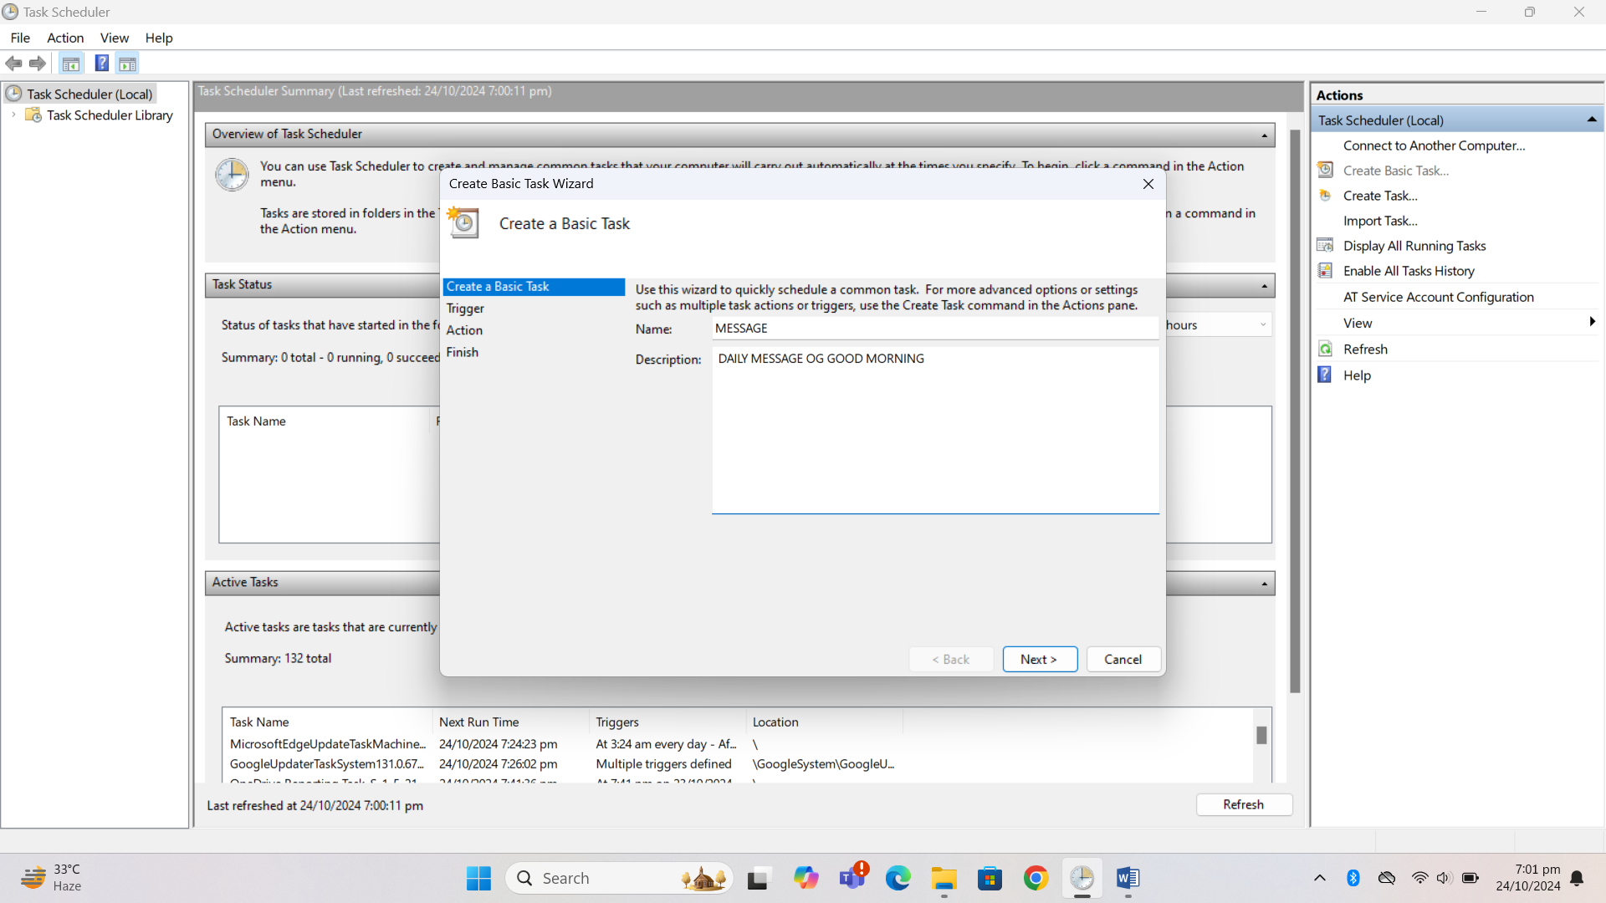

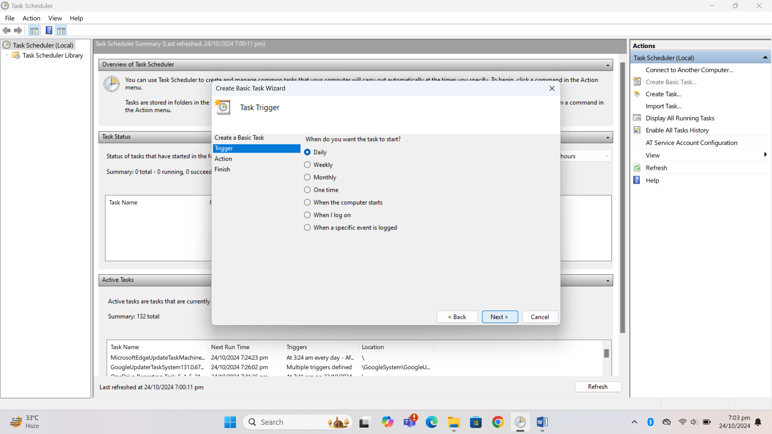

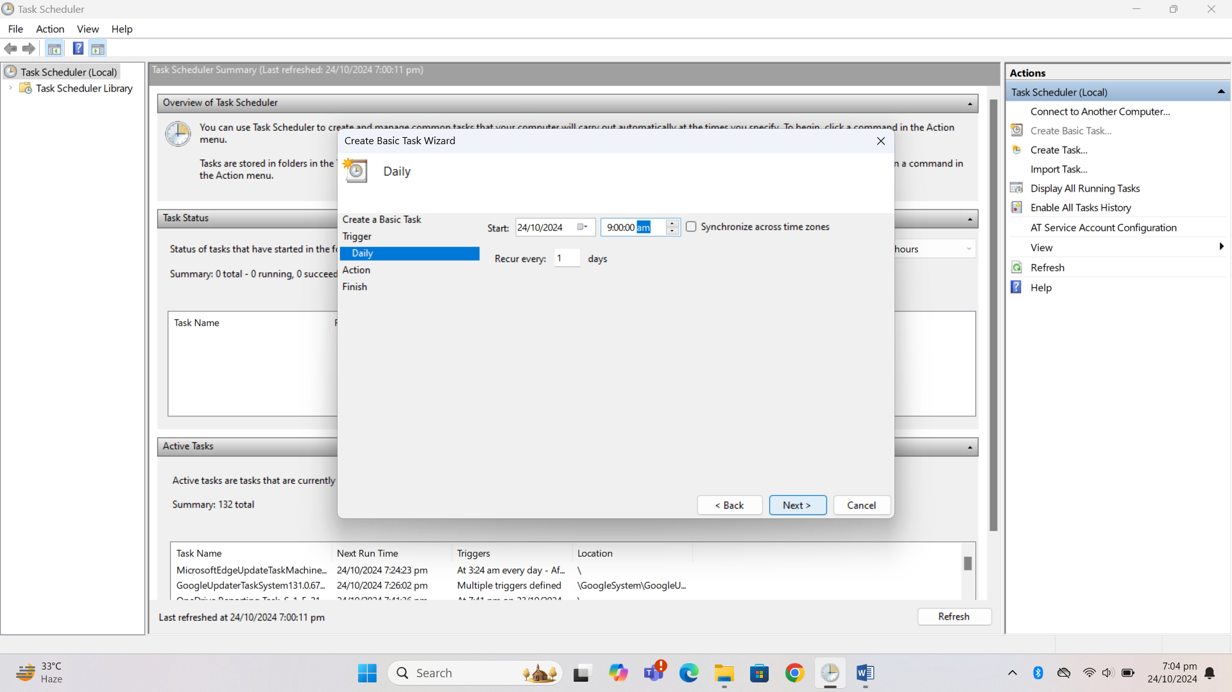

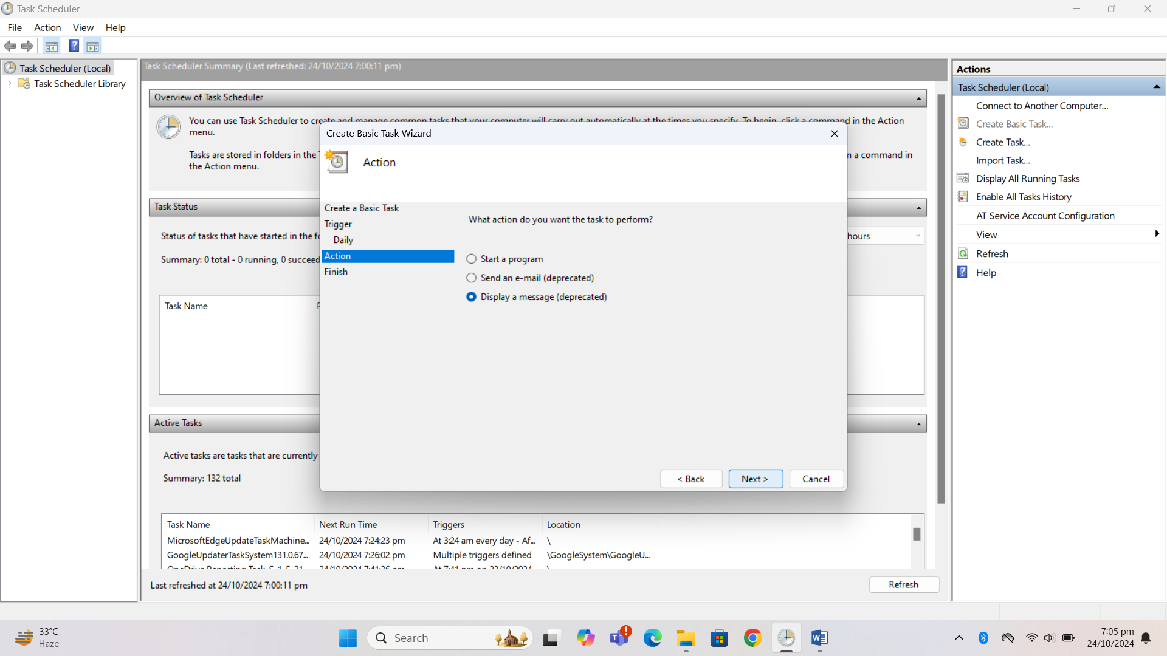

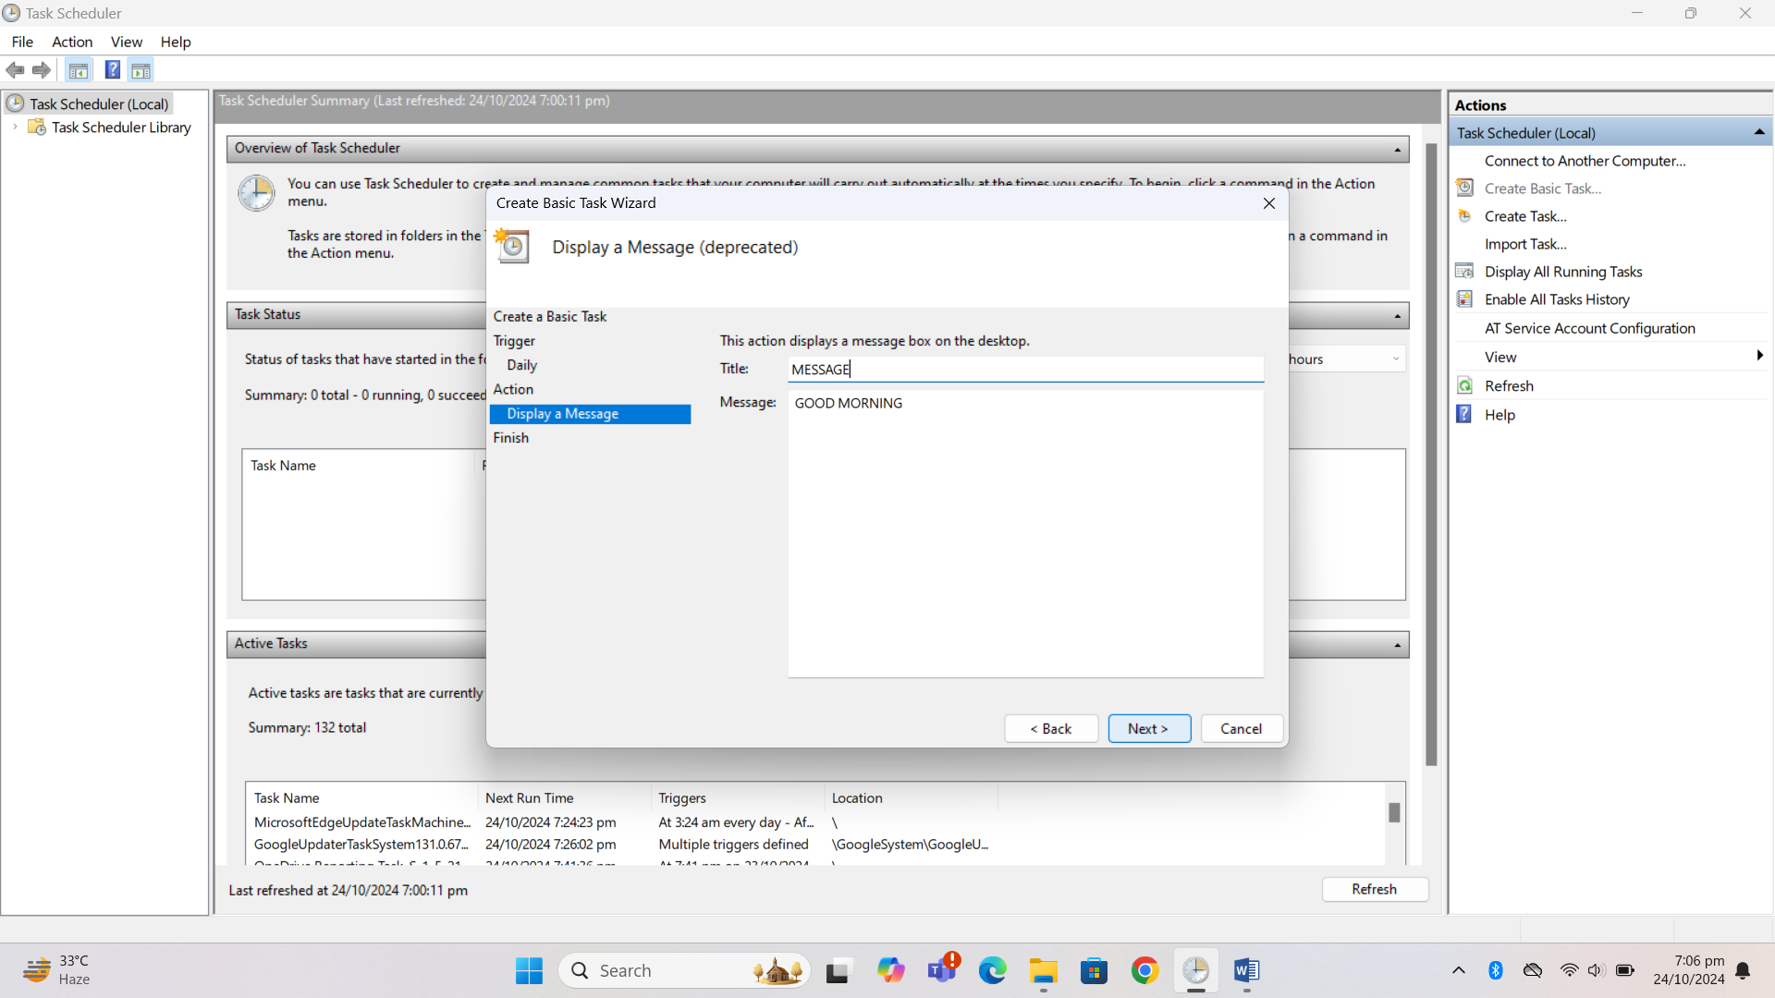

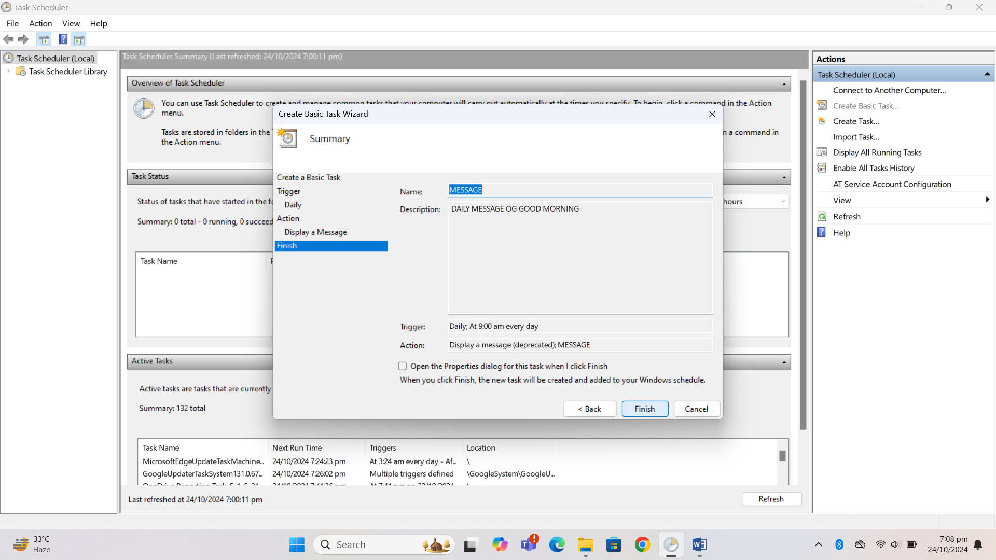

- Your computer is giving warning for low disk space that means your containing the operating system software does not have enough space to ensure reliable system operations List various ways by which you can increase your disk space.
ANSWER

There are many ways to increase disk space. Few of them are :
1. By using disk clean up tools
2. By deleting temporary files
3. By emptying the recycle bin
4. By defragmentation and optimization
5. By deleting unnecessary files and folders
6. By compressing files and folders

3. Change the name of Device of your Computer and add a screen Short

BEFORE

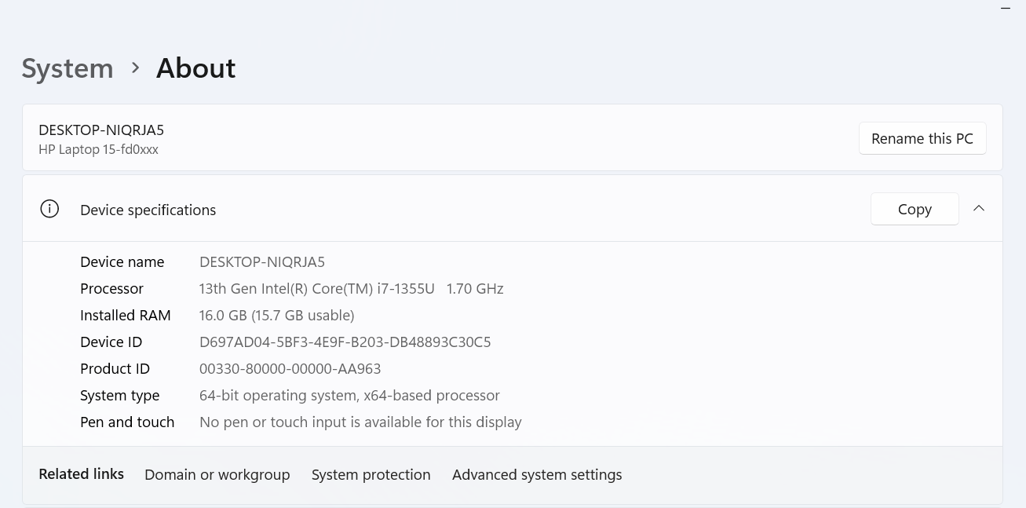

AFTER
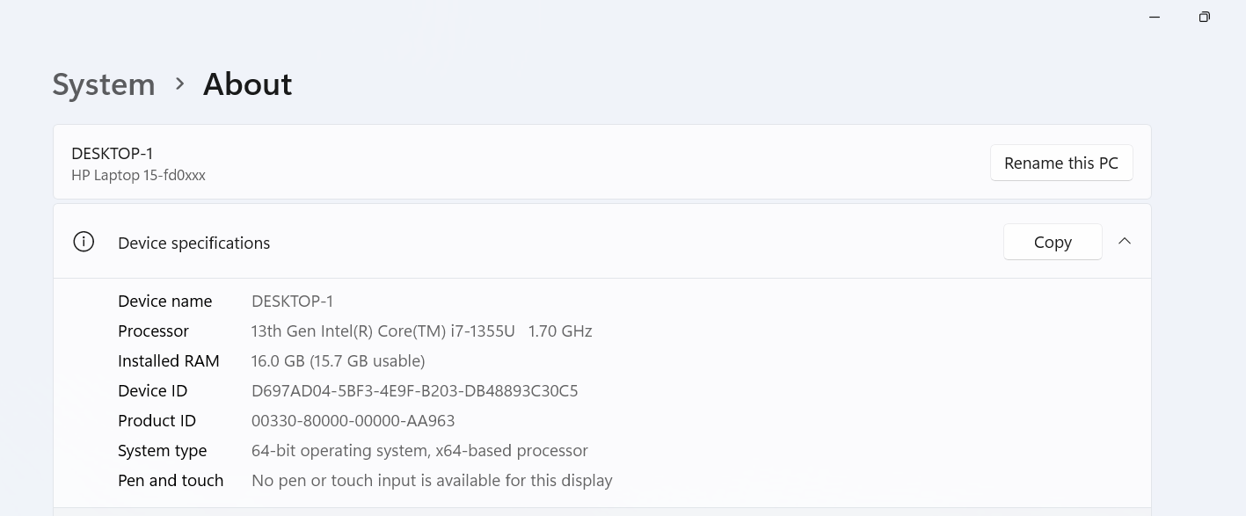

4. Change the name of a User

ANSWER

Open cmd and run it as an administrator

Type wmic useraccount where name=“hp” rename “ HP”

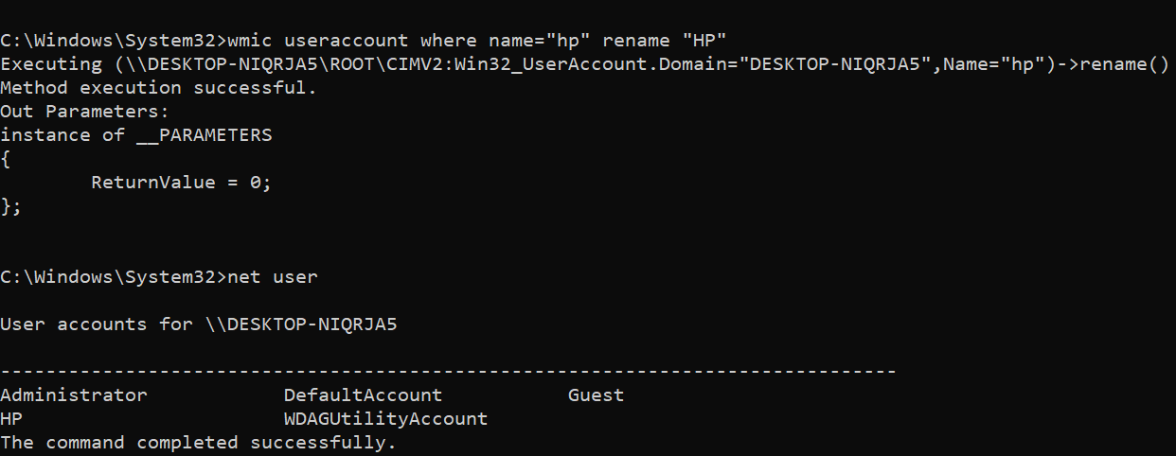
NED University of Engineering & Technology
Department of Software Engineering
Course Code & Title: CT-174 FIT Assessment Rubric for Psychomotor (P2-PLO-3)

Instructor: Batch: 2024 Class: FESE Semester: Fall 2024. Student’s Name: Roll No.:
Laboratory Session No. Date:

Psychomotor Domain Assessment Rubric-Level P2-PLO3
Skill Sets | Extent of Achievement
 | Below Average  (0--  1) | Average (2) | Good (3) | Very Good (4) | Excellent (5)
Problem Definition and Understanding | Unable to define and understand the problem clearly. | Struggles to define the problem clearly, with significant gaps in understanding | Defines the problem, but with gaps or a limited understanding of key components, impacting the overall quality of definition. | Effectively defines the problem with a good understanding of its components, showcasing proficiency in problem definition. | Demonstrates an exceptional understanding of the problem, identifying all key components and challenges with  insightful depth.
Technical Implementation Proficient use of tools to complete  the problem | Struggles to use tools effectively, requiring significant improvement. | Uses tools with noticeable inefficiencies. | Demonstrates basic proficiency in utilizing tool, with some room for improvement. | Effectively uses tools to support the task. | Integrates use of tools seamlessly to enhance the design and development process
Solution Design& Accuracy | Struggles to relate the implemented solutions to the design and development goals, requiring significant improvement. | Shows limited connection between the implemented solutions and the design and development context. | Demonstrates a basic understanding of how the solutions align with design and development requirements. | Effectively relates the implemented solutions to the overall design and development objectives | Maps the implemented solutions seamlessly to the overarching design and development goals, demonstrating a comprehensive understanding.
Trouble Shooting Skills  Issue resolution skills | Unable to trouble shoot | Limited troubleshooting | Adequate troubleshooting, minor errors remaining | Good troubleshooting, no errors remaining | Excellent trouble shooting no errors remain without delay.
Document Organization and on time submission | Poor Unclear disorganized document late submission | Somewhat clear with lack of organization and structuring late submission | Somewhat clear with lack of organization and structuring on time submission | Reasonably clear and organized with adequate structuring on time submission | Highly clear and well- structured document, On time submit

Weighted CLO (Psychomotor Score)
Instructor’s Signature with Date

OBJECT

Lab Session 04

Learning basics of Microsoft Word

Introducing Microsoft Word
Microsoft Word is a document and word processing application that enables a user to create, edit, and format different types of documents, such as letters and reports. Word provides a lot of document creation tools that have been refined to be easy to use. It also enables a user to add effects to picture from within the document and allow multiple authors to collaborate efficiently on a document.

Understanding the Microsoft Word Interface
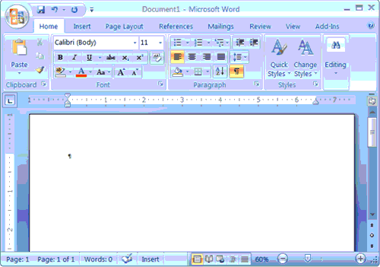
Create Sample Data and Select Text
If you type =rand() in your Word document and then press Enter, Word creates three paragraphs. You can use these paragraphs to practice what you learn. Throughout these lessons, you will be asked to select text. The following exercise teaches you how to create data and how to select data. You can select by using the arrow keys or by clicking and dragging. When using the arrow keys, use the up arrow to move up, the down arrow to move down, the left arrow to move left, and the right arrow to move right. When using the mouse, press the left mouse button and then drag in the direction you want to move.

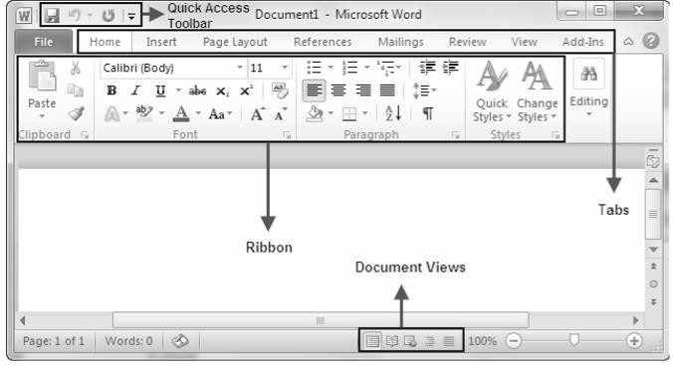
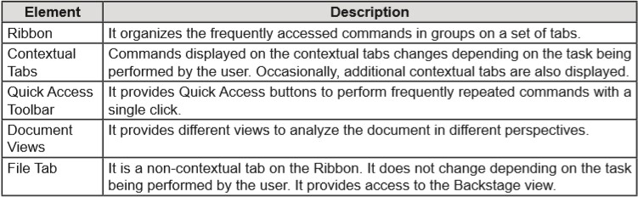

Understanding the Ribbon Interface
The Ribbon interface is a common feature in all applications included in the Microsoft Office Suite. It is an area above the document workspace. It provides easy and quick access to all the commands by organizing them in a set of main tabs. The File tab is the only non-contextual tab which provides access to the Backstage view; all other tabs are main tabs.
These main tabs are divided into groups that represent different command groups and can be customized to add buttons for frequently repetitive tasks. Also, additional contextual tabs appear as the user works with different elements. For example, when the user is editing a table, the Design and Layout tabs are displayed under a new set of tabs called Table Tools.
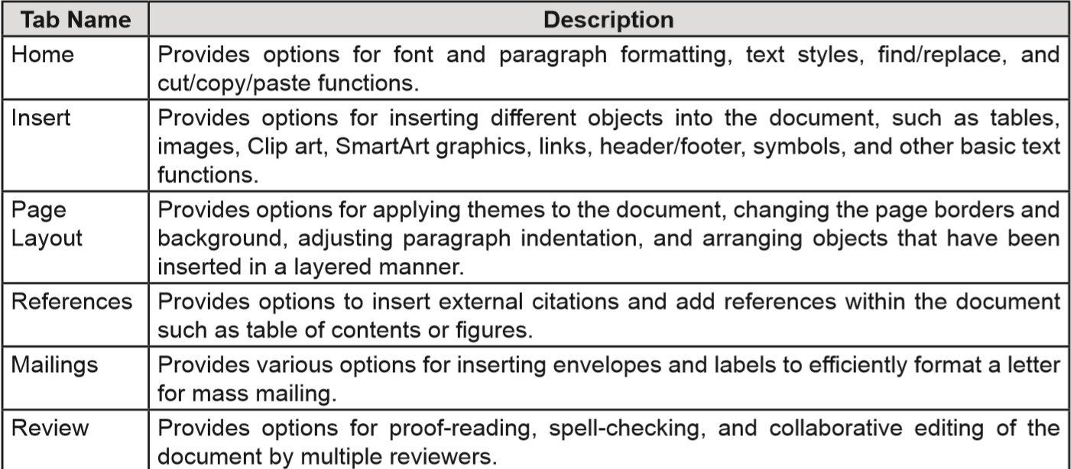

The Ribbon You use commands to tell Microsoft Word what to do. In Microsoft Word 2007, you use the Ribbon to issue commands. The Ribbon is located near the top of the screen, below the Quick Access toolbar. At the top of the Ribbon are several tabs; clicking a tab displays several related command groups. Within each group are related command buttons. You click buttons to issue commands or to access menus and dialog boxes. You may also find a dialog box launcher in the bottom-right corner of a group. Clicking the dialog box launcher gives you access to additional commands via a dialog box.
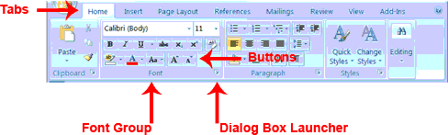

The Quick Access Toolbar
Next to the Microsoft Office button is the Quick Access toolbar. The Quick Access toolbar provides you with access to commands you frequently use. By default Save, Undo, and Redo appear on the Quick Access toolbar. You can use Save to save your file, Undo to rollback an action you have taken, and Redo to reapply an action you have rolled back.

The Title Bar
Next to the Quick Access toolbar is the Title bar. The Title bar displays the title of the document on which you are currently working. Word names the first new document you open Document1. As you open additional new documents, Word names them sequentially. When you save your document, you assign the document a new name.

The Ruler
The ruler is found below the Ribbon.
You can use the ruler to change the format of your document quickly. If your ruler is not visible, follow the steps listed here:
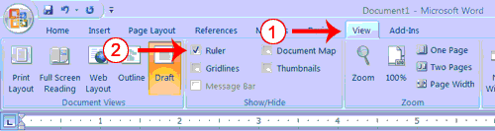
Click the View tab to choose it.
Click the check box next to Ruler in the Show/Hide group. The ruler appears below the Ribbon.

The Status Bar The Status bar appears at the very bottom of your window and provides such information as the current page and the number of words in your document. You can change what displays on the Status bar by right-clicking on the Status bar and selecting the options you want from the Customize Status Bar menu. You click a menu item to select it. You click it again to deselect it. A check mark next to an item means it is selected.

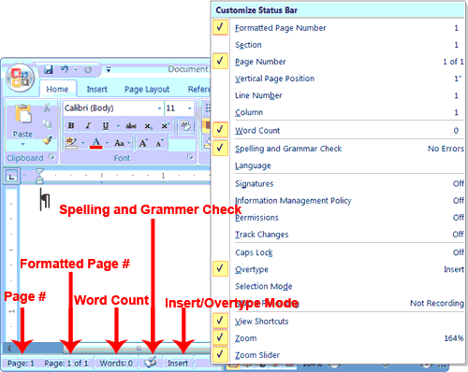
The groups on some of the main tabs contain a 'dialog box launcher' icon at the lower-right of the group. Word displays a dialog box to perform functions included in that group, when users click the dialog box launcher icon. For example, the Styles group on the Home tab contains a dialog box launcher icon.
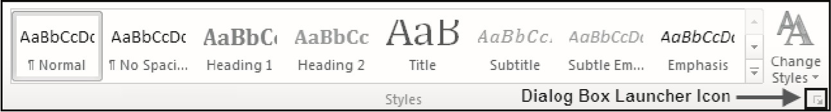

Formatting Paragraphs
Paragraph formatting includes a number of formatting attributes. Word considers a paragraph as a block of text that is preceded and followed by paragraph mark. Microsoft Word allows user to apply different types of formatting to different paragraphs. Each paragraph can have its own independent alignment, indentation, and tab settings.
To apply the formatting options to a single paragraph, users can place the cursor at any point within the paragraph. To apply the formatting options to multiple paragraphs, users must select those paragraphs.
Users can change the paragraph formatting options from the Paragraph dialog box. They can access the Paragraph dialog box using the dialog box launcher icon from the Paragraph group on the Home tab. The Paragraph dialog box contains the following two tabs:
Indents and Spacing - It provides options for alignments and indentation of the paragraph. Line and Page Breaks - It provides options for Window control and other pagination and formatting options.

Aligning a Paragraph
A paragraph is aligned on the page in relation to the left and right margin. By default all text in a paragraph is left aligned. Left aligned text means text that is aligned only to the left margin. Thus, it may appear uneven on the right side.
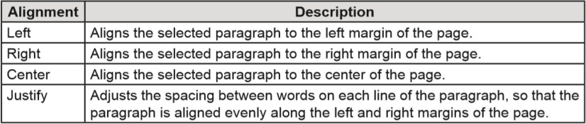
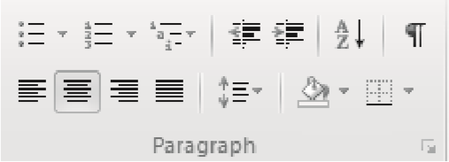

Working with Page Layout
Microsoft Word provides users with different options to modify the margins, orientation, and size of a page and change page layout.
The options for changing the page layout are located in the Page Setup group of the Page Layout tab. Word also provides the Page Setup dialog box, where users can change the page layout attributes in a detailed manner. Other than the options in Page Setup group of the Page Layout tab, the Page Layout dialog box provides options to insert a gutter or apply mirror margins to both sides of a page.
Gutter is like an invisible marker placed between the page border and content to accommodate the space required for punching holes in a spiral-bound document. Mirror margins are useful when the document is to be printed on both sides of the pages. It uses the same margin settings for both sides of the page.

Setting Page Margins
Margin controls the amount of white space between the content and borders of the page. Microsoft Word provides different pre-defined page margin settings for users to work with. These settings specify the space to be left between left, right, top, and bottom margins of the page and the content.
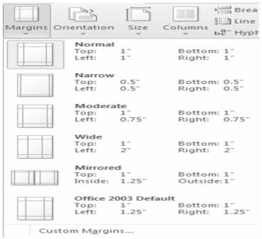
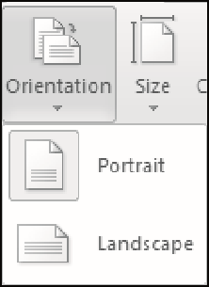

Setting Page Orientation
Page Orientation is related to how the user wants to display the document, when it will be printed. Page orientation is of two types, portrait and landscape. Portrait orientation is suitable for documents that are printed vertically and landscape orientation is suitable for documents that are printed horizontally.

Working with Lists
Numbered and bulleted lists allows the user to emphasize a list of items and make them stand out from the rest of the document. In other words, bulleted lists works best when you want to separate a list of items from other text. With Microsoft Word 2010, users can display a list of items as ordered or unordered lists. Users can also create multi-level lists with a maximum of nine levels.

Working with Tables
Tables enable the user to present the data in a grid of rows and columns.
Microsoft Word allows user to quickly add a table and format it in one of the different available styles.

Working with Graphics
Microsoft Word allows user to add different types of graphics, such as pictures, clip arts, and charts into their document. The options to insert graphics in a document are located in the Illustrations group of the Insert tab

Understanding Document Views
Draft View: Draft view is the most frequently used view. You use Draft view to quickly edit your document.
Web Layout: Web Layout view enables you to see your document as it would appear in a browser such as Internet Explorer.
Print Layout: The Print Layout view shows the document as it will look when it is printed.
Reading Layout : Reading Layout view formats your screen to make reading your document more comfortable.
Outline View: Outline view displays the document in outline form. You can display headings without the text. If you move a heading, the accompanying text moves with it.
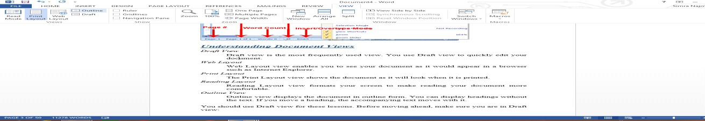
You should use Draft view for these lessons. Before moving ahead, make sure you are in Draft view:

Click the View tab.
Click Draft in the Document Views group. When the Draft option is selected it appears in a contrasting color.

Understanding Nonprinting Characters
Certain characters, called nonprinting characters, do not print and will not appear in your printed document but do affect your document layout. You can elect to see these characters on the screen as you type or you can elect to have them remain invisible. For these lessons, opt to see them onscreen. This table describes most of them:

Character | Denotes
 | A tab
. | A space
¶ | The end of a paragraph
 | Hidden text
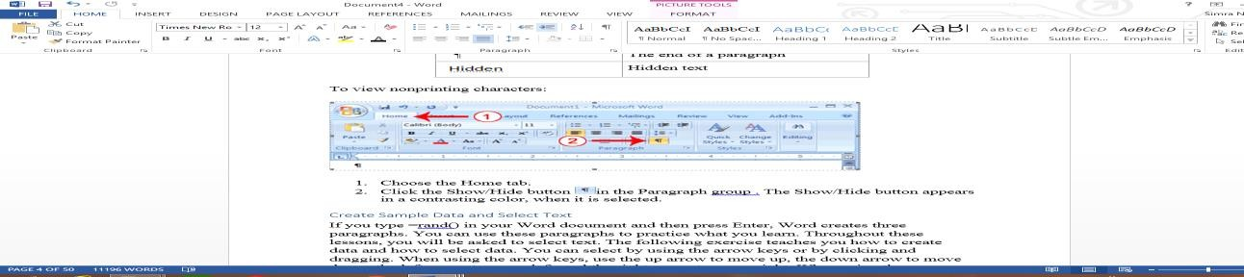
To view nonprinting characters:

Choose the Home tab.
Click the Show/Hide button in the Paragraph group . The Show/Hide button appears in a contrasting color, when it is selected

Working with Shapes

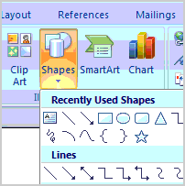
You can add a variety of shapes to your document, including arrows, callouts, squares, stars, and flow chart symbols. Want to offset your name and address from the rest of your resume? Use a line. Need to show the progress of a document through your office? Use a flow chart. While you may not need shapes in every document you create, they can add visual appeal and clarity to many documents.
In this lesson, you will learn how to insert a shape and format it by changing its fill color, outline color, shape style, and shadow effects. Additionally, you will learn to apply 3D effects to shapes that have this option.
To insert a shape:
Select the Insert tab.
Click the Shape command.
Left-click a shape from the menu. Your cursor is now a cross shape.
Left-click your mouse and while holding it down, drag your mouse until the shape is the desired size. Release the mouse button.
To change shape style: Select the shape. A new Format tab appears with Drawing Tools.
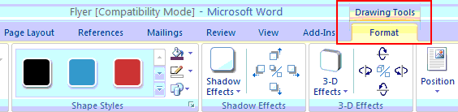
Click the More drop-down arrow in the Shapes Style group to display more style options.
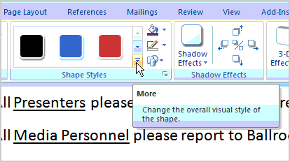
Move your cursor over the styles, and Live Preview will preview the style in your document.
Left-click a style to select it.
To change the shape fill color:
Select the shape. A new Format tab appears with Drawing Tools. Click the Shape Fill command to display a drop-down list.

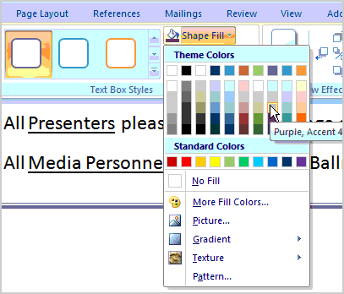
Select a color from the list, choose No Fill, or choose one of the other options.
To change the shape outline:
Select the shape. A new Format tab appears with Drawing Tools. Click the Shape Outline command to display a drop-down list.
Select a color from the list, choose No Outline, or choose one of the other options.
To change to a different shape:
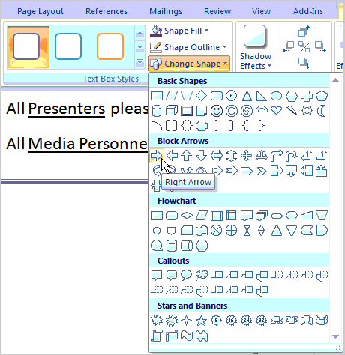
Select the shape. A new Format tab appears with Drawing Tools. Click the Change Shape command to display a drop-down list.
Select a shape from the list.
To change shadow effects:
Select the Format tab.
Left-click the Shadow Effects command.
Move your mouse over the menu options. Live Preview displays how it will appear in your document.
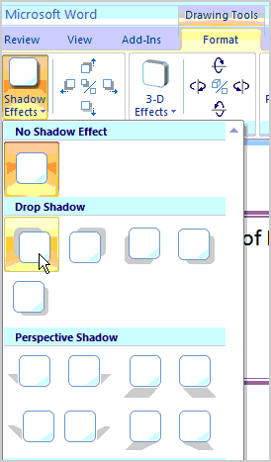
Click an option to select the shadow effect.
Select Shadow Color from the menu, and choose a color from the palette to change the color of the shadow on your shape.

To change 3D effects:
You cannot add a 3D effect to all shapes.
Select the Format tab.
Left-click the 3-D Effects command.
Move your mouse over the menu options. Live Preview displays how it will appear in your document.
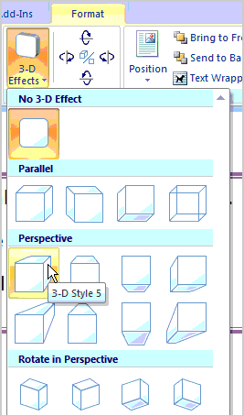
Click an option to select the 3D effect.
After you have chosen a 3D effect, you can change other elements of your shape, including the color, depth, direction, lighting, and surface of the 3D effect on your shape. This can dramatically change the way the shape looks. You can access these options by clicking the 3-D Effects command
Bold, Italicize, and Underline
When creating a document, you may need to emphasize particular words or phrases by bolding, underlining, or italicizing. Also, certain grammatical constructs require that you bold, underline, or italicize. You can bold, underline, and italicize when using Word. You also can combine these features—in other words, you can bold, underline, and italicize a single piece of text.
When you need to perform a task in Microsoft Word, you can usually choose from several methods. The exercises that follow show you how to bold, underline, or italicize using four different methods: using the launcher, the Ribbon, the Mini-toolbar/context menu, and the keyboard.
Bold with the Dialog Box Launcher
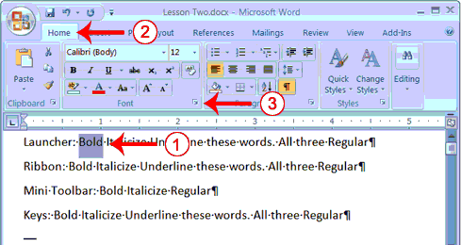
On the line that begins with Launcher, select the word "Bold." You can place the cursor before the letter "B" in "Bold." Press the Shift key; then press the right arrow key until the entire word is highlighted.
Choose the Home tab.
Click the dialog box launcher in the Font group. The Font dialog box appears Click Bold in the Font Style box.
Note: You can see the effect of your action in the Preview window. To remove the bold, click Regular. Click OK to close the dialog box.
Click anywhere in the text area to remove the highlighting. You have the word bold..

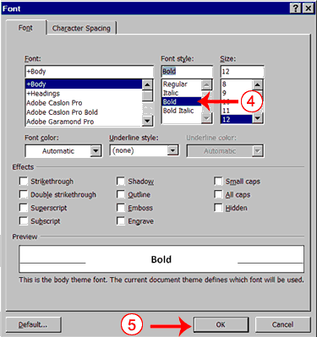
Alternate Method—Bold with the Ribbon
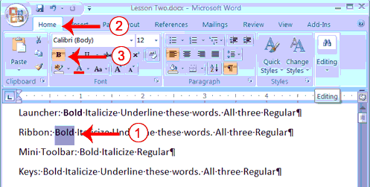
On the line that begins with "Ribbon," select the word "Bold." You can place the cursor before the letter "B" in "Bold." Press the Shift key; then press the right arrow key until the entire word is highlighted.
Choose the Home tab.
Click the Bold button in the Font group. You have bolded the word bold.
Note: To remove the bold, you can select the text and then click the Bold button again.
Click anywhere in the text area to remove the highlighting.
Alternate Method - Bold with the Mini Toolbar
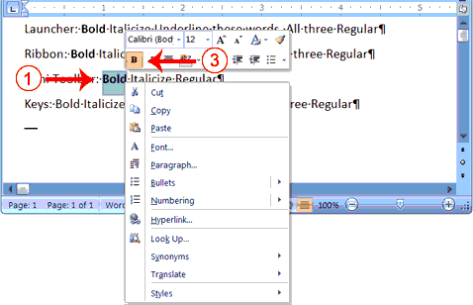

On the line that begins with "Mini Toolbar," select the word "Bold." You can place the cursor before the letter "B" in "Bold."Press the Shift key; then press the right arrow key until the entire word is highlighted.
Right-click. The Mini toolbar appears.
Click the Bold button . You have bolded the word bold.
Alternate Method—Bold with Keys
On the line that begins with "Keys," select the word "Bold." You can place the cursor before the letter "B" in "Bold." Press the Shift key; then press the right arrow key until the entire word is highlighted.
Press Ctrl+b (hold down the Ctrl key while pressing b).
Note: To remove the Bold, press Ctrl+b again. You can also remove formatting by pressing Ctrl+spacebar.
Click anywhere in the text area to remove the highlighting.
Italicize with the Dialog Box Launcher
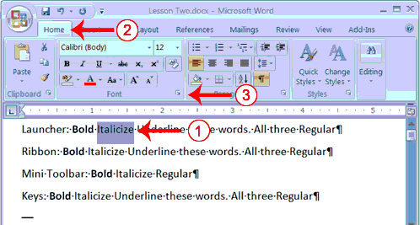
On the line that begins with Launcher, select the word "Italicize." You can place the cursor before the letter "I" in "Italicize." Press the Shift key; then press the right arrow key until the entire word is highlighted.
Choose the Home tab.
Click the dialog box launcher in the Font group. The Font dialog box appears. Click Italic in the Font Style box.
Note: You can see the effect of your selection in the Preview window. To remove the italics, click
Regular in the Font Style box.
Click OK to close the Font dialog box.
Click anywhere in the text area to remove the highlighting. You have italicized the word Italicize.

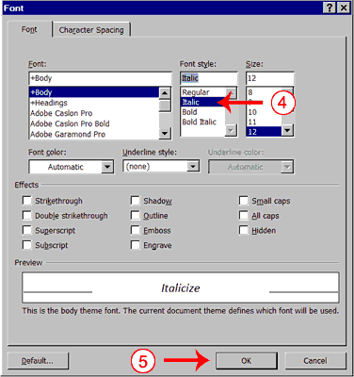
Alternate Method—Italicize with the Ribbon
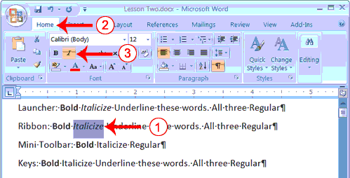
On the line that begins with "Ribbon," select the word "Italicize." You can place the cursor before the letter "I" in "Italicize." Press the Shift key; then press the right arrow key until the entire word is highlighted.
Choose the Home tab.
Click the Italic button on the Ribbon. You have italicized the word Italicize.
Note: To remove the italics, select the text and click the Italicize button again.
Click anywhere in the text area to remove the highlighting.
Alternate Method—Italicize with the Mini Toolbar
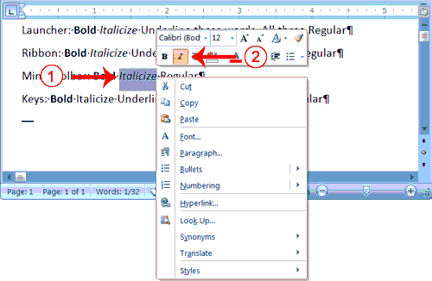

On the line that begins with "Mini Toolbar," select the word "Italicize." You can place the cursor before the letter "I" in "Italicize." Press the Shift key; then press the right arrow key until the entire word is highlighted.
Right-click. The Mini toolbar appears.
Click the Italic button . You have italicized the word Italicize.
Alternate Method—Italicize with Keys
On the line that begins with "Keys," select the word "Italicize." You can place the cursor before the letter "I" in "Italicize." Press the Shift key; then press the right arrow key until the entire word is highlighted.
Press Ctrl+i (hold down the Ctrl key while pressing i).
Note: To remove italics, press Ctrl+i again. You can also remove formatting by pressing Ctrl+spacebar.
Click anywhere in the text area to remove the highlighting.You have italicized the word Italicize.
Underline with the Dialog Box Launcher
You can underline when using Word. Word provides you with many types of underlines from which to choose.The following are some of the underlines that are available if you use the dialog box launcher:
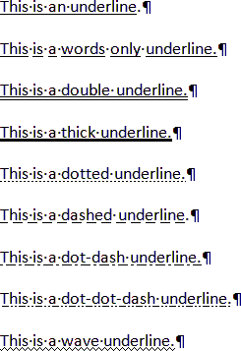

The following illustrates underlining with the dialog box launcher:
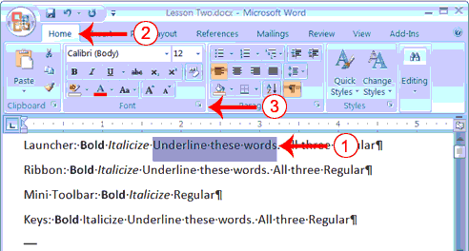
On the line that begins with "Launcher," select the words "Underline these words." Choose the Home tab.
Click the dialog box launcher in the Font group. The Font dialog box appears.

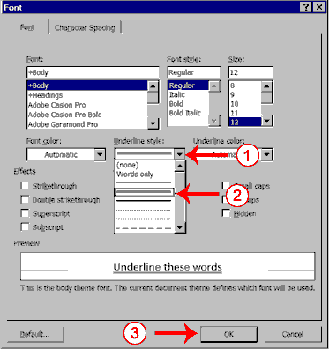
In the Underline Style box, click the down arrow to open the pull-down menu. Click the type of underline you wish to use.
Note: To remove an underline, you select None from the pull-down menu.
Click OK to close the dialog box. The underline you selected appears under the words. Click anywhere in the text area to remove the highlighting.
Alternate Method—Underline with the Ribbon
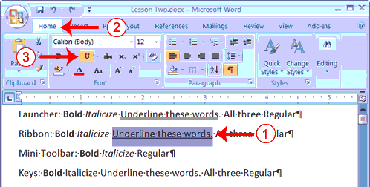
On the line that begins with "Ribbon," select the words "Underline these words." Choose the Home tab.

Click the Underline button in the Font group . Alternatively, you can press the down arrow next to the underline button and click to choose the type of underline you want.
Note: To remove the underlining, click the Underline button again.
Click anywhere in the text area to remove the highlighting.
Alternate Method—Underline with Keys
On the line that begins with "Keys," select the words "Underline these words." Press Ctrl+u (hold down the Ctrl key while pressing u).
Note: To remove the underlining, press Ctrl+u again. Click anywhere in the text area to remove the highlighting.
All Three with the Dialog Box Launcher
On the line that begins with "Launcher," select the words "All three." Choose the Home tab.
Click the dialog box launcher in the Font group. The Font dialog box appears.
In the Font Style box, click Bold Italic.
Note: You can see the effect of your selection in the preview window. To turn off the Bold Italic, click Regular.
In the Underline box, click to open the pull-down menu. Click the type of underline you want to use.
Note: To remove an underline, select None from the pull-down menu.
Click OK to close the dialog box.
Click anywhere in the text area to remove the highlighting.

Alternate Method—All Three with the Ribbon
On the line that begins with "Ribbon," select the words "All three." Choose the Home tab.
Click the Bold button in the Font group. Click the Italic button in the Font group.
Click the Underline button in the Font group.
Click anywhere in the text area to remove the highlighting.
Alternate Method—All Three with Keys
On the line that begins with "Keys," select the words "All three." Press Ctrl+b (bold).
Press Ctrl+i (italicize).
Press Ctrl+u (underline).
Note: You can remove formatting by highlighting the text and pressing Ctrl+spacebar.
Click anywhere in the text area to remove the highlighting.

Save a File and Close Word
You must save your documents if you wish to recall them later. You can use the Save option on the Microsoft Office menu, to save a document. You can also save a document by typing Ctrl+s. The first time you save a document, the Save As dialog box appears. Use the Save As dialog box to locate the folder in which you want to save your document and to give your document a name. After you have saved your document at least once, you can save any changes you make to your document simply by clicking the Save after you click the Microsoft Office button.
Use Spell Check
Word checks your spelling and grammar as you type. Spelling errors display with a red wavy line under the word. Grammar errors display with a green wavy line under the error. In Word 2007, you can use the Review tab's Spelling & Grammar button to initiate a spell and grammar check of your document.
Use Spell Check
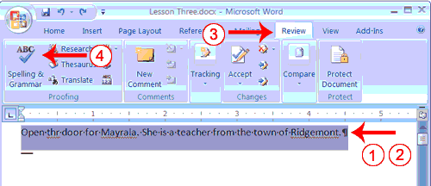
Type the following exactly as shown. Include all errors.
Open the door for Mayrala. She is a teacher from the town of Ridgemont. Select: "Open thr door for Mayrala. She is a teacher from the town of Ridgemont." Choose the Review tab.
Click the Spelling & Grammar button. The Spelling and Grammar dialog box appears.
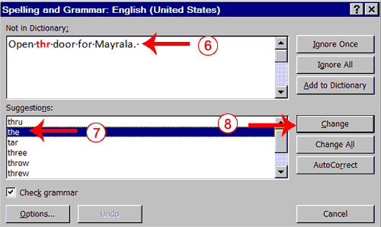
"The" is misspelled, so it is highlighted on the screen and noted in the Not in Dictionary box. Word suggests correct spellings. These suggestions are found in the Suggestions box.
Click "the" in the Suggestions box. Click Change.
Note: If the word is misspelled in several places, click Change All to correct all misspellings.
The name "Mayrala" is not in the dictionary, but it is correct. Click Ignore Once to leave "Mayrala" in the document with its current spelling.
Note: If a word appears in several places in the document, click Ignore All so you are not prompted to correct the spelling for each occurrence.

"Ridgemont" is not found in the dictionary. If you frequently use a word not found in the dictionary, you might want to add that word to the dictionary by clicking the Add to Dictionary button. Word will then recognize the word the next time it appears. Click Add to Dictionary.
The following should appear on your screen: "Word finished checking the selection. Do you want to continue checking the remainder of the document?"
Click No. If you wanted Word to spell-check the entire document, you would have clicked yes.
Note: You can also press F7 to initiate a spelling and grammar check. If you don't have anything selected, Word checks the entire document.
Find and Replace
If you need to find a particular word or phrase in your document, you can use the Find command. This command is especially useful when you are working with large files. If you want to search the entire document, simply execute the Find command. If you want to limit your search to a selected area, select that area and then execute the Find command.
After you find the word or phrase you are searching for, you can replace it with new text by executing the Replace command.
Add Sample Text
This lesson uses sample text provided by Microsoft for training and demonstration purposes. You can type the text; however, there is a quicker way. You can use the rand function.
Functions are used to obtain information. You tell the function what you want and the function returns that information to you. By default, in Word, when you type the rand function, Word returns three paragraphs. When working with functions, you use arguments to be specific about what you want the function to return. There are two arguments you can use with the rand function. The first one tells Word how many paragraphs you want, and the second one tells Word how many sentences you want in a paragraph. You place arguments between the parentheses and you separate them with a comma. For example, if you type
=rand() and then press Enter, word returns three paragraphs. To tell Word you want two paragraphs with three sentences in each paragraph, you type =rand(2,3).
Apply a Style
You can see of all the styles available to you in the style set by clicking the launcher in the Styles group and opening the Styles pane. You can leave the Styles pane open and available for use by docking it. To dock the Styles pane, click the top of the pane and drag it to the left or right edge of the Word window.
You do not need to select an entire paragraph to apply a style. If the cursor is anywhere in the paragraph, when you click on the style, Word formats the entire paragraph.

Apply the Title Style
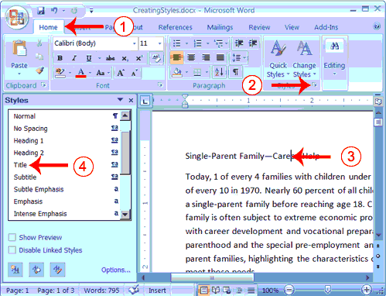
Choose the Home tab.
Click the launcher in the Styles Group. The Styles pane appears. You can drag it to the side of the Word window to dock it. To close the Styles pane, click the Close button in the upper right corner of
the pane .
Click anywhere in the paragraph "Single-Parent Family—Career Help."
Click Title in the Styles pane. Word 2007 applies the Title style to the paragraph.
Headings and subheadings mark major topics within your document. With Word 2007, you can easily format the headings and subheadings in your document.
Apply Headings
Click anywhere in the paragraph "The Nature of Single Parenthood." In the Style box, click Heading 1. Word reformats the paragraph.
Repeat steps 1 and 2 in the following paragraphs: Types of Single Parents
Career Development Needs of Single Parents Career Development Programs
Apply Subheadings
Click anywhere in the paragraph "Displaced Homemakers"
In the Style box, click Heading 2. Word reformats the paragraph. Repeat steps 1 and 2 for the following paragraphs:
Displaced Homemakers Adolescent Mothers

Single Fathers
High School Dropout Prevention Established Education Sites
Alternate Method -- Apply Styles with the Ribbon
You can also choose styles by selecting the option you want from the Styles group on the Ribbon. First you must place your cursor in the paragraph to which you want to apply the style. Then you click the More button in the Styles group to see all of the styles in the currently selected set. As you roll your cursor over each of the styles listed, Word 2007 provides you with a live preview of how the style will appear when applied.
Select the paragraphs "Emotional Support" through "Parenthood Education" (they are probably on page two).
Click the More button in the Styles group.
Locate and click the List Paragraph style. Word applies the List Paragraph style to the paragraphs you selected.
Change Style Sets
Once you have applied styles, changing to another style set is easy. You simply open the Style Set gallery. As you move your cursor down the menu, Word 2007 provides you with a live preview of the effect of applying the style set. To choose a style set, you click it.
Adding Bullets and Numbers, Undoing and Redoing, Setting Page Layouts and Printing Documents
If you have lists of data, you may want to bullet or number them. When using Microsoft Word, bulleting and numbering are easy. The first part of this lesson teaches you to bullet and number.
After you have completed your document, you may want to share it with others. One way to share your document is to print and distribute it. However, before you print you may want to add page numbers and tell Word such things as the page orientation, the paper size, and the margin setting you want to use. In this lesson you will learn how to layout and how to print your documents.
Add Bullets and Numbers
In Microsoft Word, you can easily create bulleted or numbered lists of items. Several bulleting and numbering styles are available, as shown in the examples. You can select the one you wish to use.
EXAMPLES: Numbering
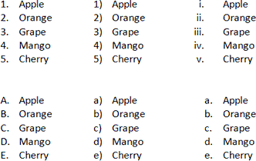
EXAMPLES: Bulleting
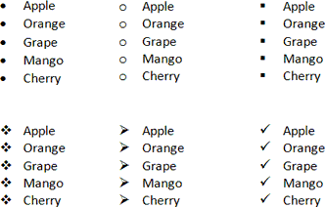

Bullets
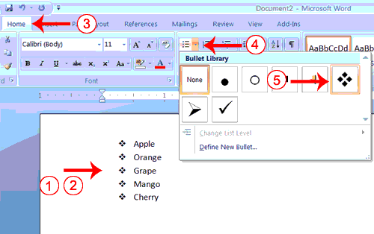
Type the following list as shown:
Apple Orange Grape Mango Cherry
Select the words you just typed. Choose the Home tab.
In the Paragraph group, click the down arrow next to the Bullets button . The Bullet Library appears. Click to select the type of bullet you want to use. Word adds bullets to your list.
Note: As you move your cursor over the various bullet styles, Word displays the bullet style onscreen.
To remove the bulleting: Select the list again. Choose the Home tab.
In the Paragraph group, click the down arrow next to the Bullets icon. The Bullet dialog box appears. Click None. Word removes the bullets from your list.
Numbers
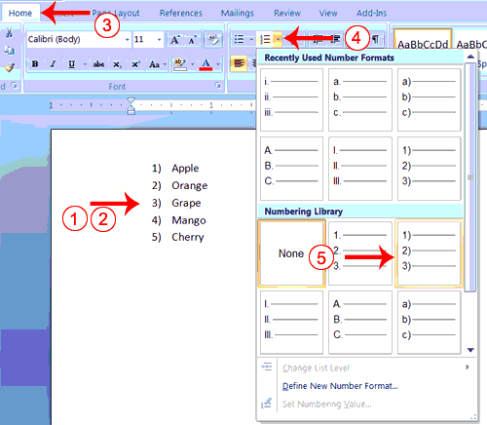
Type the following list as shown:
Apple Orange Grape Mango Cherry
Select the words you just typed. Choose the Home tab.
In the Paragraph group, click the down arrow next to the Numbering button . The Numbering Library appears.
Click to select the type of numbering you want to use. Word numbers your list.
Note: As you move your cursor over the various number styles, Word displays the number style onscreen.
To remove the numbering:
Select the list again. Choose the Home tab.
In the Paragraph group, click the down arrow next yo the Numbering icon. The Number dialog box appears. Click None. Word removes the numbering from your list.

Undo and Redo
You can quickly reverse most commands you execute by using Undo. If you then change your mind again, and want to reapply a command, you can use Redo.
Undo and Redo
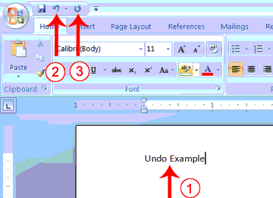
Type Undo example.
Click the Undo button on the Quick Access menu. The typing disappears. Click the Redo button on the Quick Access menu. The typing reappears. Select "Undo example."
Press Ctrl+b to bold. Word bolds the text. Press Ctrl+i. Word italicizes the text.
Press Ctrl+u Word underlines the text.
Click the down arrow next to the Undo icon. You will see the actions you performed listed. To undo the underline, click Underline; to undo the underline and italic, click Underline Italic; to undo the underline, italic, and bold click Bold etc.
To redo, click the Redo icon several times.
Alternate Method -- Undo & Redo by Using Keys
Type Undo example.
Press Ctrl+z. The typing disappears. Press Ctrl+y. The typing reappears. Select "Undo example."
Press Ctrl+u to underline.
Press Ctrl+z. The underline is removed. Press Ctrl+y. The underline reappears.
Set the Orientation
Before you print your document, you may want to change the orientation of your pages. There are two orientations you can use: portrait and landscape. Paper, such as paper sized 8 1/2 by 11, is longer on one edge than it is on the other. If you print in Portrait, the shortest edge of the paper becomes the top of the page. Portrait is the default option. If you print Landscape, the longest edge of the paper becomes the top of the page.

Portrait

Landscape
The exercises that follow use a file named SamplePrint.docx. Right click here to download the file. Click Save Target As from the menu that appears, and save the linked file to a directory on your computer. The file will download as a zip file. A zip file is a file that is compressed. Compressed files are smaller and easier to download. To open the file:

Open the folder you downloaded the file to. Right-click on the file name.
Click Extract All on the menu that appears. The Extract Compressed (Zipped) Folders dialog box appears. Enter the folder you want to put the file in or except to suggested location.
Click Extract. Windows Explorer extracts the file. You can use Microsoft Word to open the file.
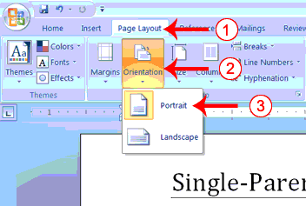
Set the Orientation
Choose the Page Layout tab.
Click Orientation in the Page Setup group. A menu appears. Click Portrait. Word sets your page orientation to Portrait.
Set the Page Size
Paper comes in a variety of sizes. Most business correspondence uses 8 1/2 by 11 paper which is the default page size in Word. If you are not using 8 1/2 by 11 paper, you can use the Size option in the Page Setup group of the Page Layout tab to change the Size setting.
Set the Page Size
Choose the Page Layout tab.
Click Size in the Page Setup group. A menu appears. Click Letter 8.5 x 11in. Word sets your page size.
Set the Margins
Margins define the amount of white space that appears at the top, bottom, left, and right edges of your document. The Margin option in the Page Setup group of the Page Layout tab provides several standard margin sizes from which you can choose. Set the Margins
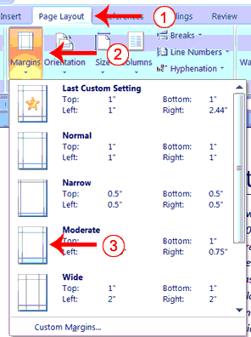
Choose the Page Layout tab.
Click Margins in the Page Setup group. A menu appears.
Click Moderate. Word sets your margins to the Moderate settings.
Add Page Numbers Page numbers help you keep your document organized and enable readers to find information quickly. You can add page numbers to the top, bottom, or margins of your pages, and you can choose where the numbers appear. For example, numbers can appear at the top of the page, on the left, right, or center of the page. Word also offers several number styles from which you can choose

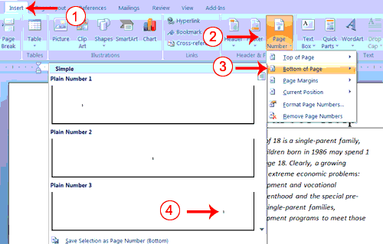
Choose the Insert tab.
Click the Page Number button in the Header & Footer group. A menu appears. Click Bottom of Page.
Click the right-side option.

Preview and Print Documents
When you have your margins, tabs, and so on the way you want them, you are ready to print. In Word, You can preview your document before you print. In the Preview mode, you can review each page, view multiple pages at the same time, zoom in on a page, and access the Size, Orientation, and Margin options.
If you press the Zoom button while you are in Preview mode, the Zoom dialog box appears. In the Zoom dialog box you can set the sizes of the pages that display as well as the number of pages that display.
When you are ready to print, you use the Print dialog box. In the Print Range area, choose All to print every page of your document, choose Current Page to print the page you are currently on, or choose Pages to enter the specific pages you want to print. Type the pages you want to print in the Pages field. Separate individual pages with commas (1,3, 13); specify a range by using a dash (4-9).
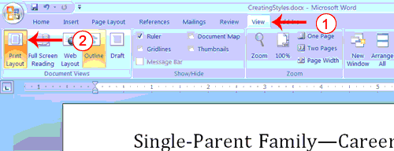
Choose the View tab.
Click Print Layout in the Document Views group. Your document changes to the Print Layout view

Insert Page Breaks:
you can display your document in any of five views: Draft, Web Layout, Print Layout, Full Screen Reading, or Online Layout. In Print Layout view you see your document as it will appear when you print it. You can clearly see where each page ends and a new page begins.
As you review your document, you may find that you want to change the point at which a new page begins. You do this by inserting a page break. For example, if a page heading appears on one page and the first paragraph under the heading appears on the next page, you may want to inser a page break before the heading to keep the heading and the first paragraph together. Change to Print View

Insert Page Breaks
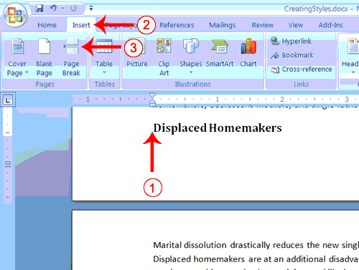
Place your cursor before the D in "Displaced Homemakers" Choose the Insert tab.
Click Page Break. Word places a page break in your document.
To delete a page break, you select the page break and then press the Delete key.

Case Changing

To change case, select the text whose case to be changed; Press Shift+F3 to change the case. Each time F3 is pressed the user will toggle through three options: UPPERCASE, lowercase, and Title Case.

Indentation
To indent both the left and right sides of the paragraph, position the insertion point in the paragraph to be indented, or select multiple paragraphs to indent; Choose Page Layout, type or select a value in the Left and then the Right indentation text boxes. You can also increase or decrease the indentation by clicking on the up and down arrows beside the text boxes.

Text Alignment
Word automatically aligns text on the left margin (horizontal alignment) and to the top margin (vertical alignment). The user can choose to change the alignment to center, right, full justified, or back to left.
To change horizontal alignment, select the paragraph(s) to be changed; Press Ctrl+L (Left), Ctrl+E (Center), Ctrl+R (Right), or Ctrl+J (Justify) to change the alignment of the paragraph accordingly (or use the Align Left, Center, Align Right, or Justify buttons on the Standard toolbar).
To change vertical alignment, move the insertion point inside the section where the text is to be aligned; Choose Page Layout, Align. Select Center, Justify, or Top to change alignment.

Customizing Paragraph Spacing
The user can customize the paragraph spacing in Word for the spacing between paragraphs and the spacing between the lines in specified paragraphs. To do this, place the insertion point in the paragraph to be modified, or highlight all of the contiguous paragraphs to be changed and right click on it; Choose Paragraph to display the dialog box, then click the Indents and Spacing tab if it is not active; In the Spacing section, select Before and After and change the value(s) in the text box to increase or decrease by points the number of lines before or after a paragraph (6 points = 1 line); To change the line spacing within paragraphs, select the drop-down arrow for the Line Spacing list box, then select one of these options: 1.5 lines, Double, At least, Exactly, or Multiple; If one of the last three options is chosen, enter a number in the At text box. When finished, choose OK.

Columns

To create columns of equal width, choose Page Layout; Select the text (or to format the entire document with columns, select the document); On the Standard toolbar, click the Columns button; Drag the pointer to select the number of columns needed. To remove columns, select the text for the columns to be removed; Click the Columns button on the Standard toolbar and select one column.

Borders, Lines, and Shading
For a finished look, the user can add borders and shading to the documents. Just select the paragraph(s) to apply a border or shading to, then choose Insert, Table and click on Insert Table. In the title bar, there appears a Table Tools box. Click on this box. Click on Border and then on Border and Shading. Then click the desired line style; Click the Line Weight button, then click the line weight to be used; Click the drop-down arrow on the Borders button, then click the type of border to be applied; Click the drop-down arrow on the Shading Color button to display the palette of gray percents and colors, then click the percent of gray or color button.

Drop Cap
A drop cap is large capital letters of the first word that is set into a paragraph to add visual interest. Just select the first letter, word, or section of the paragraph to be formatted with a drop cap; Choose Insert, Drop Cap; Select Dropped or In Margin; In the Drop Cap Options section, select the Font from the drop-down list, and increase or decrease the Lines to Drop if the default of three lines is not to be used; If the distance of the text from the drop cap is to be changed, use the increment buttons on the Distance from Text option, then choose OK. To remove drop caps, click the drop caps text, choose Drop Cap, click the None option in the Position section of the dialog box, then choose OK.

Inserting Special Characters
To insert special characters, place the insertion point at the point in the paragraph where a symbol or special character is to be placed; Choose Insert, Symbol to display the Symbol dialog box. Click the Symbols tab to select a symbol, or click the Special Characters tab to select a special character; On the Symbols tab, select the font set that contains the symbol to be inserted in the document in the Font drop-down list box. To view a symbol in the displayed table, click the symbol. The symbol is then displayed in an enlarged and highlighted view; To insert a symbol or special character, click the item to be inserted, then click the Insert button. Click the Close button to close the dialog box and return to the document.

Zooming the Document Display
Zooms customizes the on screen size of the document in a way the user wants to view it. However, zoom setting does not affect the actual formatting of the document. To adjust zooming option, click View, Zoom; In the drop- down list, select the zoom percentage to be used. The document display changes to the zoom percentage selected; If the required zoom percentage is not in the list, type the percent in the text box part of the Zoom button and press Enter.

Creating Custom Colors/Gradients/Textures

To create custom colors, right click on the graphic element to be colored. Along with the shortcut menu appears the Drawing toolbar. Then click the drop-down arrow of the Fill Color or Line Color button and select More Fill Colors to open the Colors dialog box; Click the Custom tab at the top of the Colors dialog box. Set desired color. For gradient settings, in the drop-down arrow beside the Fill Color button, select Gradient at the bottom of the color palette instead of More Fill Colors. Click the Gradient tab and make desired settings. Texture tab can also be selected to apply designs to the objects.

Inserting Clip Art/AutoShapes/Pictures/WordArt
To insert a Clip Art/ AutoShape, Picture or WordArt, position the insertion point in the document where the image is to be appeared. Choose Insert and then the desired option. Related dialog box appears, then make required selections. The inserted object can be customized in a number of ways. The user can change colors of the image, edit, reposition and resize them.
There are two ways to rotate or flip the inserted object. One is to right click on the object and then choose Format Picture/Shape. Then click on the 3-D Rotation button. From here, the desired rotation in the x, y and z axes may be chosen. The other gives access to that same tool and to the commands Rotate Left, Rotate Right, Flip Horizontal, and Flip Vertical. To do this, click the object to be adjusted choose Page Layout, click on Rotate and then choose the desired option.
These commands automatically execute. If Free Rotate is chosen (if we bring the cursor on the small green circle that appears above any object when we select it, this gives the free rotate option) continue with the following steps; Move the pointer over the rotate handle and, when it assumes the shape of the rotate tool icon, hold down the right mouse button;
The pointer changes to four circling arrows. Drag right or left. While dragging, a dotted outline indicates where the object would be if the mouse button is released; until the object is deselected it can be continuously rotated, even if the mouse button has been released. Place the pointer over a circle handle, hold down the mouse button and continue to rotate. Release the mouse button when the object is rotated to the desired position, and click outside the object to deselect it.

Creating Headers and Footers

Headers and footers contain information repeated at the top or bottom of the pages in a document. To set Header and Footer, with the document open, choose Insert, then click on Header or Footer. Choose the desired format from the drop down list. The Header pane is displayed in the document; Type and format the information for the header; To include the Page Number, Number of Pages, or current Date or Time, click the corresponding button on the Header and Footer toolbar; To create a footer, click the Go to Footer Button on the toolbar and type and format the footer just as was done for the header. Click Close Header & Footer button to return to the document.

Document Map

The Document Map is a very functional way to move quickly through long or online documents. To use Document Map, choose View, Navigation Pane. Use the mouse to click the heading or text in the Document Map pane to move to that section of the document; Click the arrow on the left of any heading to expand or collapse the headings; To adjust the size of the Navigation pane, move the mouse pointer onto the right edge of the pane so the pointer changes to a resizing pointer, then click and drag the edge to the left or right. To use the keyboard, press F6 to move to the Navigation pane. Arrow keys and the Enter key will move to the desired location in the document.

Drawing Tables

Drawing a table allows the user to place the rows and columns where he wants them. To create a table, click the Tables and Borders button to bring up the Tables and Borders toolbar and change the mouse pointer to a pencil; Drag the mouse pointer from one corner of the new table to the opposite corner to create the rectangle outline for the table; If a line is to be removed, click the Eraser button on the Tables and Borders toolbar and drag across the line.

If the user needs the data from a table, he may (rarely) want to convert the table to text with some sort of separator between the data for the former columns. To do this, select the entire table by positioning the mouse directly at the left top of the table until the pointer changes to a four directional arrow and then click it. A Table toolbar appears at the top of the document window. In the Layout tab, choose Convert to Text. Choose to separate the text with Paragraph Marks, Tabs, Commas, or type a new character in the Other text box; then choose OK. Similarly the user may want to convert the lines of text into a table. To do this, select the rows of tabbed text to be converted; Choose Insert, click on Table and then choose Insert Table.
The cells of the table can be edited and formatted, like moving and copying cells, splitting and merging cells,
adjusting row and column spacing/width, inserting and deleting rows and columns, by selecting appropriate options from the menu that appears on right clicking the table or the selected cells.

Creating Bookmarks

A bookmark is a named marker for a block of text, an entire table or a graphic, a cell or range of cells in a table, or simply a position in a document. First enter a bookmark where it is wanted, then the user can move to it or cite it as a reference in a field or formula. To create a book mark, click in the document at the location where the bookmark is to be inserted, or select the text or graphic to be named; Choose Insert, Bookmark to display the Bookmark dialog box; enter the new bookmark name in the Bookmark Name text box. The user can also select an existing bookmark name from the list, and Word moves the bookmark from its existing location to the place selected; Click the Add button to add the bookmark to the bookmark list and close the dialog box
To delete a book mark, choose Insert, Bookmark; Select the name of the bookmark to be deleted from the Bookmark Name list box; Click the Delete button. The selected bookmark name is removed from the list box and the document; Click the Close button to close the dialog box and return to the document.

Hyperlinks

The user can create a link that jumps to a document, also called a page, on his computer and on a network or intranet. Two types of hyperlinks can be created: one that jumps to a bookmark in the same document and another that jumps to a URL.

First type is for named locations. Named locations can be in the same document the user is working with (an internal link), or in a different document (an external link). The named location targets a Bookmark inserted at the position to be jumped to within a document. To do this, use the Insert Hyperlink button on the Standard toolbar to open the Insert Hyperlink dialog box; choose either Place in this document or Existing File or Webpage button. Locate the Word document containing the Bookmark this link is to jump to. The user can also jump to a named range in Excel, a database object, or a specific PowerPoint slide; choose OK to confirm the choice or Cancel to negate it.

Second type is for URLs and other links. For this click the Insert Hyperlink button on the Standard toolbar to open the Insert Hyperlink dialog box; click on the Browse the Web or Browse for File button to locate and select the document. The path and document name are automatically entered in the Address text box; choose OK to confirm the choice or Cancel to negate it.

OBJECT

Lab Session 04

Task-1
Learning basics of Microsoft Word

Lab Exercise

Perform the following operations on a single document in MS Word. Print and attach your final result. No screenshots allowed.
- In the header, put your name, today’s date, and course name using Arial, font size 11. Align the text on the right side of the document.
- In the footer, put the lab number on the left side and the page number on the right side of the document using Arial, font size 11.
- Inside the document, type the name of the task (heading) using Times New Roman, font size 16.
- Center the heading, bold and underline it, and change its color to red.
- Skip a line and type “Task Completed” in Calibri, font size 11 without any formatting.
- Add a horizontal line and start Task 02.

Task 2
- Make a heading of the task using the same formatting as Task 01.
- Change the template font and page setup settings of the first paragraph following the standard and format specified.

Font | Times New Roman, 16pt, Bold, Italic
Page Columns | Number of Columns: 2, Width: 1:3, Spacing: 0.5
Paragraph Formatting | Indentation: 0.5” (Both Left and Right), 1” (Both Top and Bottom), Alignment: Justify
Page Margins | Left and Right: 0.75”, Top and Bottom: 1”
Page Size | 8.5” x 11”
Page Background | Watermark: Made by “Student’s Name”
- Skip a line and type “Task Completed” in Calibri, font size 11 without any formatting.Add a horizontal line, a section break, and start Task 03

Task 3
- Modify the design and layout of the given table to look exactly like this (The table is spanned till next page).
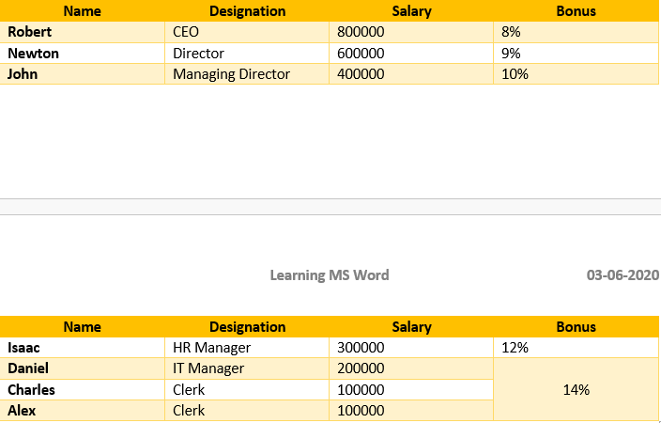

- Under the table, add a “Balance” diagram. Add some relevant content of your choice in it.

- Apply a “Shadow” border to the document with a 6 pts width and the color Dark Blue. Change the color of the page to Light Blue.
- Bookmark the heading “Table 1. Job Details” and name the bookmark as “JobDetails”.
- Skip a line and type “Task Completed” in Calibri, font size 11 without any formatting.Add a horizontal line, a section break, and start Task 04

Task 04
Continue in the document created in Task 01 and perform the following operations. Print and attach your final result. No screenshots allowed.
- Make a heading of the task using the same formatting as Task 01.
- Using advanced features of Word, create your CV.
- Add a watermark only to your CV page.

- Create the following multilevel list using the same list provided.
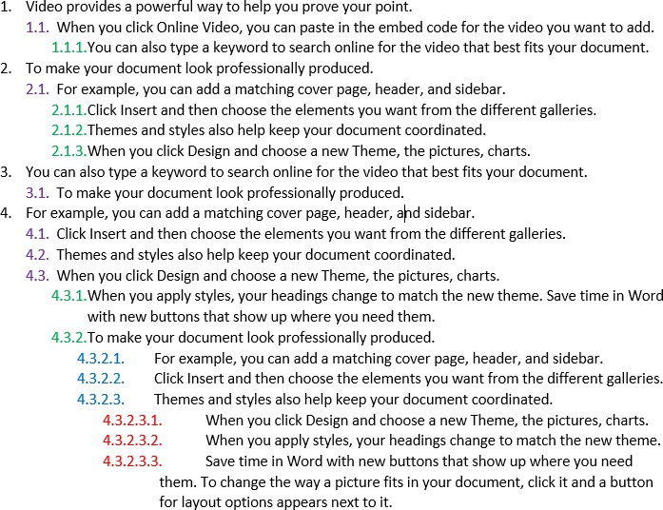

SUBMISSION GUIDELINES
  - Prepare a single word file labeled with Roll No and Lab No. e.g. ‘SE2023xxx_Lab04’.
  - Convert the file into PDF.
  - Submit the file at gcr and hardcopy
  - -100% policies for plagiarism.

NED University of Engineering & Technology
Department of Software Engineering
Course Code & Title: CT-174 FIT Assessment Rubric for Psychomotor (P2-PLO-3)

Instructor: Batch: 2024 Class: FESE Semester: Fall 2024. Student’s Name: Roll No.:
Laboratory Session No. Date:

Psychomotor Domain Assessment Rubric-Level P2-PLO3
Skill Sets | Extent of Achievement
 | Below Average (0--1) | Average (2) | Good (3) | Very Good (4) | Excellent (5)
Problem Definition and Understanding | Unable to define and understand the problem clearly. | Struggles to define the problem clearly, with significant gaps in understanding | Defines the problem, but with gaps or a limited understanding of key components, impacting the overall quality of definition. | Effectively defines the problem with a good understanding of its components, showcasing proficiency in problem definition. | Demonstrates an exceptional understanding of the problem, identifying all key components and challenges with insightful depth.
Technical Implementation Proficient use of tools to complete  the problem | Struggles to use tools effectively, requiring significant improvement. | Uses tools with noticeable inefficiencies. | Demonstrates basic proficiency in utilizing tool, with some room for improvement. | Effectively uses tools to support the task. | Integrates use of tools seamlessly to enhance the design and development process
Solution Design& Accuracy | Struggles to relate the implemented solutions to the design and development goals, requiring significant improvement. | Shows limited connection between the implemented solutions and the design and development context. | Demonstrates a basic understanding of how the solutions align with design and development requirements. | Effectively relates the implemented solutions to the overall design and development objectives | Maps the implemented solutions seamlessly to the overarching design and development goals, demonstrating a comprehensive understanding.
Trouble Shooting Skills Issue resolution  skills | Unable to trouble shoot | Limited troubleshooting | Adequate troubleshooting, minor errors remaining | Good troubleshooting, no errors remaining | Excellent trouble shooting no errors remain without delay.
Document Organization and on time submission | Poor Unclear disorganized document late submission | Somewhat clear with lack of organization and structuring late submission | Somewhat clear with lack of organization and structuring on time submission | Reasonably clear and organized with adequate structuring on time submission | Highly clear and well- structured document, On time submit

Weighted CLO (Psychomotor Score)
Instructor’s Signature with Date

Objective Theory
Lab Session: 05

To practice with the MS Excel environment

Microsoft Excel is a spreadsheet editor developed by Microsoft. It features calculation or computation capabilities, graphing tools, pivot tables, and a macro programming language called Visual Basic for Applications. It allows users to store, organize, and analyze information. Excel forms part of the Microsoft 365 suite of software.

Ribbon
MS Excel follows the same appearance as MS Word by using a Ribbon. Some tabs and menu items on the Ribbon are standard and same as MS Word, while others are specialized for MS Excel use and functions.
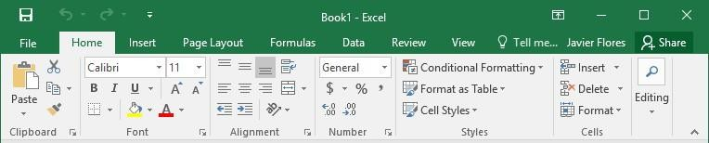
Each tab in the ribbon contains several groups of related commands. Some groups also have a small arrow in the bottom- right corner for even more options.

Worksheet
When Excel starts, a blank workbook is open by default. A workbook is just an Excel file.
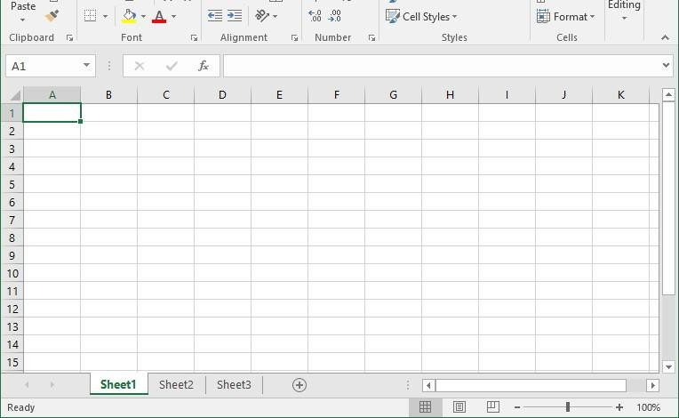
A workbook contains several worksheets. A worksheet (also known as a spreadsheet, or sheet) consists of cells in which users can enter and calculate data. The cells are organized into columns and rows. The worksheets within an excel file can be switched by clicking on the desired tab at the bottom of the Excel window. Sheets can also be renamed by right-clicking on them and selecting the rename option.

The Quick Access Toolbar

Next to the Microsoft Office button is the Quick Access toolbar. The Quick Access toolbar gives you with access to commands you frequently use. By default, Save, Undo, and Redo appear on the Quick Access toolbar. You can use Save to save your file, Undo to roll back an action you have taken, and Redo to reapply an action you have rolled back.

The Title Bar
using. At the top of the Excel window, you should see "Microsoft Excel - Book1" or a similar name.

The Formula Bar

Formula Bar
If the Formula bar is turned on, the cell address of the cell you are in displays in the Name box which is located on the left side of the Formula bar. Cell entries display on the right side of the Formula bar. If you do not see the Formula bar in your window, perform the following steps:
- Choose the View tab.
- Click Formula Bar in the Show/Hide group. The Formula bar appears.
Note: The current cell address displays on the left side of the Formula bar.

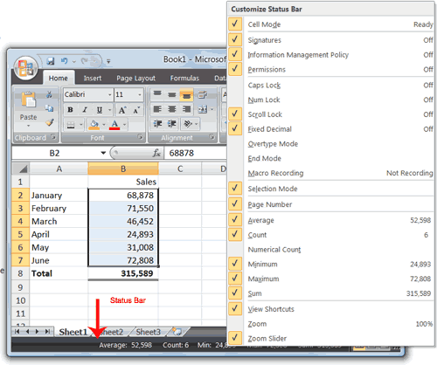
Next to the Quick Access toolbar is the Title bar. On the Title bar, Microsoft Excel displays the name of the workbook you are currently

The Status Bar
The Status bar appears at the very bottom of the Excel window and provides such information as the sum, average, minimum, and maximum value of selected numbers. You can change what displays on the Status bar by right-clicking on the Status bar and selecting the options you want from the Customize Status Bar menu. You click a menu item to select it. You click it again to deselect it. A check mark next to an item means the item is selecte

Cell
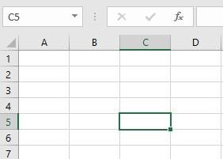
Each rectangle in a worksheet is called a cell. It is the intersection of a row and a column. Cells are the basic building blocks of a worksheet. Every worksheet is made up of thousands of cells.
Columns in Excel are labeled using alphabets and run from the top to the bottom of the worksheet. Rows are labeled using numbers and run from the left of the worksheet to the right.
Each cell has a name/identity of itself called the cell address. The name of cell is the “name of column + number of row”. The presently selected cell is highlighted by a colored border around it and cell's column and row headings are highlighted when the cell is selected. Its name is also displayed in the name box on the top-left of the worksheet. For example, in the image, the selected cell is C5.
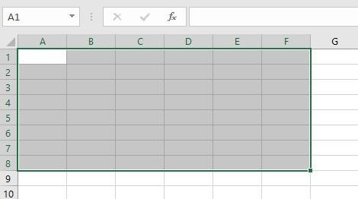
Multiple cells can also be selected simultaneously. A group of cells is called a range. Ranges are referred to using the first and last cell in the cell range. For example,
C1:C5 is a range of five consecutive cells in column C, i.e., C1, C2, C3, C4, and C5.
Ranges can also span multiple rows and
columns, as shown. In this case, the cell range is A1:F8. Moreover, cell ranges can be named to keep track of important cell ranges in the spreadsheet. This can be done by selecting the cell range, then selecting Define Name on the Formulas tab.

Cell Content
All information entered into the worksheet is stored in cells. Each cell can contain different types of content, including text (letters, numbers, dates), formatting (formatted text, colored backgrounds, etc.), and formulas and functions that calculate the cells values.
Inserting Content
To insert content in a cell, simply select a cell and insert data from the keyboard or paste previously copied data. The content will appear in the cell and the formula bar.
Deleting Content
Select the cell or range to clear. Then select Clear Contents under the Clear command on the Home tab. Alternatively, press Del/Delete key on the keyboard.
Copying/Pasting Content
Select the cell/range that will be copied. Right-click on the selection and select Copy or press Ctrl+C on the keyboard. The copied cell(s) will have a dashed box around them.
Select the cell/range to paste the content. Right-click on the selection and select Paste or press Ctrl+V on the keyboard.
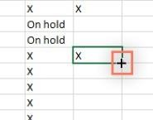
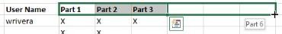
Fill Handle
Fill handle is particularly useful when copying content into adjacent cells.
Selects the cell(s) that will be copied, then hover the mouse over the lower- right
corner of the cell so the fill handle appears. Click and drag the fill handle until
all of the cells to be filled are selected. Release the mouse to fill the selected cells.
Fill handle can also be used to continue a series, i.e., a range of cells that follows a sequential order such as numbers (1, 2, 3, …) or days of the week

(Monday, Tuesday, Wednesday, …) etc.
In most cases, multiple cells must be
selected before using the fill handle to help Excel determine the series order.
To use the fill handle to continue a series, select the cell range that contains the series. Click and drag the fill handle to continue the series. Release the mouse. If Excel understood the series, it will be continued in the selected cells.
Adding Cells
This will insert an entire row/column in the worksheet. Right-click on the row/column where the new cells will be inserted, then select Insert.
Deleting Cells
This will delete an entire row/column in the worksheet. Right-click on the row/column that will be deleted, then select
Delete.

Formulas and Functions
Formulas
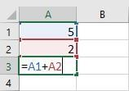
One of the most powerful features in Excel is the ability to calculate numerical information using formulas. Just like a calculator, Excel can add, subtract, multiply, and divide, and uses standard operators for formulas.
+ Addition
- Subtraction
* Multiplication
/ Division
^ Exponents
All formulas in Excel must begin with an equals sign (=). This is because the cell contains, or is equal to, the formula and the value it calculates. Formulas can be created using numbers or cell addresses; the latter is more common. In the example shown, cell A3 will contain the sum of cell A1 and A2. If the content of either A1 and/or A2 is changed, the change will be reflected in cell A3.
Formulas can also include a combination of cell references and numbers, e.g., N10*1.05. Formulas can also be copied to adjacent cells with the fill handle. Formulas can also be edited either in the cell or in the formula bar.

Move Around a Worksheet
By using the arrow keys, you can move around your worksheet. You can use the down arrow key to move downward one cell at a time. You can use the up arrow key to move upward one cell at a time. You can use the Tab key to move across

the page to the right, one cell at a time. You can hold down the Shift key and then press the Tab key to move to the left, one cell at a time. You can use the right and left arrow keys to move right or left one cell at a time. The Page Up and Page Down keys move up and down one page at a time. If you hold down the Ctrl key and then press the Home key, you move to the beginning of the worksheet.
Move Around the Worksheet

The Down Arrow Key
- Press the down arrow key several times. Note that the cursor moves downward one cell at a time.
The Up Arrow Key
- Press the up arrow key several times. Note that the cursor moves upward one cell at a time.
The Tab Key
- Move to cell A1.
- Press the Tab key several times. Note that the cursor moves to the right one cell at a time.
The Shift+Tab Keys
  - Hold down the Shift key and then press Tab. Note that the cursor moves to the left one cell at a time.
The Right and Left Arrow Keys
- Press the right arrow key several times. Note that the cursor moves to the right.
- Press the left arrow key several times. Note that the cursor moves to the left.
Page Up and Page Down
- Press the Page Down key. Note that the cursor moves down one page.
- Press the Page Up key. Note that the cursor moves up one page.
The Ctrl-Home Key
- Move the cursor to column J.
- Stay in column J and move the cursor to row 20.
Hold down the Ctrl key while you press the Home
- key. Excel moves to cell A1.

Go To Cells Quickly
The following are shortcuts for moving quickly from one cell in a worksheet to a cell in a different part of the worksheet.

Go to -- F5
The F5 function key is the "Go To" key. If you press the F5 key, you are prompted for the cell to which you wish to go. Enter the cell address, and the cursor jumps to that cell.
  - Press F5. The Go To dialog box opens.
  - Type J3 in the Reference field.
The Name Box
You can also use the Name box to go to a specific cell. Just type the cell you want to go to in the
  - Press Enter. Excel moves to cell J3.
Go to -- Ctrl+G
You can also use Ctrl+G to go to a specific cell.
- Hold down the Ctrl key while you press "g" (Ctrl+g). The Go To dialog box opens.
- Type C4 in the Reference field.
- Press Enter. Excel moves to cell C4.

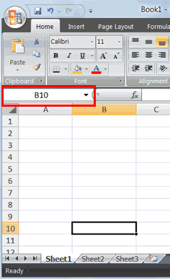
Name box and then press Enter. 1. Type B10 in the Name
box.
- Press Enter. Excel moves to cell B10.

Select Cells
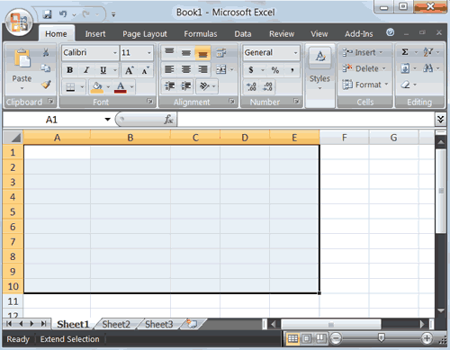

Alternative Method: Select Cells by Dragging You can also select an area by holding down the left mouse button and dragging the mouse over the area. In addition, you can select noncontiguous areas of the worksheet by doing the following:
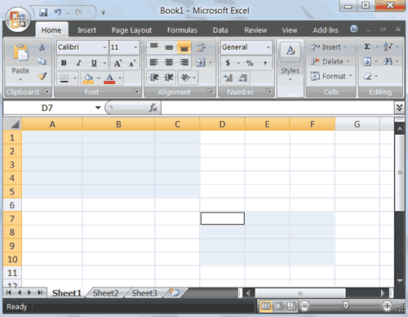

Enter Data

If you wish to perform a function on a group of cells, you must first select those cells by highlighting them. The exercises that follow teach you how to select.

- Go to cell A1.
- Hold down the Ctrl key. You won't release it until step 9. Holding down the Ctrl key enables you to select noncontiguous areas of the worksheet.
- Press the left mouse button.
- While holding down the left mouse button, use the mouse to move from cell A1 to C5.
- Continue to hold down the Ctrl key, but release the left mouse button.
- Using the mouse, place the cursor in cell D7.
- Press the left mouse button.
- While holding down the left mouse button, move to cell F10. Release the left mouse button.
- Release the Ctrl key. Cells A1 to C5 and cells D7 to F10 are selected.
- Press Esc and click anywhere on the worksheet to remove the highlighting.

In this section, you will learn how to enter data into your worksheet. First, place the cursor in the cell in which you want to start entering data. Type some data, and then press Enter. If you need to delete, press the Backspace key to delete one character at a time.

Enter Data
- Place the cursor in cell A1.
- Type John Jordan. Do not press Enter at this time.

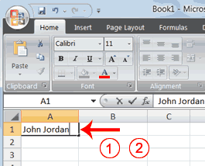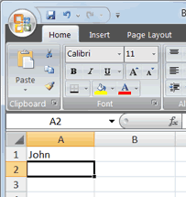

Delete Data

The Backspace key erases one character at a time.

  - Press the Backspace key until Jordan is erased.
  - Press Enter. The name "John" appears in cell A1.

Edit a Cell
After you enter data into a cell, you can edit the data by pressing F2 while you are in the cell you wish to edit.

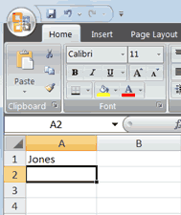
Edit a Cell

Change "John" to "Jones."

    - Move to cell A1.
    - Press F2.
    - Use the Backspace key to delete the "n" and the "h."
    - Type nes.

    - Press Enter.

Alternate Method: Editing a Cell by Using the Formula Bar

You can also edit the cell by using the Formula bar. You change "Jones" to "Joker" in the following exercise.

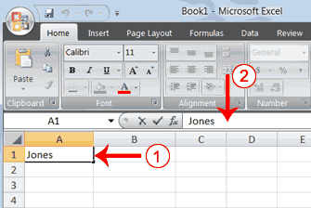
      - Move the cursor to cell A1.
      - Click in the formula area of the Formula bar.

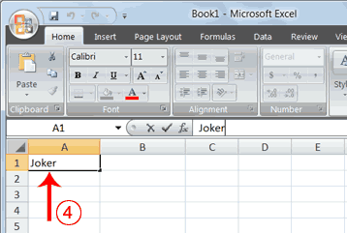

Alternate Method: Edit a Cell by Double-Clicking in the Cell

You can change "Joker" to "Johnson" as follows:
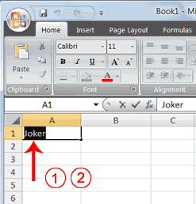

- Move to cell A1.
- Double-click in cell A1.
- Use the backspace key to erase the "s," "e," and "n."
- Type ker.
- Press Enter.

- Press the End key. Your cursor is now at the end of your text.
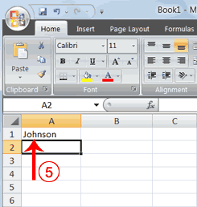

- Use the Backspace key to erase "r," "e," and "k."
- Type hnson.
- Press Enter.

Change a Cell Entry

Typing in a cell replaces the old cell entry with the new information you type.

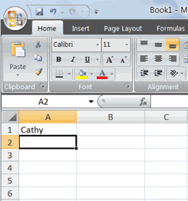
  - Move the cursor to cell A1.
  - Type Cathy.
  - Press Enter. The name "Cathy" replaces "Johnson."

Wrap Text

When you type text that is too long to fit in the cell, the text overlaps the next cell. If you do not want it to overlap the next cell, you can wrap the text.

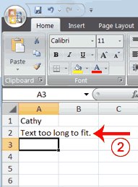
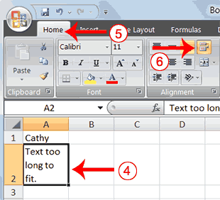
Wrap Text

- Move to cell A2.
- Type Text too long to fit.
- Press Enter.

- Return to cell A2.
- Choose the Home tab.
- Click the Wrap Text button . Excel wraps the text in the cell.

Create Borders
You can use borders to make entries in your Excel worksheet stand out. You can choose from several types of borders. When you press the down arrow next to the Border button , a menu appears. By making the proper selection from the menu, you can place a border on the top, bottom, left, or right side of the selected cells; on all sides; or around the outside border. You can have a thick outside border or a border with a single-line top and a double-line bottom.
Accountants usually place a single underline above a final number and a double underline below. The following illustrates:

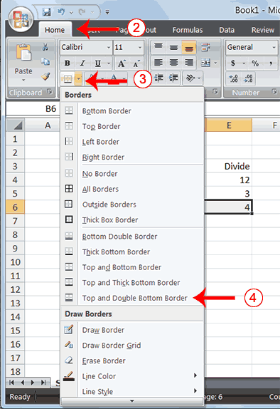
Create Borders
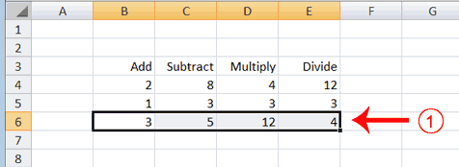
- Select cells B6 to E6.

- Choose the Home tab.

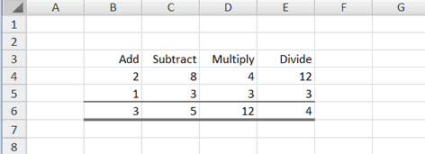
- Click the down arrow next to the Borders button . A menu appears.
- Click Top and Double Bottom Border. Excel adds the border you chose to the selected cells.

Merge and Center

Sometimes, particularly when you give a title to a section of your worksheet, you will want to center a piece of text over several columns or rows. The following example shows you how.

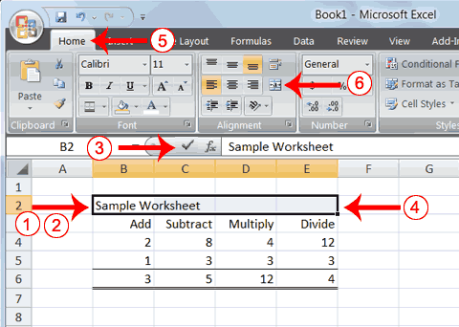
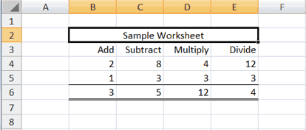
Merge and Center
2.
3.
4.
5.
6.
Type Sample Worksheet.
Click the check mark on the Formula bar. Select cells B2 to E2.
Choose the Home tab.
Click the Merge and Center button
in
the Alignment group. Excel merges cells B2, C2, D2, and E2 and then centers the content.

- Go to cell B2.
Note: To unmerge cells:
- Select the cell you want to unmerge.
- Choose the Home tab.
- Click the down arrow next to the Merge and Center button. A menu appears.

- Click Unmerge Cells. Excel unmerges the cells.

- ​

Add Background Color
To make a section of your worksheet stand out, you can add background color to a cell or group of cells.

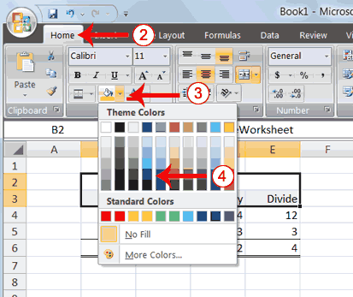
Add Background Color
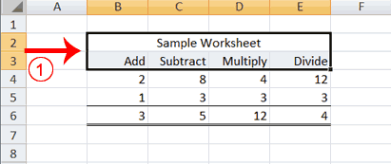
- Select cells B2 to E3.
- Choose the Home tab.
- Click the down arrow next to the Fill Color button .
- Click the color dark blue. Excel places a dark blue background in the cells you selected.

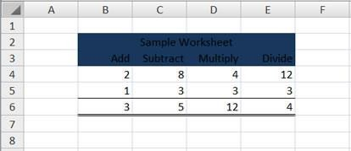

Change the Font, Font Size, and Font Color

A font is a set of characters represented in a single typeface. Each character within a font is created by using the same basic style. Excel provides many different fonts from which you can choose. The size of a font is measured in points. There are 72 points to an inch. The number of points assigned to a font is based on the distance from the top to the bottom of its longest character. You can change the Font, Font Size, and Font Color of the data you enter into Excel.

Change the Font

- Select cells B2 to E3.

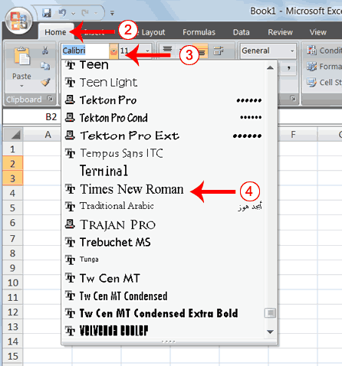
- Choose the Home tab.
- Click the down arrow next to the Font box. A list of fonts appears. As you scroll down the list of fonts, Excel provides a preview of the font in the cell you selected.
- Find and click Times New Roman in the Font box. Note: If Times New Roman is your default font, click another font. Excel changes the font in the selected cells.

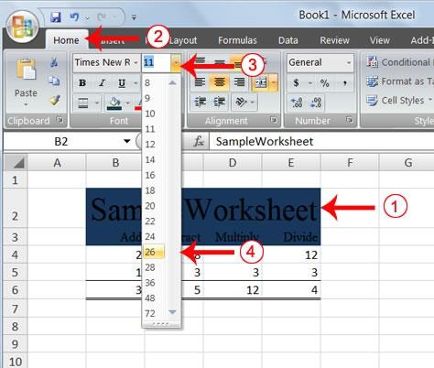
Change the Font Size

- Select cell B2.
- Choose the Home tab.
- Click the down arrow next to the Font Size box. A list of font sizes appears. As you scroll up or down the list of font sizes, Excel provides a preview of the font size in the cell you selected.
- Click 26. Excel changes the font size in cell B2 to 26.

Change the Font Color

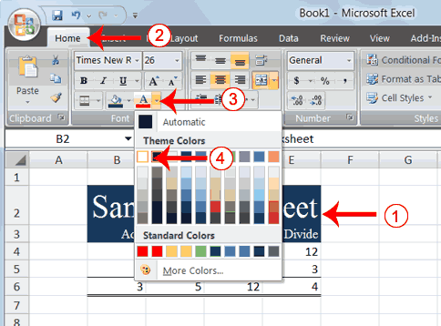

  - Select cells B2 to E3.
  - Choose the Home tab.

  - Click the down arrow next to the Font Color button .
  - Click on the color white. Your font color changes to white.
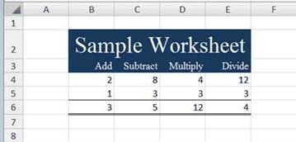

Your worksheet should look like the one shown here

Move to a New Worksheet

In Microsoft Excel, each workbook is made up of several worksheets. Each worksheet has a tab. By default, a workbook has three sheets and they are named sequentially, starting with Sheet1. The name of
the worksheet appears on the tab. Before moving to the next topic, move to a new worksheet. The exercise that follows

shows you how. Move to a New Worksheet
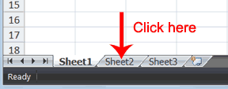
    - Click Sheet2 in the lower-left corner of the screen. Excel moves to Sheet2.

Bold, Italicize, and Underline

When creating an Excel worksheet, you may want to emphasize the contents of cells by bolding, italicizing, and/or underlining. You can easily bold, italicize, or underline text with Microsoft Excel. You can also combine these features—in other words, you can bold, italicize, and underline a single piece of text. In the exercises that follow, you will learn different methods you can use to bold, italicize, and underline.

Bold with the Ribbon
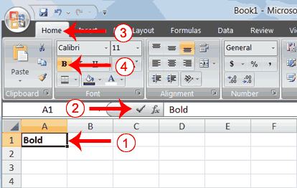

- Type Bold in cell A1.

- Click the check mark located on the Formula bar.
- Choose the Home tab.
- Click the Bold button . Excel bolds the contents of the cell.
- Click the Bold button again if you wish to remove the bold.

Italicize with the Ribbon

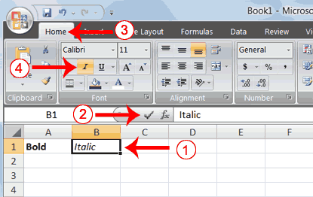

Underline with the Ribbon

- Type Italic in cell B1.
- Click the check mark located on the Formula bar.
- Choose the Home tab.
- Click the Italic button . Excel italicizes the contents of the cell.
- Click the Italic button again if you wish to remove the italic.

Microsoft Excel provides two types of underlines. The exercises that follow illustrate them.

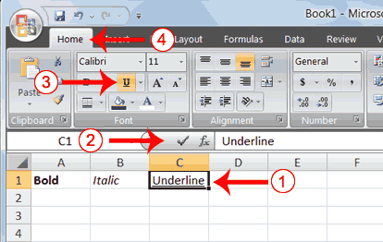
Single Underline:

- Type Underline in cell C1.
- Click the check mark located on the Formula bar.
- Choose the Home tab.
- Click the Underline button . Excel underlines the contents of the cell.
- Click the Underline button again if you wish to remove the underline.

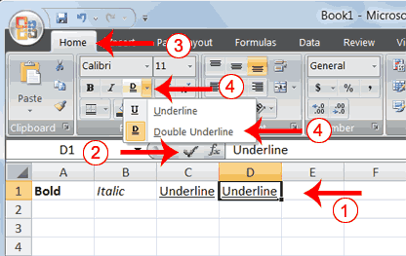
Double Underline

  - Type Underline in cell D1.

  - Click the check mark located on the Formula bar.
  - Choose the Home tab.
  - Click the down arrow next to the Underline button and then click Double Underline. Excel double-underlines the contents of the cell. Note that the Underline button changes to the button shown here , a D with a double underline under it. Then next time you click the Underline button, you will get a double underline. If you want a single underline, click the down arrow next to the Double Underline button and then choose Underline.
  - Click the double underline button again if you wish to remove the double underline.

Bold, Underline, and Italicize
    - Type All three in cell E1.
    - Click the check mark located on the Formula bar.
    - Choose the Home tab.
    - Click the Bold button . Excel bolds the cell contents.

    - Click the Italic button . Excel italicizes the cell contents.
    - Click the Underline button . Excel underlines the cell contents

Work with Long Text
Whenever you type text that is too long to fit into a cell, Microsoft Excel attempts to display all the text. It left-aligns the text regardless of the alignment you have assigned to it, and it borrows space from the blank cells to the right. However, a long text entry will never write over cells that already contain entries—instead, the cells that contain entries cut off the long text. The following exercise illustrates this.
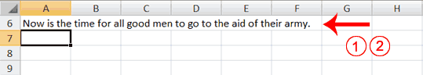
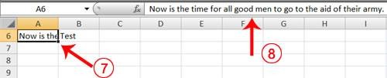
Work with Long Text

      - Move to cell A6.
      - Type Now is the time for all good men to go to the aid of their army.
      - Press Enter. Everything that does not fit into cell A6 spills over into the adjacent cell.
      - Move to cell B6.
      - Type Test.
      - Press Enter. Excel cuts off the entry in cell A6.

      - Move to cell A6.
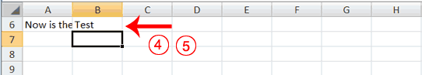
      - Look at the Formula bar. The text is still in the cell.

Change A Column's Width
You can increase column widths. Increasing the column width enables you to see the long text.
Change Column Width

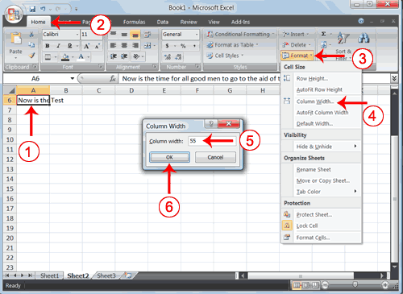
- Make sure you are in any cell under column A.
- Choose the Home tab.
- Click the down arrow next to Format in the Cells group.
- Click Column Width. The Column Width dialog box appears.
- Type 55 in the Column Width field.
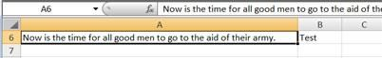
- Click OK. Column A is set to a width of 55. You should now be able to see all of the text.

Change a Column Width by Dragging

You can also change the column width with the cursor.

- Place the mouse pointer on the line between the B and C column headings. The mouse pointer should look like the one displayed here
, with two arrows.
- Move your mouse to the right while holding down the left mouse button. The width
indicator appears on
the screen.
- Release the left mouse button when the width indicator shows approximately 20. Excel increases the column width to 20.

Format Numbers

You can format the numbers you enter into Microsoft Excel. For example, you can add commas to separate thousands, specify the number of decimal places, place a dollar sign in front of a number, or display a number as a percent.

Format Numbers

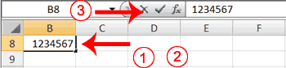

  - Move to cell B8.
  - Type 1234567.
  - Click the check mark on the Formula bar.
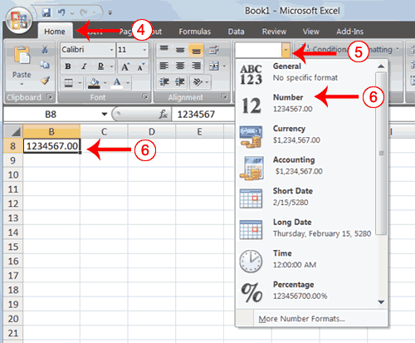

  - Choose the Home tab.
  - Click the down arrow next to the Number Format box. A menu appears.

  - Click Number. Excel adds two decimal places to the number you typed.
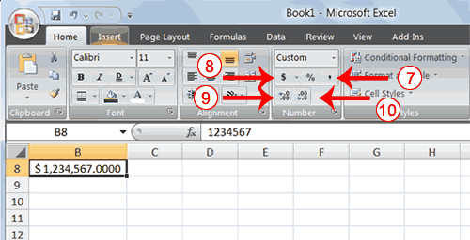

  - Click the Comma Style button . Excel separates thousands with a comma.
  - Click the Accounting Number Format button
. Excel adds a dollar sign to your number.
  - Click twice on the Increase Decimal button to change the number format to four decimal places.
  - Click the Decrease Decimal button if you wish to decrease the number of decimal places.

Change a decimal to a percent.

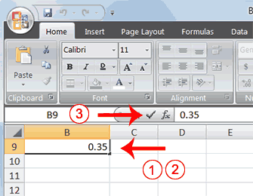
- Move to cell B9.
- Type .35 (note the decimal point).
- Click the check mark on the formula bar.
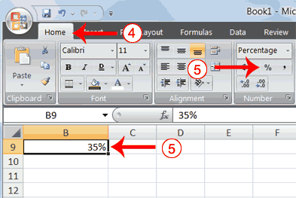
- Choose the Home tab.
- Click the Percent Style button . Excel turns the decimal to a percent.

Creating Excel Functions and Filling Cells
By using functions, you can quickly and easily make many useful calculations, such as finding an average, the highest number, the lowest number, and a count of the number of items in a list. Microsoft Excel has many functions that you can use.
Using Reference Operators
To use functions, you need to understand reference operators. Reference operators refer to a cell or a group of cells. There are two types of reference operators: range and union.
A range reference refers to all the cells between and including the reference. A range reference consists of two cell addresses separated by a colon. The reference A1:A3 includes cells A1, A2, and A3. The reference A1:C3 includes cells A1, A2, A3, B1, B2, B3, C1, C2, and C3.
A union reference includes two or more references. A union reference consists of two or more numbers, range references, or cell addresses separated by a comma. The reference A7,B8:B10,C9,10 refers to cells A7, B8 to B10, C9 and the number 10.

Working with Data
Excel workbooks are designed to store a lot of information. Whether working with 20 cells or 20,000, Excel has several features to help users organize data and find what is needed.
Freezing Rows and Columns
By freezing rows or columns in place, especially header cells, users can scroll through the content while continuing to view the frozen cells. By freezing rows or columns in place, especially header cells, users can scroll through the content while continuing to view the frozen cells.
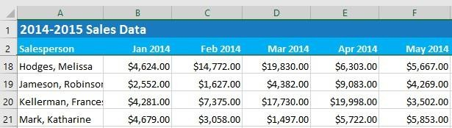

To practice with the MS Excel environment

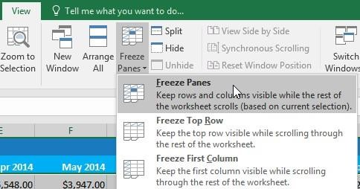
Freezing rows/columns is useful when certain headers (rows/columns) must always be visible as the content is scrolled through.
To freeze rows/columns, select the row/column below/ after the row/column that will be frozen. On the View tab, select the Freeze Panes com mand, then choose Freeze Panes
from the drop-down menu. Frozen rows/columns will be indicated by a gray line.
To unfreeze, click the Freeze Panes command, then select Unfreeze Panes from the dropdown menu.
Sorting Data
A worksheet can be sorted alphabetically, numerically, and in several other ways. When sorting data, it is important to first decide if sorting should be applied to the entire worksheet or just a cell range.
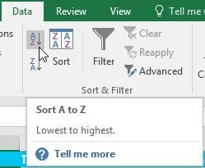
Sort sheet organizes all the data in the worksheet by one column. Related information across each row is kept together when the sort is applied. Select a cell in the column to sort. Select the Data tab on the Ribbon, then click the A- Z command to sort A to Z (ascending order), or the Z-A command to sort Z to A (descending order). The worksheet will be sorted by the selected column.
Sort range sorts the data in a range of cells, which can be helpful when working with a sheet that contains several tables. Sorting a range will not affect other content in the worksheet. Select the cell range to sort. Select the Data tab on the Ribbon, then click the Sort command. The Sort dialog box will appear.
Choose the column to sort. Decide the sorting order (either ascending or descending). Click OK. The cell range will be sorted by the selected column.

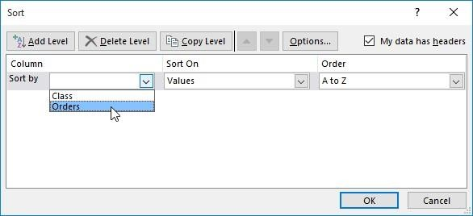

Filtering Data
Filters can be used to narrow down the data in the worksheet, allowing users to view only the information needed. In order for filtering to work correctly, the worksheet should include a header row, which is used to identify the name of each column.
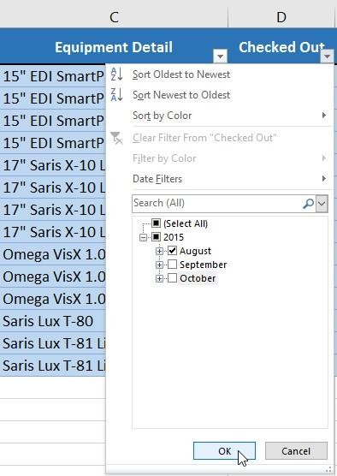
To filter the data, select the Data tab, then click the Filter command. A drop-down arrow will appear in the header cell for each column. Click the drop-down arrow for the column to filter. In the Filter menu, check the boxes next to the data to filter, then click OK. The data will be filtered, temporarily hiding any content that doesn't match the criteria.
Filters are cumulative, which means multiple filters can be applied to help narrow down the results.
To clear a filter, click the drop-down arrow for the filter to clear. In the Filter menu, choose Clear Filter From [COLUMN NAME] from the Filter menu. The filter will be cleared from the column. The previously hidden data will be displayed.

OBJECT

Lab Session 06

Working with Formulas conditions, logical &Trigonometric functions in Microsoft Excel
Entering Formulas

Format worksheet
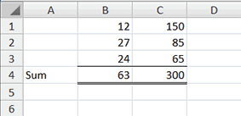
- Move to cell A4.
- Type the word Sum.
- Select cells B4 to C4.
- Choose the Home tab.
- Click the down arrow next to the Borders button .

you can also calculate a sum by using the AutoSum button .

Calculate an Average
You can use the AVERAGE function to calculate the average of a series of numbers.

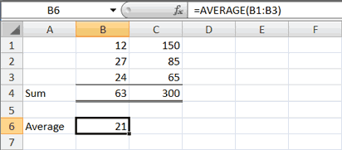
- Move to cell A6.
- Type Average. Press the right arrow key to move to cell B6.
- Type =AVERAGE(B1:B3).
- Press Enter. The average of cells B1 to B3, which is 21, appears.

Calculate an Average with the AutoSum Button
In Microsoft Excel, you can use the AutoSum button to calculate an average.

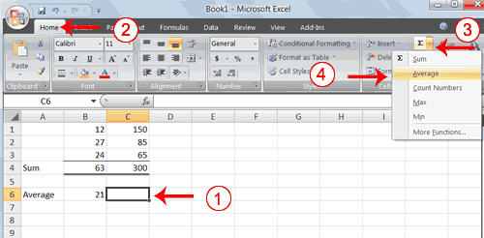
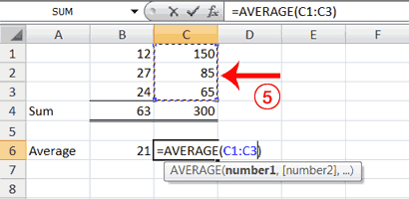
- Move to cell C6.
- Choose the Home tab.
- Click the down arrow next to the AutoSum button .
- Click Average.

- Select cells C1 to C3.
- Press Enter. The average of cells C1 to C3, which is 100, appears.

Find the Minimum Number

You can use the MIN function to find the lowest number in a series of numbers.

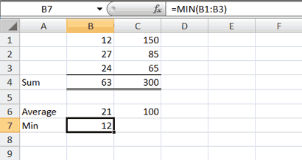
- Move to cell A7.
- Type Min.
- Press the right arrow key to move to cell B7.
- Type = MIN(B1:B3).
- Press Enter. The lowest number in the series, which is 12, appears.

Note: You can also use the drop-down button next to the AutoSum button to calculate minimums, maximums, and counts.

Find the Maximum Number

You can use the MAX function to find the highest number in a series of numbers.

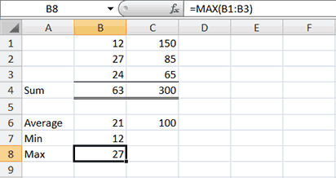
- Move to cell A8.
- Type Max.
- Press the right arrow key to move to cell B8.
- Type = MAX(B1:B3).
- Press Enter. The highest number in the series, which is 27, appears
.
- .
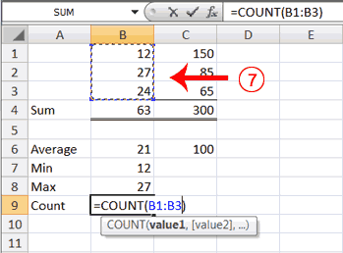
Count the Numbers in a Series of Numbers
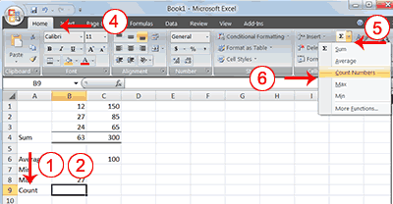
You can use the count function to count the number of numbers in a series.

- Select B1 to B3.
- Press Enter. The number of items in the series, which is 3, appears.

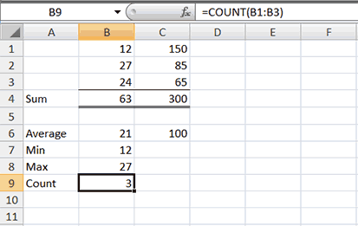
- Move to cell A9.
- Type Count.
- Press the right arrow key to move to cell B9.
- Choose the Home tab.
- Click the down arrow next to the AutoSum button .
- Click Count Numbers. Excel places the count function in cell C9 and takes a guess at which cells you want to count. The guess is incorrect, so you must select the proper cells.

Formulas and Functions
Formulas

One of the most powerful features in Excel is the ability to calculate numerical information using formulas. Just like a calculator, Excel can add, subtract, multiply, and divide, and uses standard operators for formulas.
+ Addition
- Subtraction
* Multiplication
/ Division
^ Exponents
All formulas in Excel must begin with an equals sign (=). This is because the cell contains, or is equal to, the formula and the value it calculates. Formulas can be created using numbers or cell addresses; the latter is more common. In the example shown, cell A3 will contain the sum of cell A1 and A2. If the content of either A1 and/or A2 is changed, the change will be reflected in cell A3.

Formulas can also include a combination of cell references and numbers, e.g., N10*1.05. Formulas can also be copied to adjacent cells with the fill handle. Formulas can also be edited either in the cell or in the formula bar. Finally, more complex formulas follow the mathematical rules of operator precedence.
Some common Excel formula errors are presented below.
#### | Reason: The column isn't wide enough to display the value.  Solution: Click on the right border of the column header and increase the column width or double-click the right border of the column header to automatically fit the  widest entry in that column.
#NAME? | Reason: Excel does not recognize text in a formula. Solution:  Correct the spelling mistake.
#VALUE! | Reason: A formula has the wrong type of argument.  Solution: Either change the value of cell to a number or use a function to ignore cells that contain text.
#DIV/0! | Reason: A formula tries to divide a number by 0 or an empty cell.  Solution: Either change the value of the cell (in denominator) to a value that is not equal to 0 or prevent the error from being displayed by using the logical function IF.
#REF! | Reason: A formula refers to a cell that is not valid (or deleted afterwards). Solution:  Either delete +#REF! in the formula of the cell or undo the original deletion.

Functions

A function is a predefined formula that performs calculations using specific values in a particular order. Excel includes many common functions that can be used to quickly find specific results or perform certain calculations. To work correctly, a function must be written in a specific way.
This is called the syntax. The basic syntax is shown. All functions are composed of function names and a list of arguments. Arguments can refer to both individual cells and cell ranges and must be enclosed within parentheses. Users can include one argument or multiple arguments, depending on the
syntax required for the function. Some common functions are presented below.
Average | Returns the Average of a list of supplied numbers.
AverageIf | Returns the average of cell values (of a supplied range), that satisfies a given criteria.
Count | Returns the number of numerical values in a supplied set of cells.
CountIf | Returns the number of cells (of a supplied range), that satisfies a given criteria.
If | Checks whether a condition is met and returns one value if true and another value if false.
Max | Returns the largest value from a list of supplied numbers.
Min | Returns the smallest value from a list of supplied numbers.
Sum | Returns the sum of a supplied list of numbers.
SumIf | Returns the sum of cell values (of a supplied range), that satisfies a given
 | criteria.
Functions can also be accessed from the Function Library on the Formulas tab.

Formulas enable the user to perform calculations by using values in the worksheet. Arithmetic operators that can be used in formulas include + for addition, - for subtraction, * for multiplication, / for division, % for percentage, and ^ for exponentiation. For example: =a1+b1 adds the contents of a1 and b1 in the cell where the formula is typed.
To fill the same formula in multiple cells, select the adjacent cells or ranges to be filled; With the range(s) still selected, type the formula or value in the active cell; Press Ctrl+Enter (rather than just Enter) to enter the formula or value.
To reference cells in other Worksheets, select the cell where the formula is to be appeared , and type an equal sign (=) to start the formula; Click the sheet tab containing the cell to be referenced in the formula; Select the cell or range to be referred to. The complete reference appears in the formula bar; Finish the rest of the formula; then press Enter to complete the formula.
Excel also provides functions like SUM, AVERAGE, etc. Select the cell where the function is to be appeared, and type an equal sign (=) to start the function; Type the function name (such as SUM, AVERAGE, etc) and a left parenthesis; Select the range of cells for the argument and press Enter. Excel automatically adds the closing parenthesis and enters the function. References to columns or rows can also be entered manually, using comas (,) for separation. If colon (:) is used between two references then, it acts as range operator, which produces one reference to all the cells between two references, including the two reference. Following are some of the most commonly used formula.

- SUM: Adds all the numbers in a range of cells.
Syntax: =SUM(number1, number2, …..)

- AVERAGE: Returns the average (arithmetic mean) of the arguments. Syntax:
=AVERAGE(number1, number2, …..)

- COUNT: Counts the number of cells that contain numbers and numbers within the list of arguments.

Syntax: =COUNT(value1, value2, …..)
- COUNTA: Counts the number of cells that are not empty and the values within the list of arguments.

Syntax: =COUNTA(value1, value2, …..)

- PRODUCT: Multiplies all the numbers given as arguments and returns the product.
Syntax: =PRODUCT(number1, number2, …..

Data Validation
Use data validation in Excel to make sure that users enter certain values into a cell.

Steps:
- Select a cell.
- On the Data tab, in the Data Tools group, click Data Validation.
- On the Settings tab, specify the validation criteria.
- If you optionally want to show a message (tooltip) on the selected cell, check 'Show input message when cell is selected' and add a message accordingly.
- If a user ignores the input message and enters a number that is not valid, an error alert can be shown. Check 'Show error alert after invalid data is entered' and add an error message accordingly

FIT Lab Session 05
NED University of Engineering & Technology – Department of Software Engineering

SUM PRODUCT FUNCTION: Calculate the product and then return the total sum of the product.
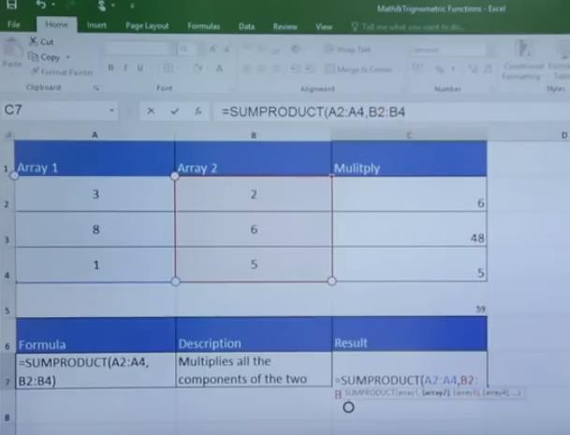

SUMIF: Adds the cells specified by a given criteria.
Syntax: SUMIF(range, criteria, sum_range)
Where ‘Range’ is the range of cells to be evaluated according to the given criteria. ‘Criteria’ is the criteria in the form of a number, expression, or text that defines which cells will be added. ‘Sum_range’ are the actual cells to sum. The cells in sum_range are summed only if their corresponding cells in range match the criteria. If sum_range is omitted, the cells in range are summed.
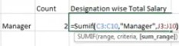
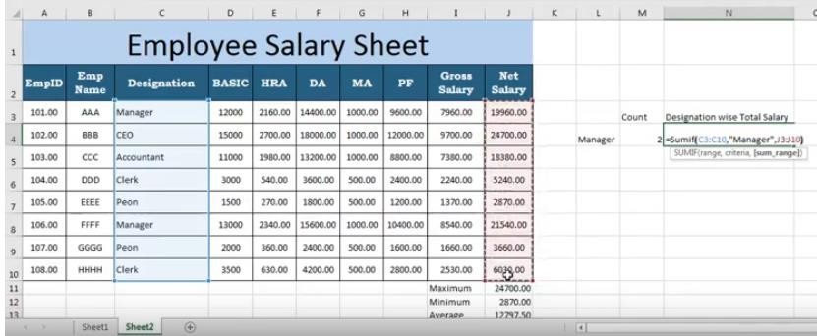

FIT Lab Session 05
NED University of Engineering & Technology – Department of Software Engineering

How to use Sumifs, Countifs
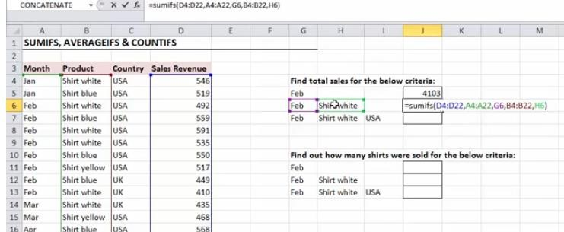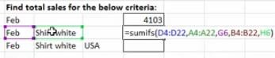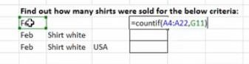
Formulas: Absolute, Relative, and Mixed Cell References Cell References
There are two types of cell references: Relative and Absolute. Both references behave differently when copied and filled to other cells.

Relative references
Relative references change when a formula is copied across multiple cells. By default, all cell references are relative references i.e. they change based on the relative position of rows and columns. For example, if you copy the formula
=A2+B2 from row 1 to row 2, the formula will become =A3+B3 automatically. Relative references are especially convenient whenever you need to repeat the same calculation across multiple rows or columns.

Absolute references
There may be times when you do not want a cell reference to change when filling cells. Unlike relative references, absolute references do not change when copied or filled. You can use an absolute reference to keep a row and/or column constant. An absolute reference is designated in a formula by the addition of a dollar sign ($). It can precede the column reference, the row reference, or both.
Reference | Description
$A$2 | The column and the row do not change when copied.
A$2 | The row does not change when copied.
$A2 | The column does not change when copied.

FIT Lab Session 06
NED University of Engineering & Technology – Department of Software Engineering

Logical Functions
The logical functions enable the user to add decision-making and logical tests to the worksheets. The IF statement is useful for testing conditions and making decisions based on a cell's contents. The AND and OR functions can test multiple criteria or test conditions for use in IF functions. The following examples show the use:



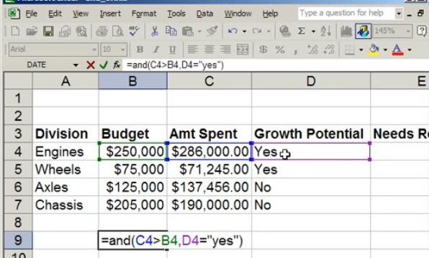


1. =AND(D15,G23<30) result is TRUE only when D15 is not zero and G23 is less than 30 OR =AND C4>B4,D4=”YES” RESULT IS TRUE comparison of two values
• =IF(AND(D17>10,D17<30),"Valid","Invalid") returns Valid if the contents of cell D17 is greater than 10 and less than 30; otherwise the formula returns Invalid
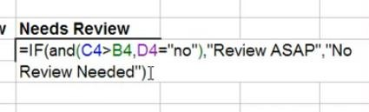
3. NESTED IF

=    IF(OR(D17=10,D17=30),"Contains 10 or 30","Not 10or30") | tests whether
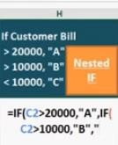
cell D17 contains the result 10 or 30 and produces the message Contains 10 or 30 when it does; otherwise, the formula produces the message Not 10 or 30

FIT Lab Session 06
NED University of Engineering & Technology – Department of Software Engineering

Math and Trigonometric Functions
Like logical functions, math and trigonometric functions can also be used in the Worksheets.
Trigonometric functions use angles measured in radians.
Following are some examples:
=Radians(NUMBER) : Convert Degree In To Radian
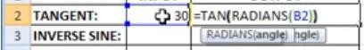
Tangent:
Sin Function: =SIN(NUMBER) : sin(radians(30))
- number - The angle in radians for which you want the sine.
Inverse sine: Result Will Be In Degrees according to formula given below.
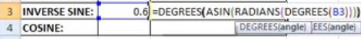

- number - The angle in radians for which you want the cosine.
ACOS: The Excel ACOS function calculates the arccosine (i.e. the inverse cosine) of a given number, and returns an angle, in radians, between 0 and π.
Result In Radian
For degrees =degree(ACOS(RADIAN(DEGREES(30))))
Arguments
Syntax COS
=COS (number) : =Cos(radians(30))
Or =Radians(30) Convert Degree In To Radian





=ABS(A10)returns 18 when cell A10 contains -18

=ACOS(0.5)returns 1.047198 (radians)
=DEGREES(0.5) returns 28.64789 (degrees)

=ROUND(102.927,2) returns 102.93
  - Mround
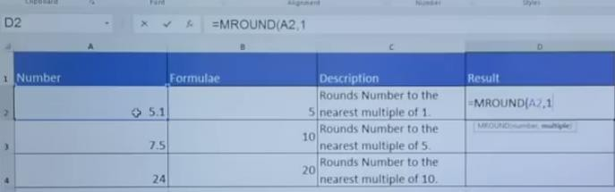

FIT Lab Session 06

NED University of Engineering & Technology – Department of Software Engineering

Vlookup and Hlookup Functions
The Vlookup (Vertical lookup) function looks for a value in the leftmost column of a table, and then returns a value in the same row from another column you specify.

Steps:
- Insert the Vlookup function in another table. A function argument dialog box appears.
- Enter a value for the Lookup_value field. This field contains the value that is to be found in the first column of the main table, and can be a value, a reference, or a text string.
- Next, select a set of values for table_array field that contains data to be retrieved. It can be a reference or a range.
- Then, provide a Col_index_num value. It is the column number in table_array from which the matching value should be returned.
- Lastly, in the range_lookup field, provide a Boolean value. The boolean False tells the Vlookup function to return an exact match. If the VLOOKUP function cannot find the value in the first column, it will return a #N/A error. The boolean TRUE tells the VLOOKUP function to return an approximate match. If the VLOOKUP function cannot find the value in the first column, it will return the largest value smaller than that number.

If the leftmost column of the table contains duplicates, the Vlookup function matches the first instance only. Also, it performs case-insensitive lookups.

In a similar way, you can use the Hlookup (Horizontal lookup) function.

VLOOKUP and HLOOKUP are functions in Excel that allow users to search a table of data based on what the user has supplied and give appropriate information from that table. VLOOKUP allows searching in a table that is set up vertically. All of the data should be set up in columns and each column is responsible for one kind of data. HLOOKUP is the exact same function but looks up data that has been formatted by rows instead of columns.
VLOOKUP/HLOOKUP have three arguments in order.
lookup_value | User input. This is the value that the function uses to search on.
table_array | The area of cells in which the table is located. This includes the entire range/table from which the data will be extracted. All columns of the data must  be included.
col_index_num | The column of data that contains the answer. For HLOOKUP, this will be  row_index_num.
range_lookup | A TRUE or FALSE value. When set to TRUE, the lookup function gives the closest match to the lookup_value without going over the lookup_value. When set to FALSE, an exact match must be found to the lookup_value or the function will return #N/A. Note, this requires that the column containing the  lookup_value be formatted in ascending order.
Formula Errors
Some of the common Excel formula errors are as follows:

Error | Description | Solution
##### Error | When your cell contains this error code, the column isn't wide enough to display the value. | Click on the right border of the column header and increase the column  width or Double click the right border of the column header to automatically fit the widest entry in that column.
#NAME? error | It occurs when Excel does not recognize text in a formula. | Correct the spelling mistake.
#VALUE! Error | Excel displays this error when a formula has the wrong type of argument. | Either change the value of cell to a number or Use a function to ignore cells that contain text.
#DIV/0! Error | Excel displays this error when a formula tries to divide a number by 0 or an empty cell. | Either change the value of the cell (in denominator) to a value that is not equal to 0 or Prevent the error from being displayed by using the logical function IF.
#REF! error | Excel displays this error when a formula refers to a cell that is not valid (or deleted afterwards). | To fix this error, you can either delete +#REF! in the formula of the cell or you can undo your deletion.

FIT Lab Session 06

NED University of Engineering & Technology – Department of Software Engineering

OBJECT

Entering Formulas

EXERCISES

Lab Session 06

Working with Formulas conditions, logical &Trigonometric functions in Microsoft Excel

Task 01
Perform the following operations then print and attach your result.

- Make the following columns in your worksheet: Roll No, Name, English, Math, Physics, Chemistry, Computing, Total, Percentage. Resize the columns if required.

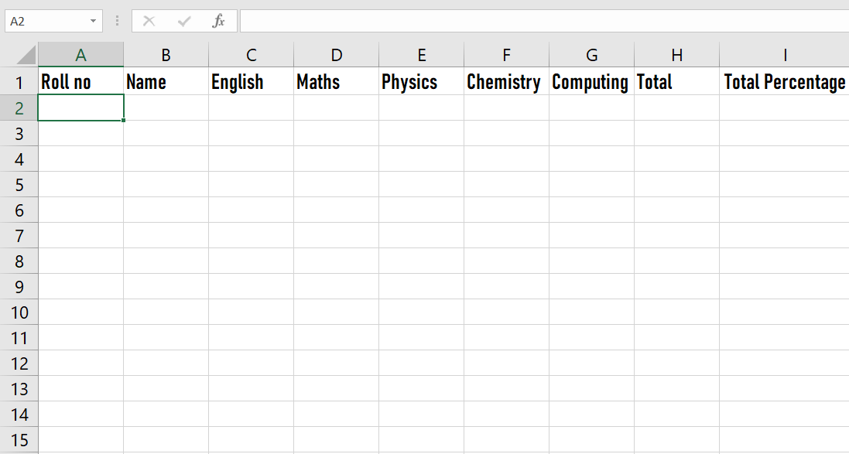

- Apply data validation to ensure that the roll number is of the format 20XXX-BCE-XXX.

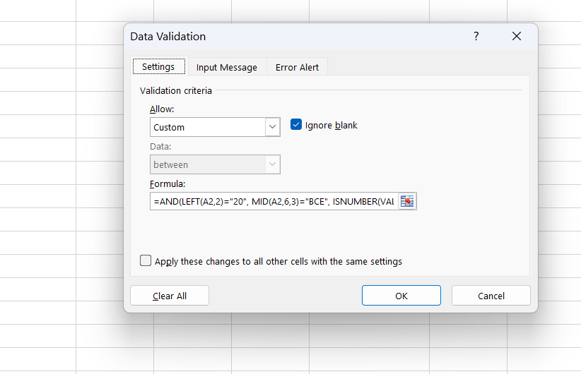
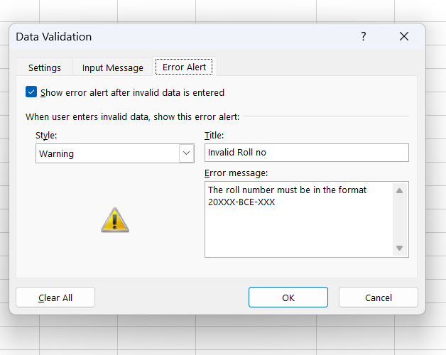

- Enter random roll numbers and student names (at least 10).

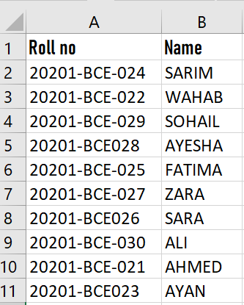

- Sort the students based on their roll numbers.

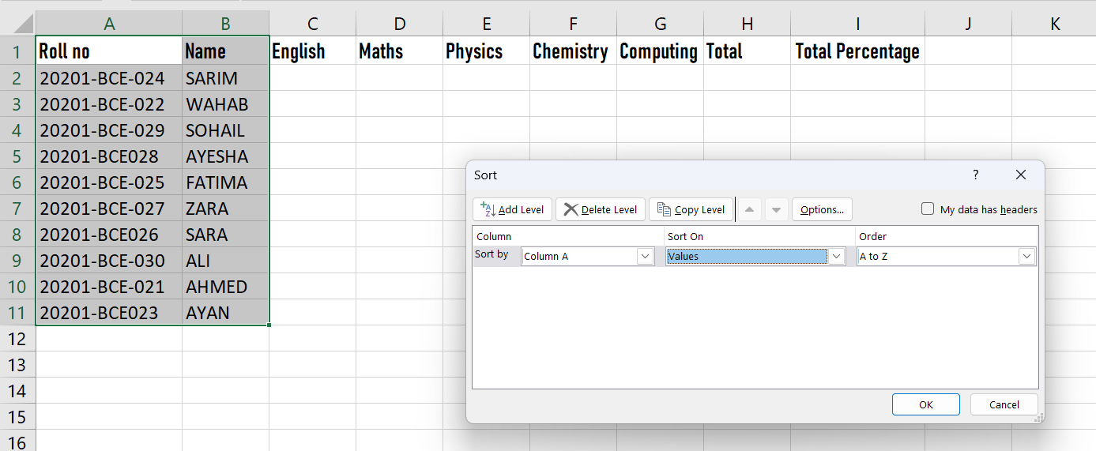

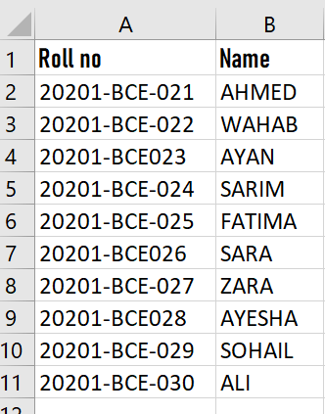

- Use the RANDBETWEEN function to enter the marks of each subject (0-100).

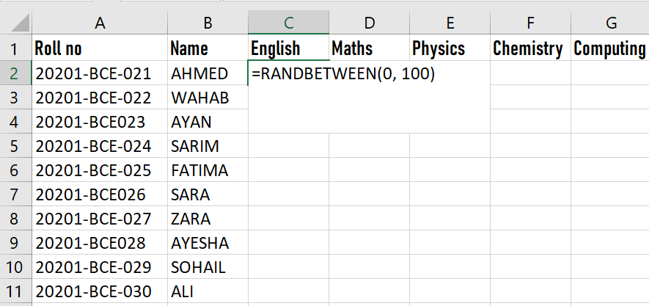
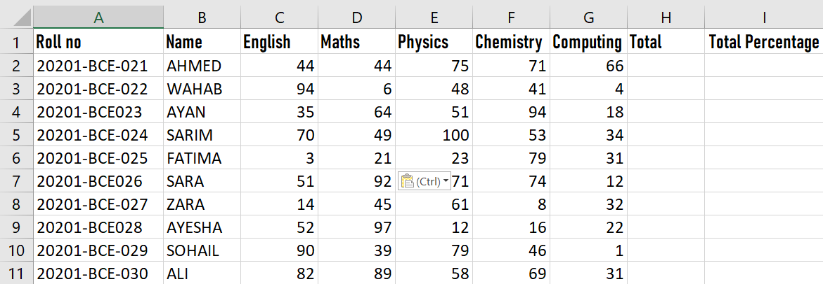

- Calculate the total marks of a student using the SUM function.

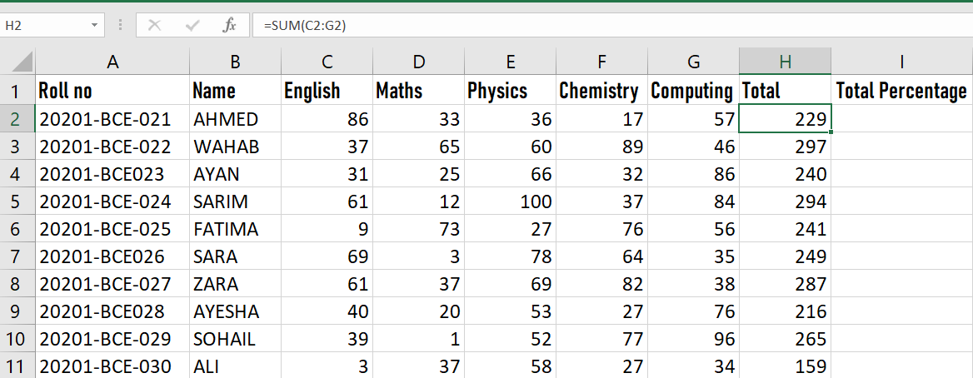

- Calculate the percentage of each student by entering the appropriate formula. Round it to 1 decimal place.

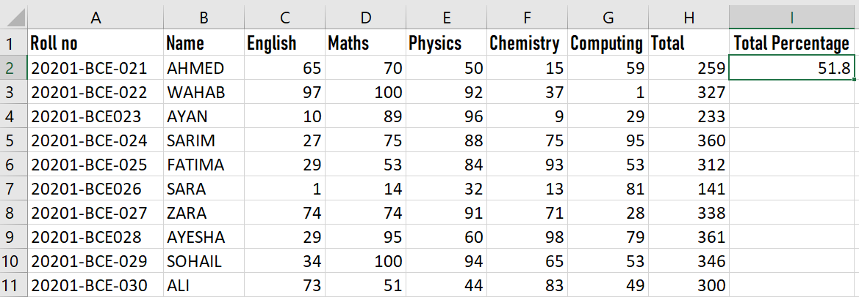
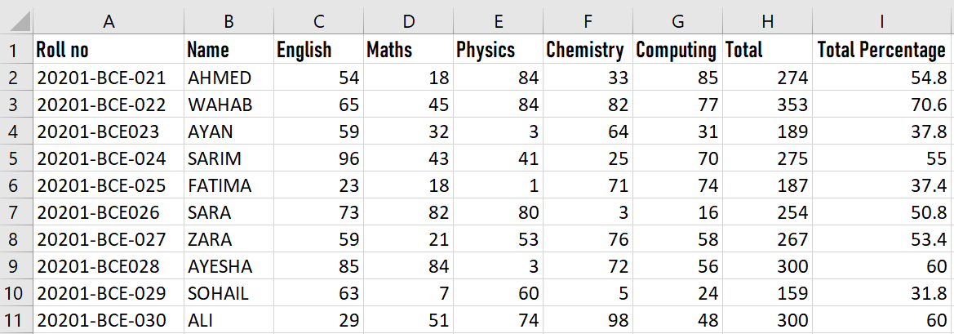

- Find the maximum and minimum marks of English. Then use the fill handle to find the maximum and minimum marks of all the subjects.

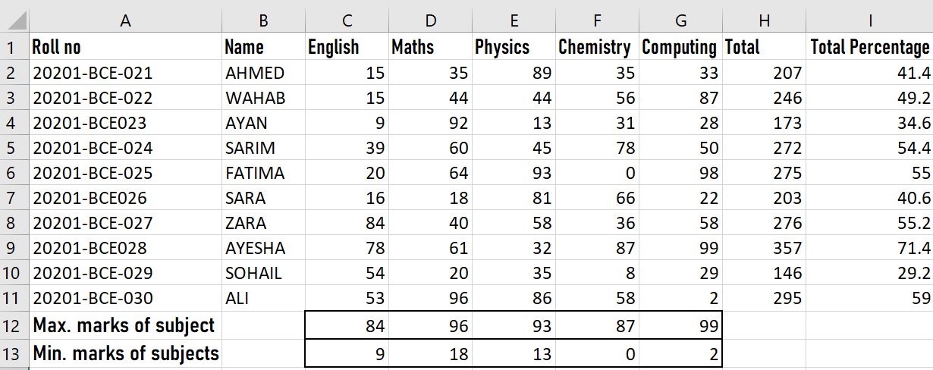

- Use a formula to automatically assign grades based on the following criteria: A: 90-100%, B: 80-90%, C: 70-80%, F:< 70%. (Use logical IF).

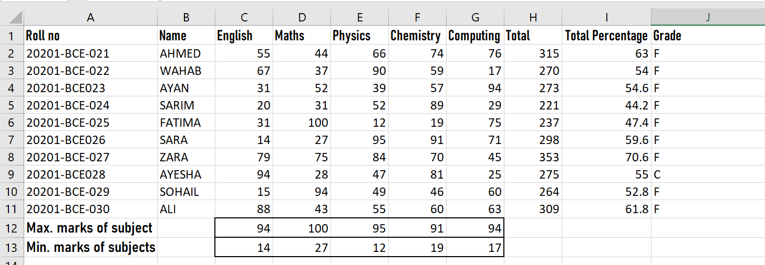

- Apply the following conditional formatting to the data: A: Green, B: Blue, C: Yellow, D: Red.

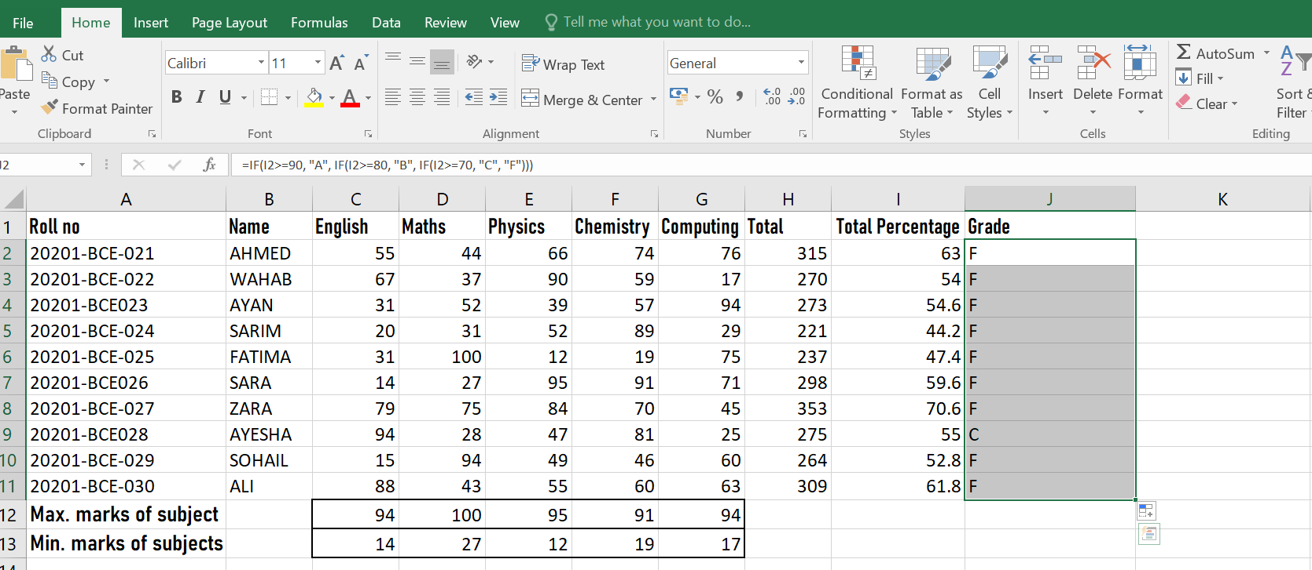

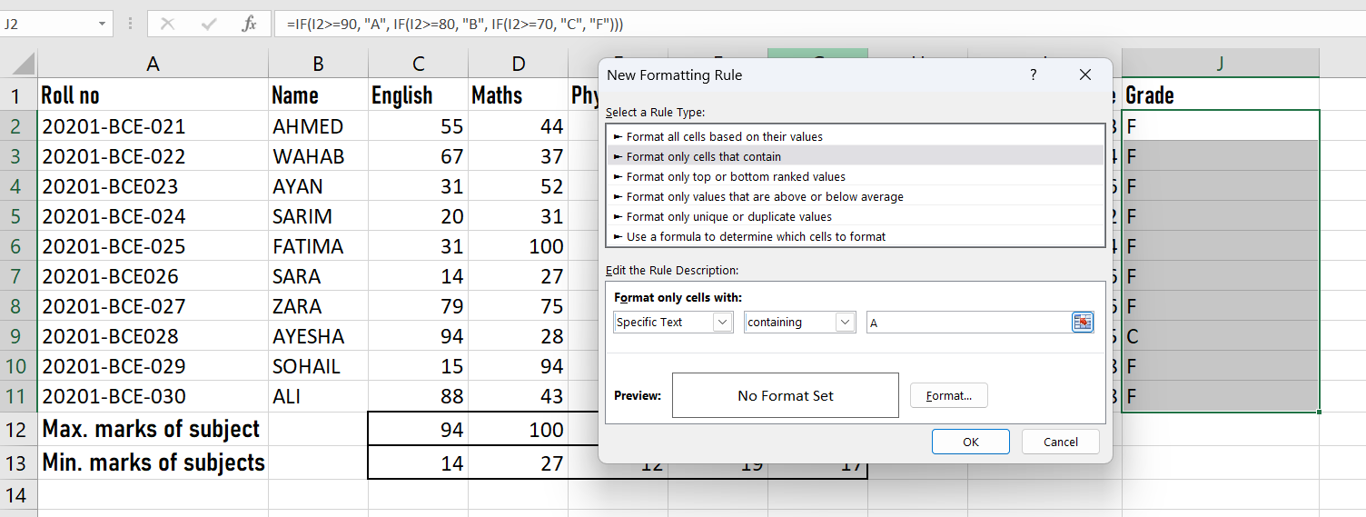
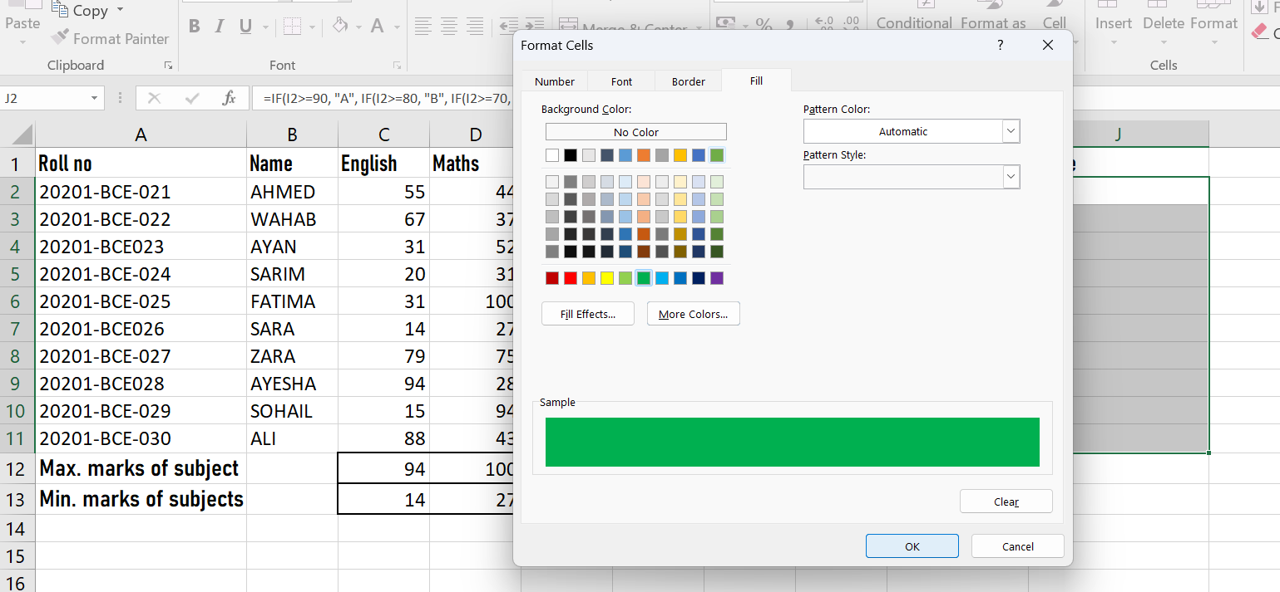

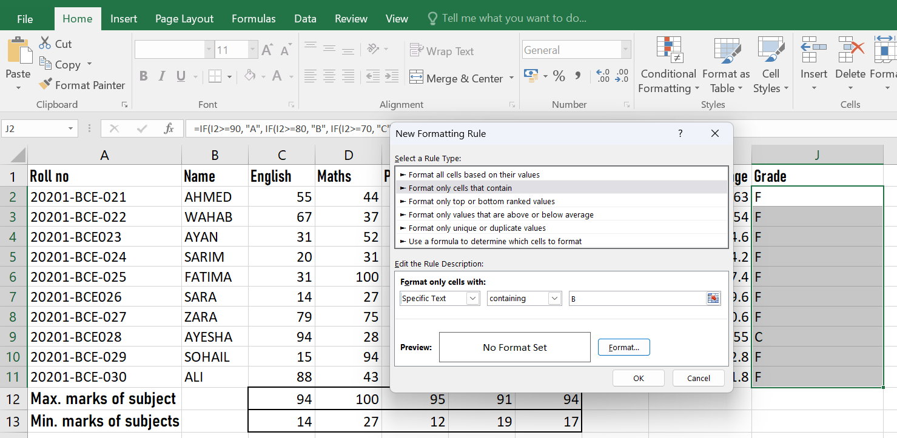
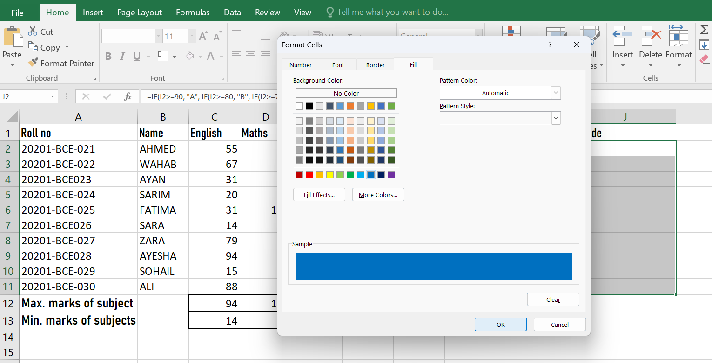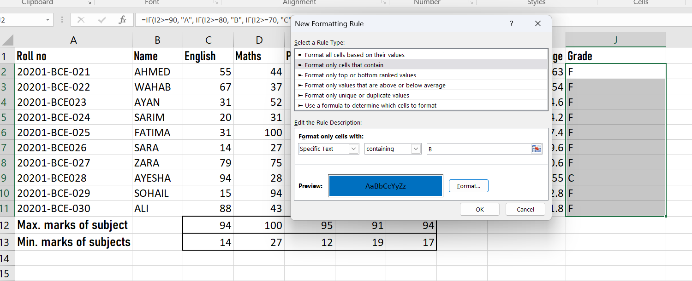

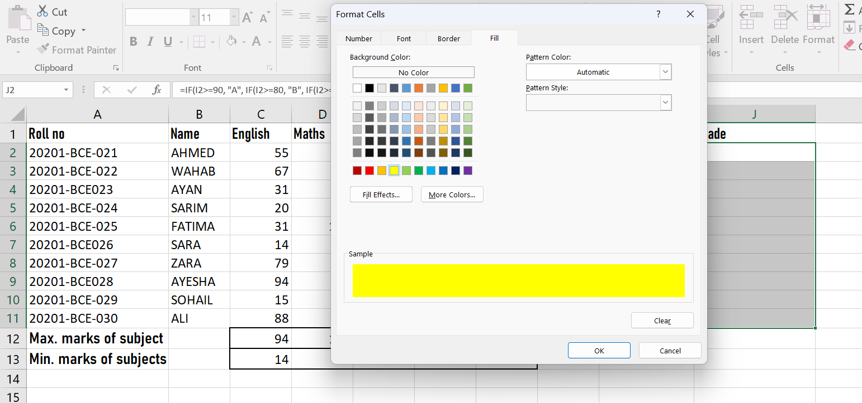
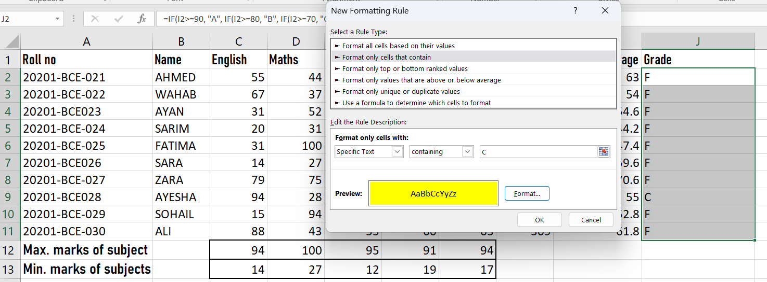

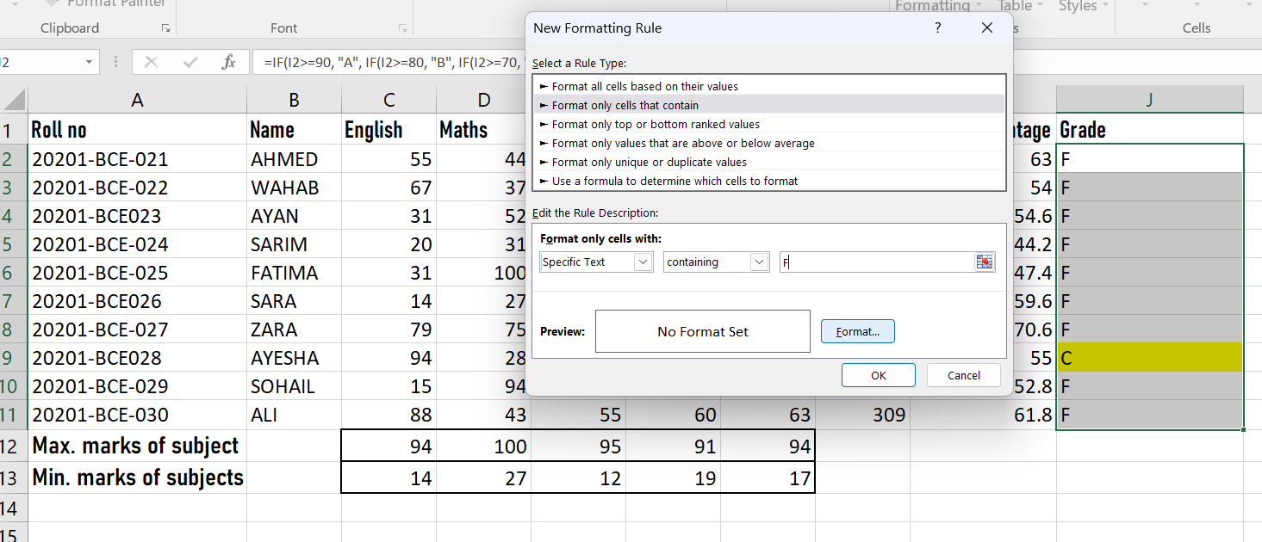

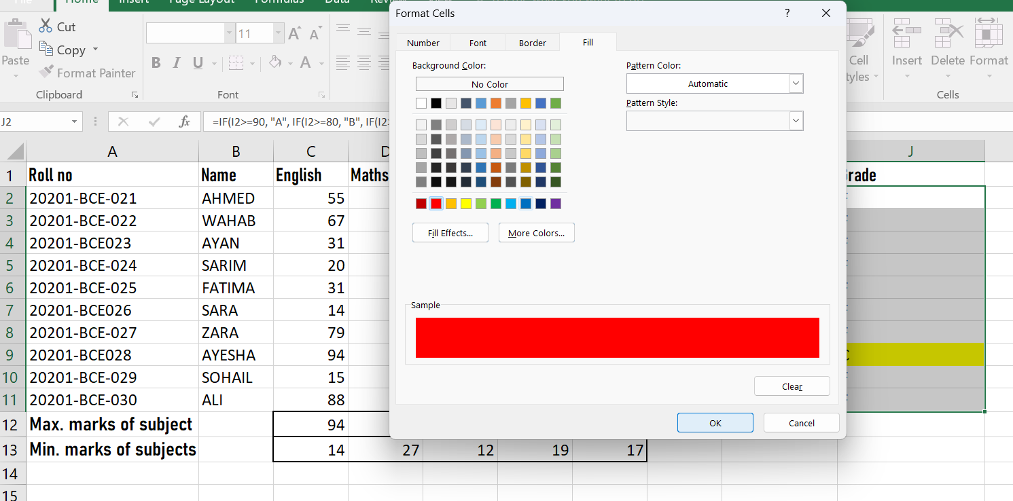

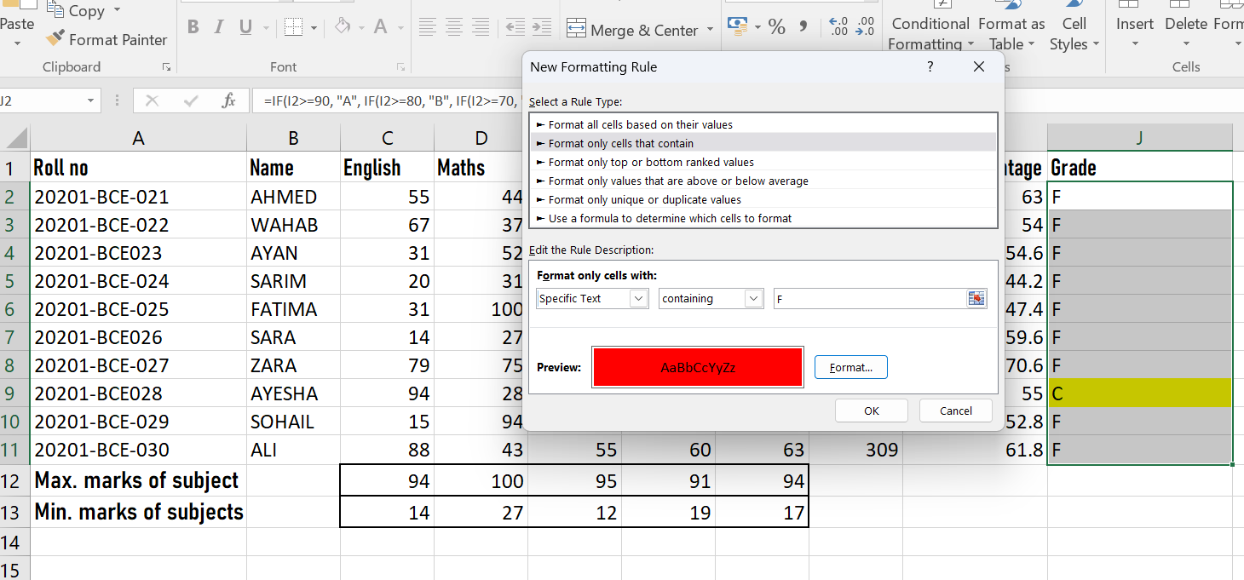

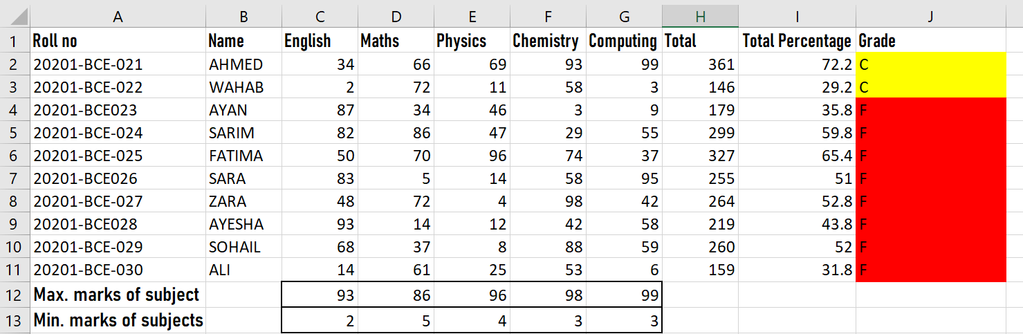

- Perform VLOOKUP on your data. Set the roll number as the lookup field. The data returned should be the percentage

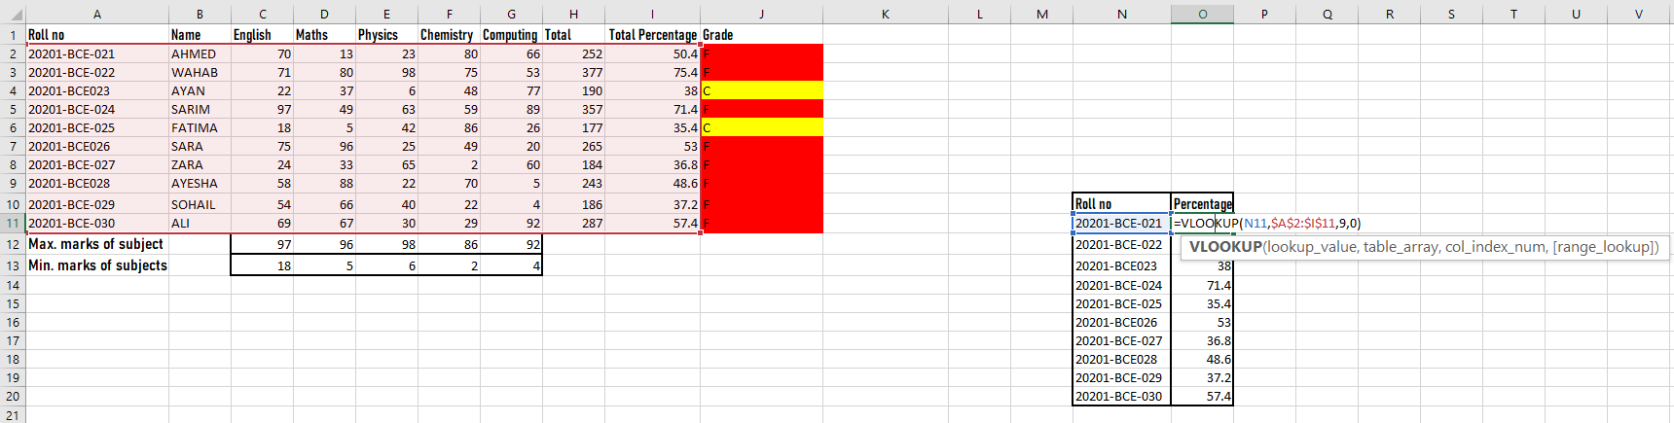
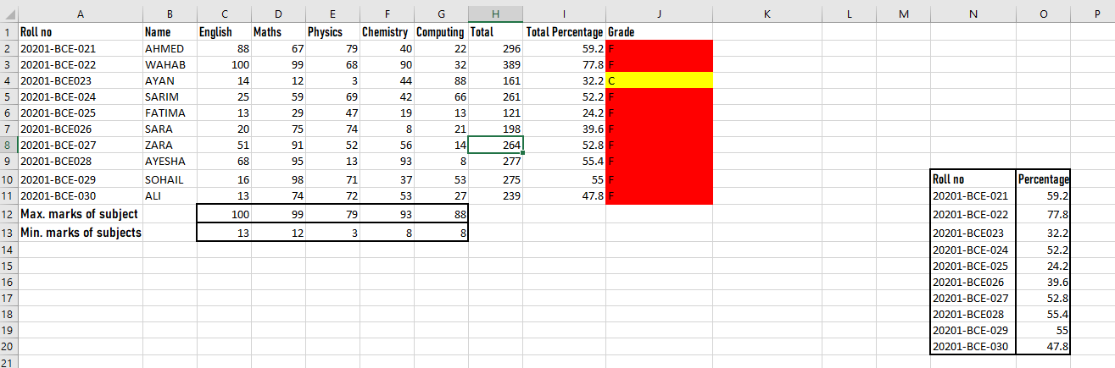

- Design a TEMPERATURE CONVERTER from Celsius to Fahrenheit and Fahrenheit to Celsius. Present the Converter with appropriate design. Formulas for conversion are as
follows:
[°C] = ([°F] − 32) · 5/9 [°F] = [°C] · 9/5 + 32
Also report the weather conditions as HOT if the temperature exceeds 35°C, WARM if the temperature is between 20°C to 35°C and COLD if the entered temperature is below 20°C.

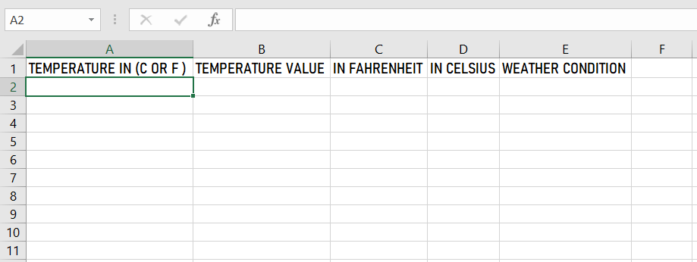

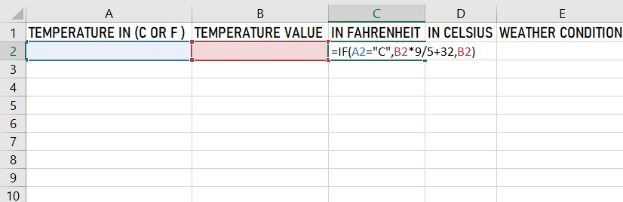
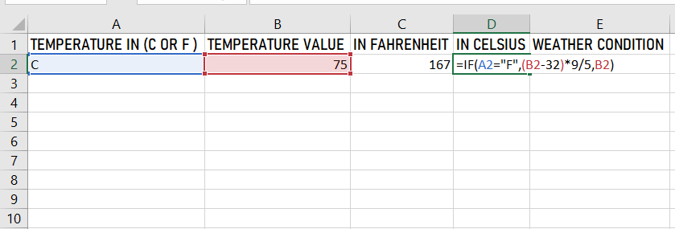

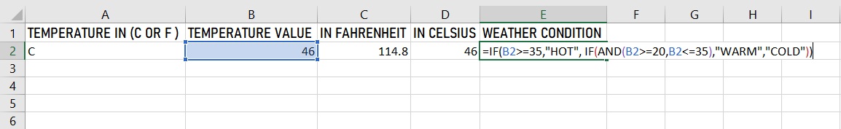

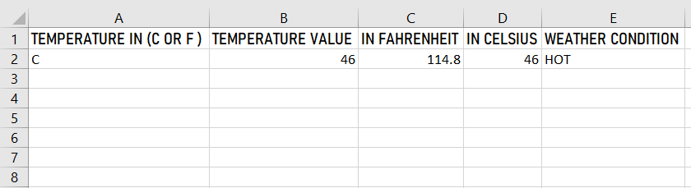

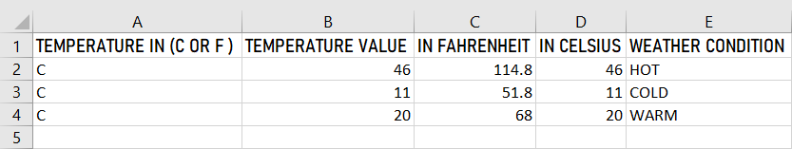
- Create a magic square puzzle as per given example below, the sum of all the numbers in a row must be equal, simultaneously the sum of all the numbers in a column must be equal, and the sum of diagonal numbers should also be equal:
  - Take the input from the user in all the squares. For a user all the squares will be blank initially and the box given below will contain the text “KEEP TRYING” unless the user enters all correct entries. If user solves the puzzle correctly then a message “WELL DONE” appears below. Format your work accordingly.
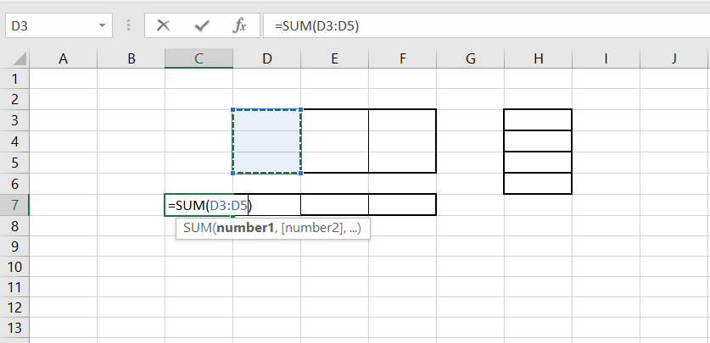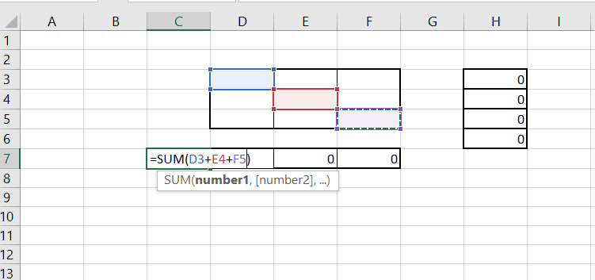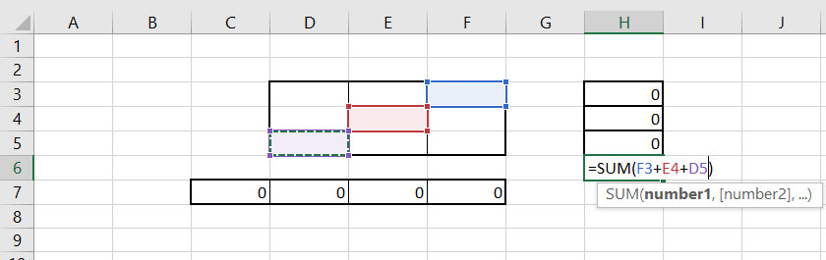
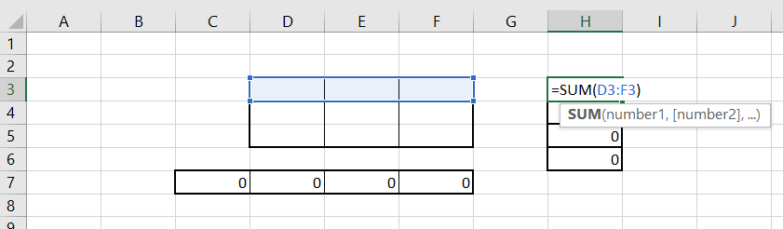
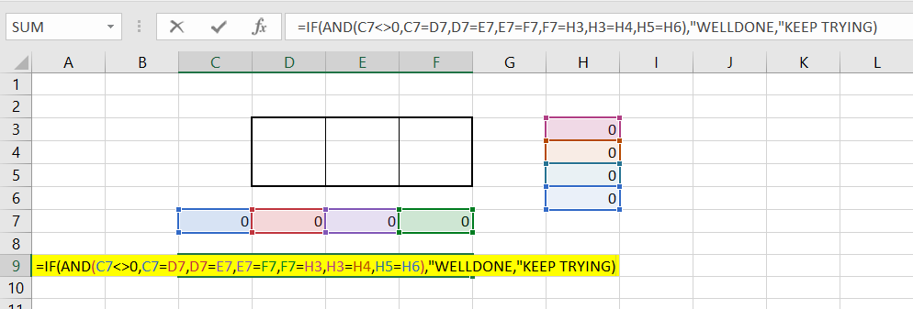

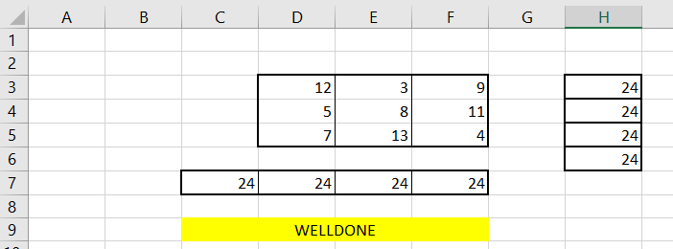

 |  |  | 12 | 3 | 9 |  | 24
 |  |  | 5 | 8 | 11 |  | 24
 |  |  | 7 | 13 | 4 |  | 24
24 |  |  | 24 | 24 | 24 |  | 24
 | WELL DONE!!!

NED University of Engineering & Technology
Department of Software Engineering
Course Code & Title: CT-174 FIT Assessment Rubric for Psychomotor (P2-PLO-3)

Instructor: Batch: 2024 Class: FESE Semester: Fall 2024. Student’s Name: Roll No.:
Laboratory Session No. Date:

Psychomotor Domain Assessment Rubric-Level P2-PLO3
Skill Sets | Extent of Achievement
 | Below Average (0--1) | Average (2) | Good (3) | Very Good (4) | Excellent (5)
Problem Definition and Understanding | Unable to define and understand the problem clearly. | Struggles to define the problem clearly, with significant gaps in understanding | Defines the problem, but with gaps or a limited understanding of key components, impacting the overall quality of definition. | Effectively defines the problem with a good understanding of its components, showcasing proficiency in problem definition. | Demonstrates an exceptional understanding of the problem, identifying all key components and challenges with insightful depth.
Technical Implementation Proficient use of tools to complete  the problem | Struggles to use tools effectively, requiring significant improvement. | Uses tools with noticeable inefficiencies. | Demonstrates basic proficiency in utilizing tool, with some room for improvement. | Effectively uses tools to support the task. | Integrates use of tools seamlessly to enhance the design and development process
Solution Design& Accuracy | Struggles to relate the implemented solutions to the design and development goals, requiring significant improvement. | Shows limited connection between the implemented solutions and the design and development context. | Demonstrates a basic understanding of how the solutions align with design and development requirements. | Effectively relates the implemented solutions to the overall design and development objectives | Maps the implemented solutions seamlessly to the overarching design and development goals, demonstrating a comprehensive understanding.
Trouble Shooting Skills  Issue resolution skills | Unable to trouble shoot | Limited troubleshooting | Adequate troubleshooting, minor errors remaining | Good troubleshooting, no errors remaining | Excellent trouble shooting no errors remain without delay.
Document Organization and on time submission | Poor Unclear disorganized document late submission | Somewhat clear with lack of organization and structuring late submission | Somewhat clear with lack of organization and structuring on time submission | Reasonably clear and organized with adequate structuring on time submission | Highly clear and well- structured document, On time submit

Weighted CLO (Psychomotor Score)
Simra Najm:
Instructor’s Signature with Date

Objective:

Lab Session 7

Data Analysis with MS Excel Charts and Graphs

Working with Pivot Tables and Pivot Charts. To learn how to depict data graphically.

Introduction
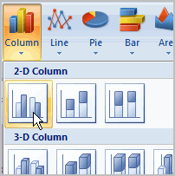

A chart is a tool you can use in Excel to communicate your data graphically. Charts allow your audience to more easily see the meaning behind the numbers in the spreadsheet, and to make showing comparisons and trends much easier. In this lesson, you will learn how to insert and modify Excel charts and see how they can be an effective tool for communicating information.

Creating a chart

Charts can be a useful way to communicate data. When you insert a chart in Excel, it appears in the selected worksheet with the source data by default.

To create a chart:

  - Select the worksheet you want to work with. In this example, we use the Summary worksheet.
  - Select the cells you want to chart, including the column titles and row labels.
  - Click the Insert tab.
  - Hover over each Chart option in the Charts group to learn more about it.
  - Select one of the Chart options. In this example, we'll use the Columns command.
  - Select a type of chart from the list that appears. For this example, we'll use a 2-D Clustered Column. The chart appears in the worksheet.
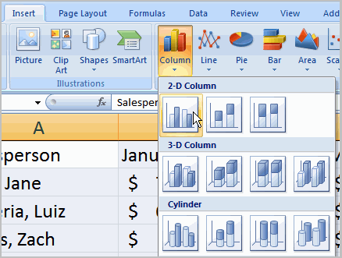

Identifying the parts of a chart : Have you ever read something you didn't fully understand but when you saw a chart or graph, the concept became clear and understandable? Charts are a visual representation of data in a worksheet. Charts make it easy to see comparisons, patterns, and trends in the data.
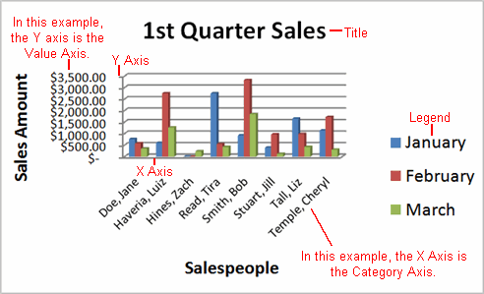

Source data :The range of cells that make up a chart. The chart is updated automatically whenever the information in these cells changes.
Title
The title of the chart.
Legend
The chart key, which identifies what each color on the chart represents.
Axis
The vertical and horizontal parts of a chart. The vertical axis is often referred to as the Y axis, and the horizontal axis is referred to as the X axis.
Data series
The actual charted values, which are usually rows or columns of the source data.
Value axis
The axis that represents the values or units of the source data.
Category axis
The axis identifying each data series.

Chart tools
Once you insert a chart, a new set of Chart Tools, arranged into three tabs, will appear above the Ribbon. These are only visible when the chart is selected.

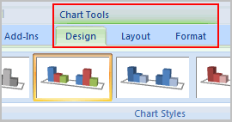
To change the chart type:

  - Select the Design tab.
  - Click the Change Chart Type command. A dialog box appears.
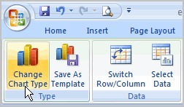

  - Select another chart type.
  - Click OK.

The chart in the example compares each salesperson's monthly sales to his or her other months' sales; however, you can change what is being compared. Just click the Switch Row/Column Data command, which will rotate the data displayed on the x and y axes. To return to the original view, click the Switch Row/Column command again.

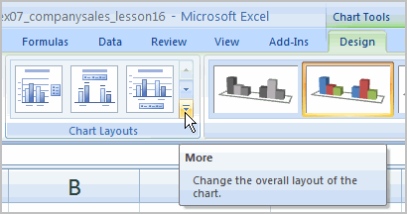
To change chart layout:
  - Select the Design tab.
  - Locate the Chart Layouts group.
  - Click the More arrow to view all of your layout options.
  - Left-click a layout to select it.

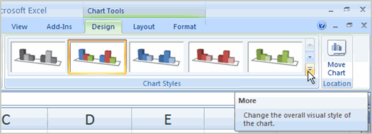
To change chart style:
  - Select the Design tab.
  - Locate the Chart Style group.
  - Click the More arrow to view all of your style options.
  - Left-click a style to select it.

To move the chart to a different worksheet:
  - Select the Design tab.
  - Click the Move Chart command. A dialog box appears. The current location of the chart is selected.
  - Select the desired location for the chart (i.e., choose an existing worksheet, or select New Sheet and name it).
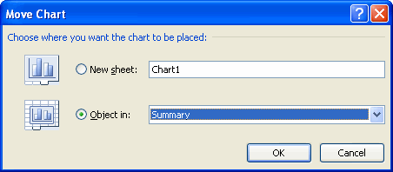

PivotTables
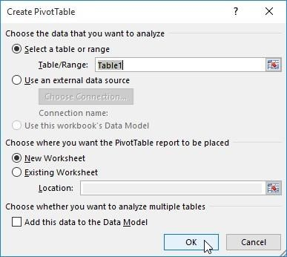
PivotTables can help make worksheets more manageable by summarizing data and allowing users to manipulate it in different ways. They are generally used for analysis of large amounts of data. A PivotTable can instantly calculate and summarize the data in a way that will make it much easier to read.
Creating a PivotTable
To create a PivotTable, select the table or cells (including column headers) to be included in the PivotTable. From the Insert tab, click the PivotTable command. The Create PivotTable dialog box will appear. Choose the settings, then click OK.
A blank PivotTable and Field List will appear in the selected
location. Each field is simply a column header from the source data. In the PivotTable Fields list, check the box for each field to include in the PivotTable. The selected fields will be added to one of the four areas below. The PivotTable will calculate and summarize the selected fields.
The data in the PivotTable can be sorted using the Sort & Filter command on the Home tab. Moreover, any number formatting may also be on the PivotTable.
Note that any changes in the data in the source worksheet will not automatically update the PivotTable. To manually update it, select the PivotTable and then go to Analyze > Refresh.
Pivoting Data
PivotTables allow for quick pivoting (reorganization) of data, allowing users to examine the worksheet in several ways. Pivoting data can help answer different questions and even experiment with data to discover new trends and patterns.
The PivotTable can include multiple rows and columns. To increase/decrease the number of rows/columns, drag a field from the Fields List into/out of the respective area (rows/columns).
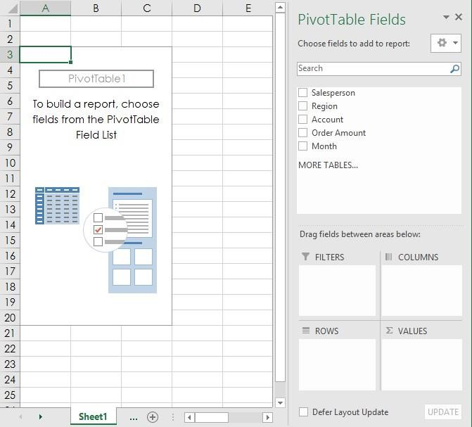

Filters
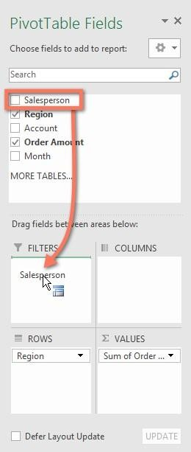
Filters can be used to narrow down the data in the PivotTable to show only the information needed. To apply a filter, drag a field from the Field List to the Filters area. The filter will appear above the PivotTable. Click the drop-down arrow, then check/uncheck the box next to any item to include/exclude it from the table. The PivotTable will adjust to reflect the changes.
Slicers
Slicers are just like filters but are easier and faster to use. Slicers are used when frequent filtering of the PivotTable is required.
To add a slicer, select any cell in the PivotTable. From the Analyze tab, click the Insert Slicer command. A dialog box will appear. Check the box next to the desired field, then click OK. The slicer will appear next to the PivotTable. Each selected item will be highlighted in blue.
Just like filters, only selected items are used in the PivotTable. When an item is selected or deselected, the PivotTable will instantly reflect the change. Pressing and holding the Ctrl key on the keyboard allows the user to select multiple items
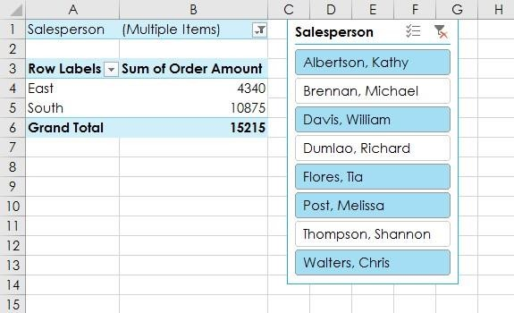
at once.

PivotCharts
PivotCharts are like regular charts, except they display data from a PivotTable. Just like regular charts, users can select a chart type, layout, and style that will best represent the data.
Select any cell in the PivotTable. From the Insert tab, click the PivotChart command. The Insert Chart dialog box will appear. Select the desired chart type and layout, then click OK. The PivotChart will appear.
Filters or slicers can be used to narrow down the data in the PivotChart. To view different subsets of information, change the columns or rows in the PivotTable.

Working with Pivot Tables and Pivot Charts

Perhaps the most powerful analytical tool that Excel provides is the PivotTable command, with which you can cross-tabulate data stored in Excel lists. A cross-tabulation summarizes information in two (or more) ways: for example, sales by product and state, or sales by product and month.
Alternatively, Pivot charts work when you have only a limited number of rows in your cross-tabulation. Say, less than half a dozen rows. And pivot charts work when it makes sense to show information visually, such as in a bar chart, etc. Most of the time you won’t use a pivot chart but a pivot table instead.

Steps for creating a Pivot Table:
- Click cell A1 to make it the active cell.
- Click the Insert tab’s PivotTable command button. Excel displays the Create PivotTable dialog box. Also, it automatically selects the worksheet range that holds the data that you want to pivot.
- If not specified earlier, you can still enter the list range into the Table/Range text box. You can do so in two ways. You can type the range coordinates: For example, if the range is cell A1 to cell D25, type
$A$1:$D$25. Alternatively, you can click the button at the right end of the Table/Range text box. Excel collapses the Create PivotTable dialog box, so you can then use the mouse or the navigation keys to select the worksheet range.
- After you select the worksheet range, click the button at the end of the Range text box again. Excel redisplays the Create PivotTable dialog box.
- Next, select the Row field. You need to decide first which field from the list you want to summarize by using rows in the pivot table. Drag the field from the PivotTable Fields List box to the Rows box.
- Then, Select the Column field that indicates what list information you want stored in the
- columns of your cross-tabulation. Drag the field item from the PivotTable Fields List to the box marked Columns.
- Lastly, select the data item that you want cross-tabulated in the pivot table.

One thing that is noticeable is that if you select a numeric data item, Excel automatically cross-tabulates by summing the data item values.

Steps for creating a Pivot Chart:
- Click cell A1 to make it the active cell.
- Click the Insert tab’s PivotChart command button. Excel displays the Create PivotChart dialog box. Also, it automatically selects the worksheet range that holds the data that you want to pivot.
- Select the Legend (Series) field. You need to decide first what data series should show in a chart. Drag the field from the PivotChart Fields List box to the Legend (Series) box.
- Then, Select the Data Category that organizes the values in a data series. Drag the field item from the PivotChart Fields List to the box marked Axis (Categories).
- Lastly, select the data item that you want plotted in the pivot chart.

Slicer
You can insert slicers in Excel to quickly and easily filter pivot tables.

Steps:
  - Click any cell inside the pivot table.
  - On the Analyze tab, in the Filter group, click Insert Slicer.
  - Check your desired Category and click OK.
  - Now click one or multiple values and filter the table accordingly.

Objective:

Lab Session 7
Data Analysis with MS Excel Charts and Graphs

Working with Pivot Tables and Pivot Charts.
To learn how to depict data graphically.

Exercise 1

- Create a Pivot table and the type of Chart (if specified) for each of the following.

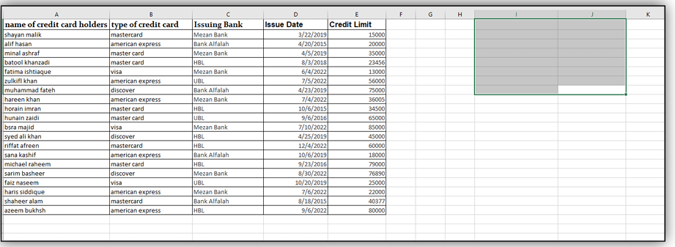

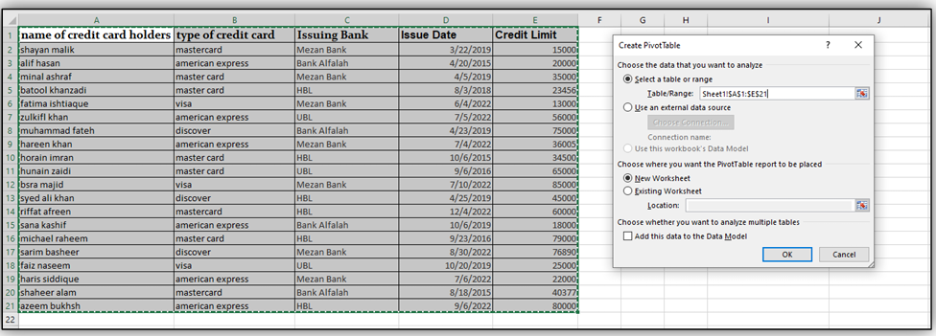

  - Credit cardholders by Card Type. (Pie Chart)

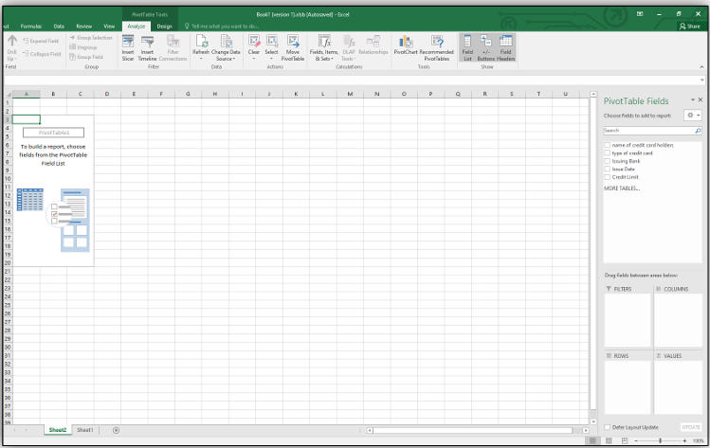

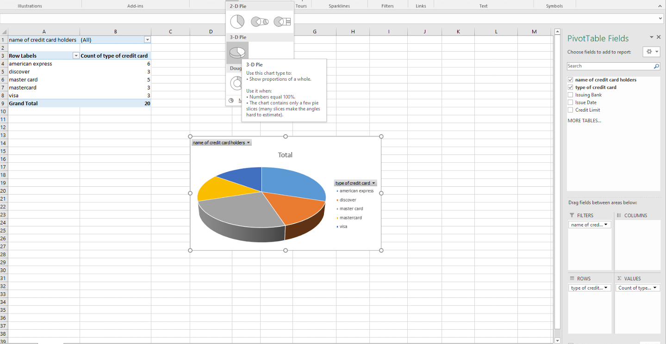
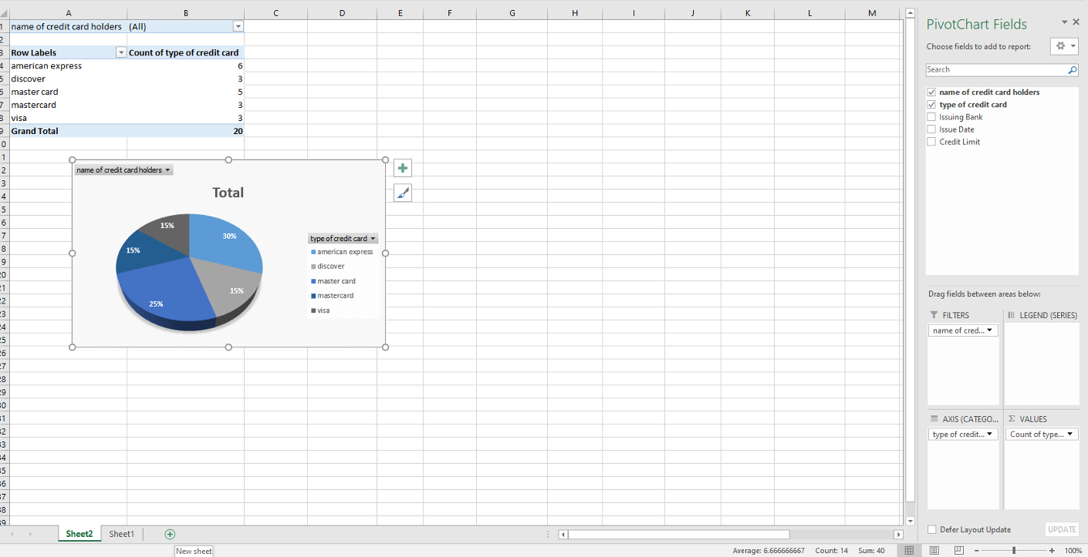

  - Credit cardholders by Issue date grouped (in rows) in Years and Quarters. (Column Chart)

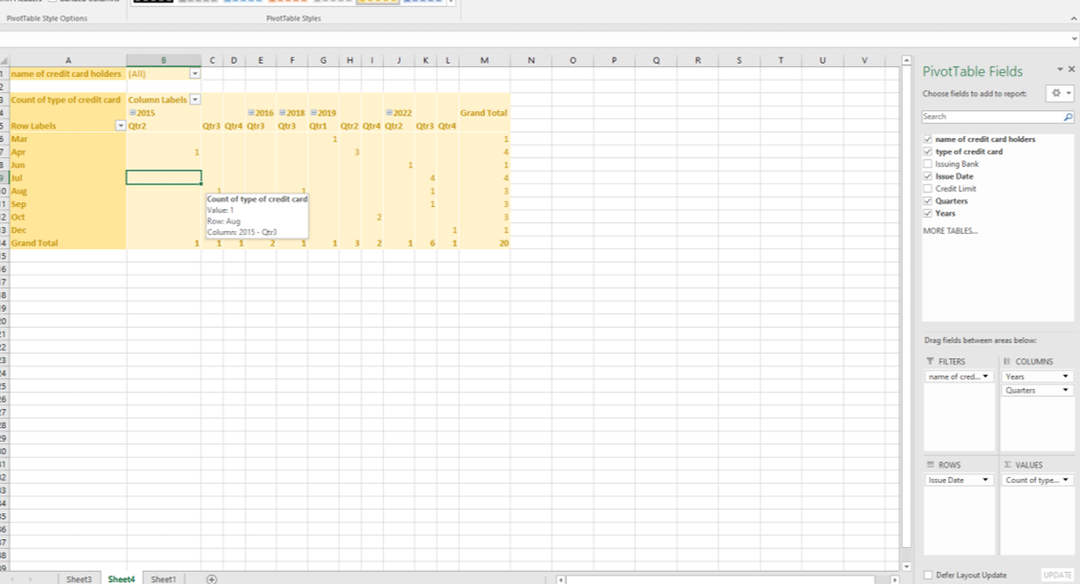
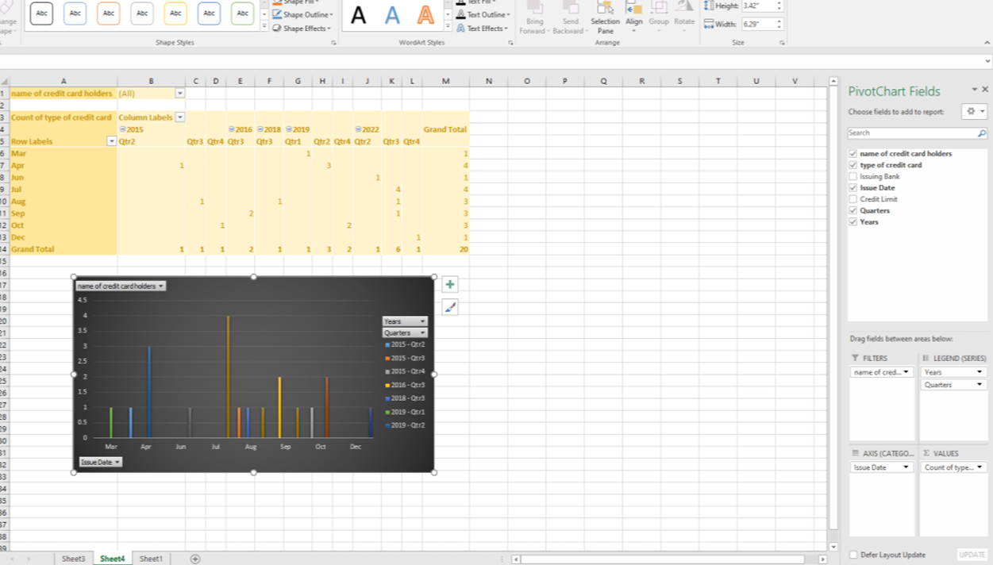

  - Credit cardholder by Issuing bank grouped (in columns) in Years. Highlight the Top 10 items with green color and the Bottom 10 items with red color.

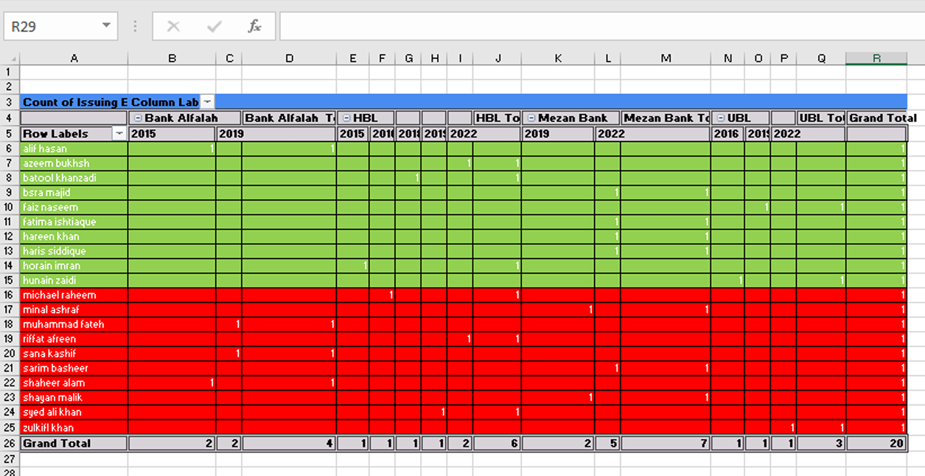

  - Credit cardholders by Credit Limit grouped in ranges with a size of 20000. (Bar Chart)

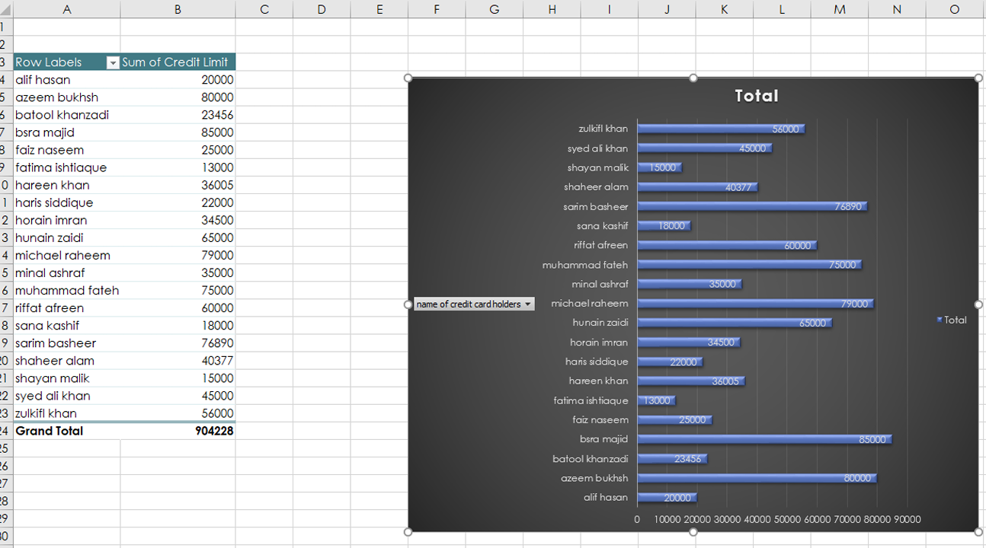

  - Credit card type by Issuing Bank grouped (in rows) by Credit Card type.

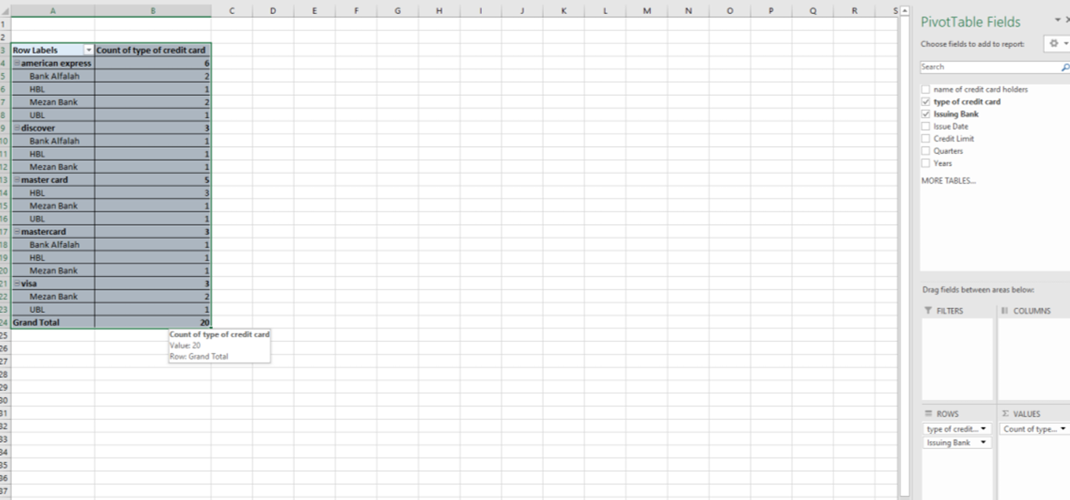

- Create a dashboard using these Charts

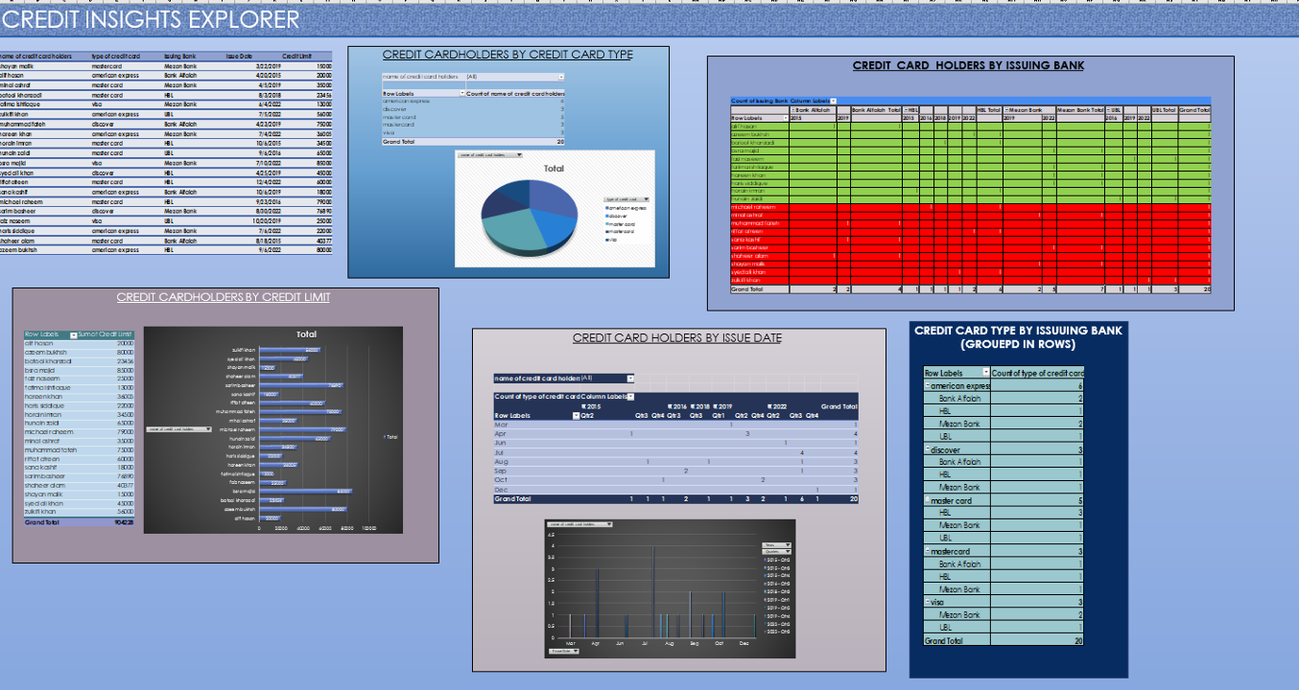

- Answer the following questions.

  - Which bank issued least number of Credit cards and what were their types?

Answer: UBL issued least number of credits cards and their types were
American express
Master card
Visa

  - How many Credit Cards were issued in 2nd quarter of 2012?

Answer: 1

  - Which is the most issued Credit Card Type?

Answer: master card

  - What range of Credit Limits had been offered most by the Issuing banks?

Answer: 30000

Exercise 4

- Build a chart with grades taking data from lab 6 on the x-axis and number of students on the y-axis. Chart must contain title, axis title, and legend.

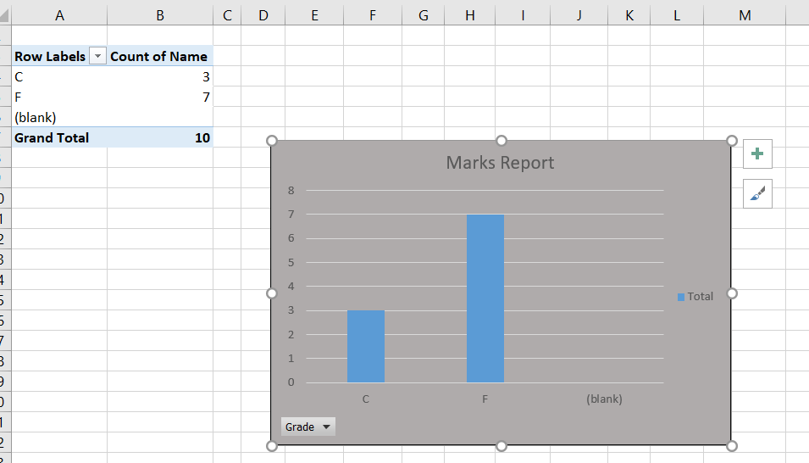

- USING RADAR CHART IN EXCEL. Demonstrate the use of Radar & Bar chart by comparing the average monthly temperature of three cities. Label the graph as ‘Average Monthly Temperatures’.
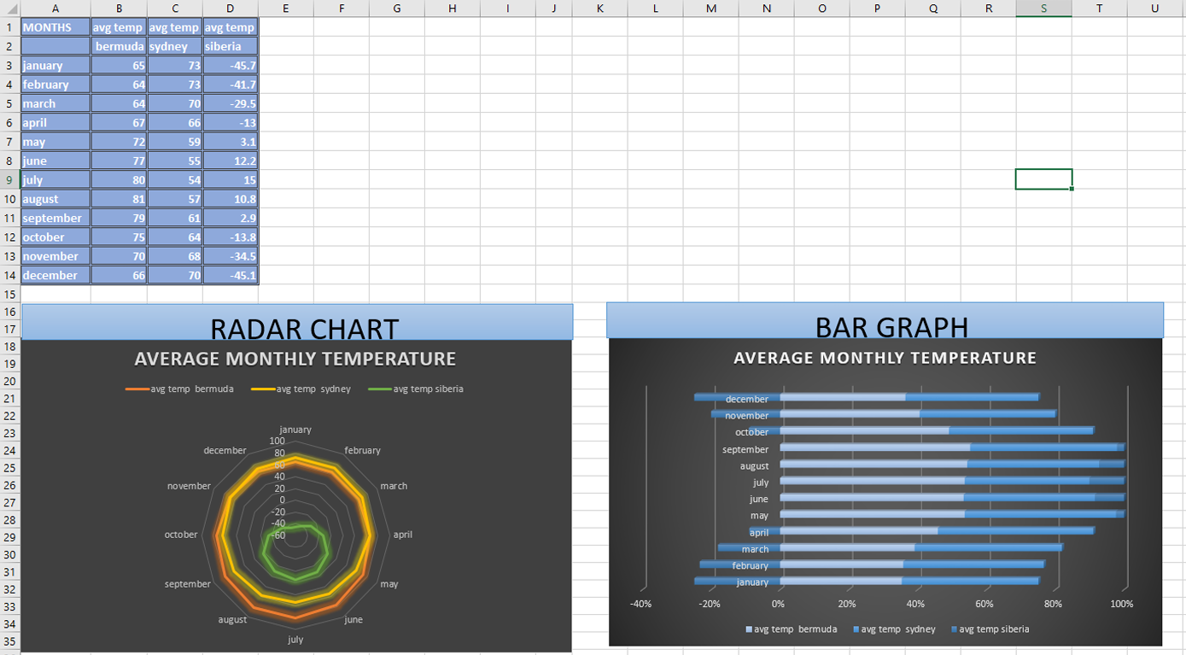

Exercise5

TRIGONOMATRIC GRAPHS
Draw a sine (sinƟ) wave and a cosine (cosƟ) wave on a single graph. Angle (Ɵ) ranges from 0o to 3600 with the interval of 150.Attach the formula sheets also for the sine and cosine chart

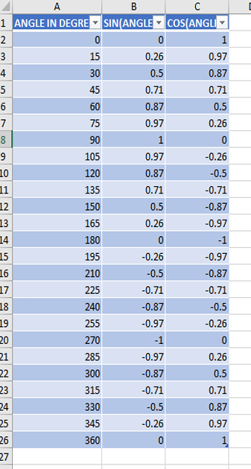
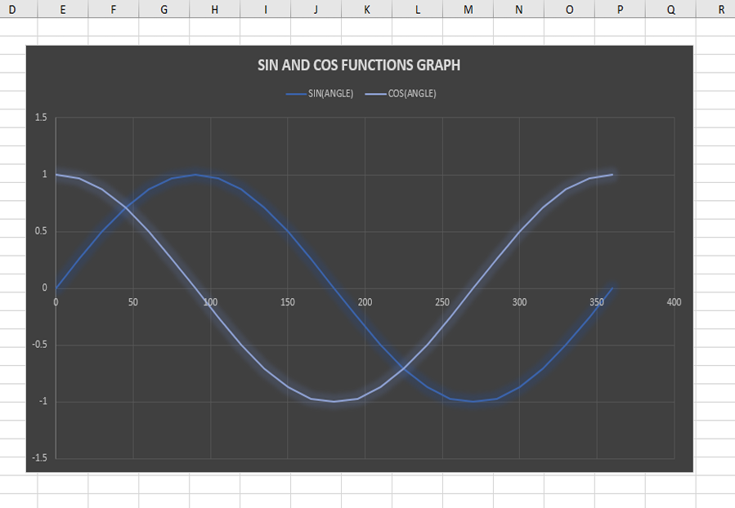.SUBMISSION GUIDELINES
- Take a screenshot of each task.
- Place all the screenshots in a single word file labeled with Roll No and Lab No. e.g. ‘se-2023xxx_Lab07’.
- Convert the file into PDF.
- Place all the related files along with the PDF file in a folder labeled with Roll No and Lab No. e.g. ‘se2023xxx_Lab07’.
- Submit the folder at GCR -100% policies for plagiaris

NED University of Engineering & Technology Department of Software Engineering
Course Code & Title: CT-174 FIT Assessment Rubric for Psychomotor (P2-PLO-3)

Instructor: Batch: 2024 Class: FESE Semester: Fall 2024. Student’s Name: Roll No.:
Laboratory Session No. Date:
Psychomotor Domain Assessment Rubric-Level P2-PLO3
Skill Sets | Extent of Achievement
 | Below Average (0--1) | Average (2) | Good (3) | Very Good (4) | Excellent (5)
Problem Definition and Understanding | Unable to define and understand the problem clearly. | Struggles to define the problem clearly, with significant gaps in understanding | Defines the problem, but with gaps or a limited understanding of key components, impacting the overall quality of definition. | Effectively defines the problem with a good understanding of its components, showcasing proficiency in problem definition. | Demonstrates an exceptional understanding of the problem, identifying all key components and challenges with insightful depth.
Technical Implementation Proficient use of  tools to complete the problem | Struggles to use tools effectively, requiring significant improvement. | Uses tools with noticeable inefficiencies. | Demonstrates basic proficiency in utilizing tool, with some room for improvement. | Effectively uses tools to support the task. | Integrates use of tools seamlessly to enhance the design and development process
Solution Design& Accuracy | Struggles to relate the implemented solutions to the design and development goals, requiring significant improvement. | Shows limited connection between the implemented solutions and the design and development context. | Demonstrates a basic understanding of how the solutions align with design and development requirements. | Effectively relates the implemented solutions to the overall design and development objectives | Maps the implemented solutions seamlessly to the overarching design and development goals, demonstrating a comprehensive understanding.
Trouble Shooting Skills  Issue resolution skills | Unable to trouble shoot | Limited troubleshooting | Adequate troubleshooting, minor errors remaining | Good troubleshooting, no errors remaining | Excellent trouble shooting no errors remain without delay.
Document Organization and on time submission | Poor Unclear disorganized document late submission | Somewhat clear with lack of organization and structuring late submission | Somewhat clear with lack of organization and structuring on time submission | Reasonably clear and organized with adequate structuring on time submission | Highly clear and well- structured document, On time submit

Weighted CLO (Psychomotor Score)
Instructor’s Signature with Date

OBJECTIVE(S)

Lab Session 8

- Learn about Relational Database Management Systems
- Learn about Creating Database in Microsoft Access
- Learn about Creating Relationships
- Learn about Creating Queries

What is a Database?

A database is a collection of organized data that can easily be accessed, managed, and updated.

Database Management Systems

A Database Management System (DBMS) is a software program that enables the creation and management of databases. Generally, these databases will be more complex than the text files/spreadsheets.

Relational Database Management System

A relational Database Management System is a type of database management system (DBMS) which stores data in the form of related tables.

Popular RDBMS
- MS Access
- Oracle
- MySQL
- Microsoft SQL Server

Table

Customer Table
CustomerID | CustomerName | Address | City | Country
1 | Alan Turing | 13 Guild Street | London | UK
2 | Dennis Ritchie | 61 Farnum Road | New York | USA
3 | John Neumann | Csabai kapu 4 | Budapest | USA
4 | Ada Lovelace | 68 Crown Street | London | UK

Database Relationship

Book has a Chapter:
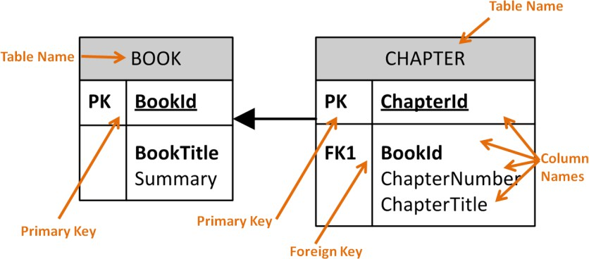

Columns

A field also called a column in a relational database, is part of a table that is assigned a specific data type. The data type determines what kind of data the column is allowed to hold. This enables the designer of the table to help maintain the integrity of the data.

Every database table must consist of at least one column. Columns are those elements within a table that hold specific types of data, such as a person’s name or address. For example, a valid column in a customer table might be the customer’s name.

Rows

A row is a record of data in a database table. For example, a row of data in a customer table might consist of a particular customer’s identification number, name, address, phone number, and fax number. A row is composed of fields that contain data from one record in a table. A table can contain as little as one row of data and up to as many as millions of rows of data or records.

Integrity Constraints

Integrity constraints ensure the accuracy and consistency of data in a relational database. Data integrity is handled in a relational database through the concept of referential integrity. Many types of integrity constraints play a role in referential integrity (RI).

Referential integrity is a data quality concept that ensures that when you make changes to data in one place, those changes are reflected in other related records

Primary Key

The primary key of a relational table uniquely identifies each record in the table. It can either be a normal attribute that is guaranteed to be or it can be generated by the DBMS. Primary keys may consist of a single attribute or multiple attributes in combination.

Example

Imagine we have a Students table that contains a record for each student at a university. The student's unique student ID number would be a good choice for a primary key in the STUDENTS table. The student's first and last name would not be a good choice, as there is always the chance that more than one student might have the same name.

Foreign Key

A foreign key is a key used to link two tables together. A FOREIGN KEY in one table points to a PRIMARY KEY in another table. Let’s illustrate the foreign key with an example. Look at the following two tables:

Person Table

P_Id | LastName | FirstName | Address | City
1 | Hansen | Ola | Timoteivn 10 | Sandnes
2 | Svendson | Tove | Borgvn 23 | Sandnes
3 | Pettersen | Kari | Storgt 20 | Stavanger

Orders Table

O_Id | OrderNo | P_Id
1 | 77895 | 3
2 | 44678 | 3
3 | 22456 | 2

- The "P_Id" column in the Orders table points to the "P_Id" column in the Person table.
- The "P_Id" column in the Person table is the PRIMARY KEY in the Person table.
- The P_Id column in the Orders table is a FOREIGN KEY in the Orders table.
- The FOREIGN KEY constraint is used to prevent actions that would destroy links between tables. It also prevents invalid data from being inserted into the foreign key column, because it has to be one of the values contained in the table it points to.
FAMILIARIZATION WITH SOME BASIC DATABASE RELATED TERMS

USING MICROSOFT ACCESS
Microsoft Access is a Database Management System (DBMS) from Microsoft that combines the relational Microsoft Jet Database Engine with a graphical user interface and software development tools. It is a member of the Microsoft Office suite of applications, included in the professional and higher editions

- A record in a row on a datasheet and is a set of values defined by fields. In a mailing list table, each record would contain the data for one person as specified by the intersecting fields.

- A field is a column on a datasheet and defines a data type for a set of values in a table. For a mailing list table might include fields for first name, last name, address, city, state, zip code, and telephone number.

- A table is a grouping of related data organized in fields (columns) and records (rows) on a datasheet. By using a common field in two tables, the data can be combined. Many tables can be stored in a single database.

- A database is a collection of related information.
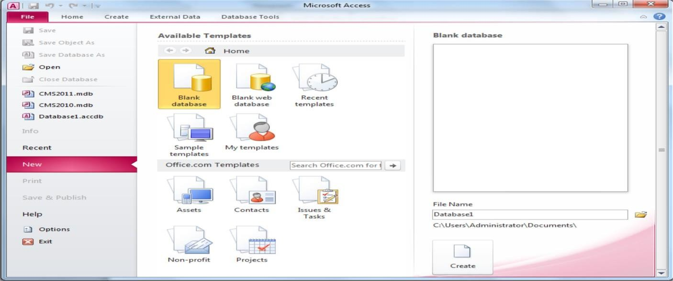

GETTING STARTED
Figure 11.1 MS Access Welcome window

After opening Access, you will be presented with two major options as shown in figure above. First if you are creating a new database or the second if you want to open and edit an existing database. Details about both of these choices are given below:
Open an existing database
If the database was opened recently on the computer, it will be listed in the File Menu either directly or inside Recent option. Highlight the database name and click OK. Otherwise, click Open (Ctrl + O) from File Menu, navigate to proper folder location, highlight the database name in the listing and click OK.
Creating a new database
Click New (Ctrl + N) option inside the File Menu. You will be presented with MS Access available database templates both offline and online and then you are required to select any one of them to create your new database. Some of the example offline database templates include Blank Database, Blank Web database, sample database etc. Some of the example online database templates include Assets, Contacts, Issues and Tasks etc. Unlike Word documents, Excel worksheets, and Power Point presentations, you must save an Access database before you start working on it. After selecting "Blank Access database" for example, you will first be prompted to specify a location and name for the database.

Creating Database in Microsoft Access

With database management systems, you need to create your tables before you can enter data. Microsoft Access makes creating tables extremely easy. In fact, when you create a database, Access creates your first table for you.

Using our blank database, we are going to rename Table1 to Customers. This table will have 4 columns: CustomerId, FirstName, LastName, and DateCreated.

Steps
- Rename the ID field to CustomerId. To do this, Right-click on the ID column and select Rename Field. Enter CustomerId when prompted.
- In the next field, click on Click to Add and select Short Text.
- At this point, Access will conveniently highlight/select the field name (currently Field1) so that you can name the field. Call it FirstName.
- Do the same again for the next field (LastName) and select data type Short Text.
- In the next field, select the Date & Time data type and name the field DateCreated.

Database Window
The Database Window (figure 11.2) organizes all of the objects in the database e.g. Tables, Queries, Forms etc. The default table listing provides links for creating or modifying tables and will list all of the tables in the database when they have been added.

Design View
Design View (Figure 11.3) customizes the fields in the database so that data can be entered.

Datasheet View
The datasheet view (Figure 11.4) allows you to enter data into the database.
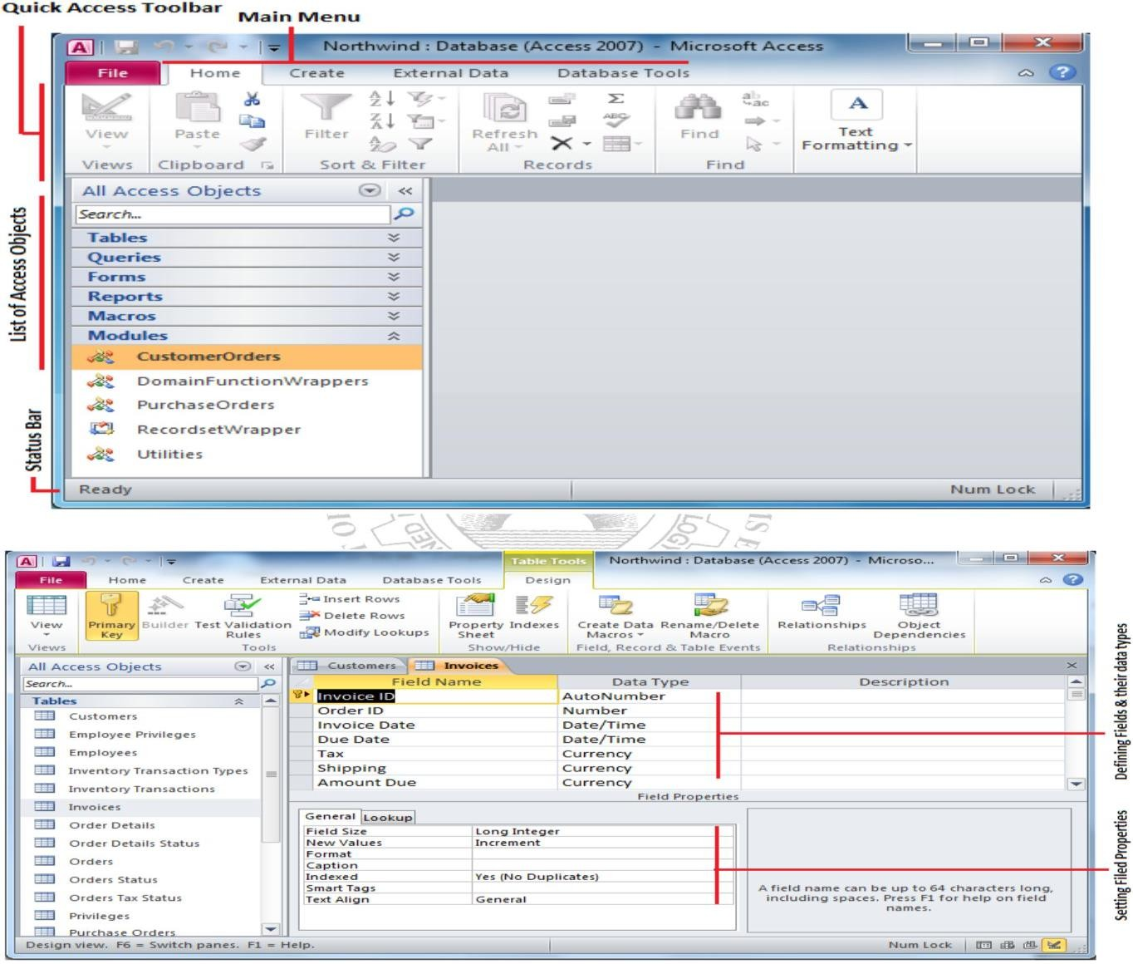
Figure 11.2: Database Window
Figure 11.3: Design View

Design view
Design view enables you to design and set up your database. It is kind of a "Behind the scenes" view of your database. This is where you set up and configure your tables, forms, reports, etc

Switch to Design View: The following steps demonstrate how to switch to the Design view.
Steps
- Click on the View icon at the top left (just under the File menu).
- At this point, Access will ask you to name and save the table you just created. Type Customers and click OK.
- You are now looking at your Customer table in Design view. Click on the Date Created field, then in the bottom pane, enter =Now() in the Default Value field. Also, click in the Format field and select General Date from the contextual menu.
CREATING TABLES
Introduction to Tables
Tables are grids that store information in a database similar to the way an Excel worksheet stores information in a workbook. To create a table Click Create from Main Menu. Access provides two ways to create a table for which there are icons Table and Table design. Double-click on any icon to create a table.
  - Create table in Design view will allow you to create the fields of the table. This is the most common way of creating a table and is explained in detail below.
  - Create table by entering data will give you a blank datasheet with just ID field and the rest with unlabeled columns that looks much like an Excel worksheet. Enter data into the cells and click the Save button. After the table is saved, the empty cells of the datasheet are trimmed. The fields are given generic names such as "Field1", "Field2", etc. To rename them with more descriptive titles that reflect the content of the fields, change the view to Design view again and modify names as per requirements.
Create a Table in Design View
Design View will allow you to define the fields in the table before adding any data to the datasheet. The window is divided into two parts: a top pane for entering the field name, data type, and an option description of the field, and a bottom pane for specifying field properties as shown in (figure 11.3)
Field Name - This is the name of the field and should represent the contents of the field such as "Name", "Address", "Final Grade", etc. The name cannot exceed 64 characters in length and may include spaces.
Data Type is the type of value that will be entered into the fields.
Text - The default type, text type allows any combination of letters and numbers up to a maximum of 255 characters per field record.
Memo - A text type that stores up to 64,000 characters. oNumber - Any number can be stored.
Date/Time - A date, time, or combination of both.
Currency - Monetary values that can be set up to automatically include a dollar sign ($) and correct decimal and comma positions.
AutoNumber - When a new record is created, Access will automatically assign a unique integer to the record in this field. From the General options, select Increment if the numbers should be assigned in order or random if any random number should be chosen. Since every record in a datasheet must include at least one field that distinguishes it from all others, this is a useful data type to use if the existing data will not produce such values.
Yes/No - Use this option for True/False, Yes/No, On/Off, or other values that must be only one of two. OLE Object - An OLE (Object Linking and Embedding) object is a sound, picture, or other object such as a Word document or Excel spreadsheet that is created in another program. Use this data type to embed an OLE object or link to the object in the database.

Hyperlink - A hyperlink will link to an Internet or Intranet site, or another location in the database. The data consists of up to four parts each separated by the pound sign (#): DisplayText#Address#SubAddress#ScreenTip. The Address is the only required part of the string.
Examples:
Internet hyperlink example: FGCU Home Page#http://www.fgcu.edu# Database link example: #c:\My Documents\database.mdb#MyTable

  - Description (optional) - Enter a brief description of what the contents of the field are.
  - Field Properties - Select any pertinent properties for the field from the bottom pane.
Field Properties
Properties for each field are set from the bottom pane of the Design View window.

- Field Size is used to set the number of characters needed in a text or number field. The default field size for the text type is 50 characters. If the records in the field will only have two or three characters, you can change the size of the field to save disk space or prevent entry errors by limiting the number of characters allowed. Likewise, if the field will require more than 50 characters, enter a number up to 255. The field size is set in exact characters for Text type, but options are given for numbers:
  - Byte - Positive integers between 1 and 255
  - Integer - Positive and negative integers between -32,7613 and 32,7613
  - Long Integer (default) - Larger positive and negative integers between -2 billion and 2 billion.
  - Single - Single-precision floating-point number
  - Double - Double-precision floating-point number
  - Decimal - Allows for Precision and Scale property control
- Format confirms the data in the field to the same format when it is entered into the datasheet. For text and memo fields, this property has two parts that are separated by a semicolon. The first part of the property is used to apply to the field and the second applies to empty fields.
Primary Key
Every record in a table must have a primary key that differentiates it from every other record in the table. In some cases, it is only necessary to designate an existing field as the primary key if you are certain that every record in the table will have a different value for that particular field. A social security number is an example of a record whose values will only appear once in a database table.
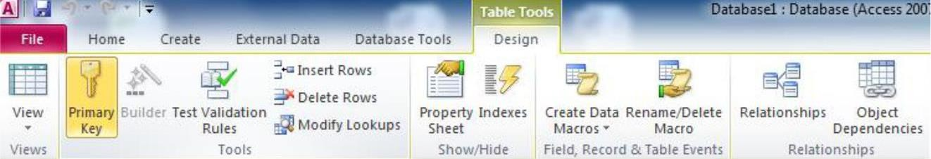
Figure 11.5 Quick Access Toolbar – Table Tools
Designate the primary key field by right-clicking on the record and selection Primary Key from the shortcut menu or select Primary Key from the Quick Access Toolbar as given in figure above. The primary key field will be noted with a key image to the left. To remove a primary key, repeat one of these steps.
Indexes
Creating indexes allows Access to query and sort records faster. To set an indexed field, select a field that is commonly searched and change the Indexed property to Yes (Duplicates OK) if multiple entries of the same data value are allowed or Yes (No Duplicates) to prevent duplicates.
Field Validation Rules
Validation Rules specify requirements (change word) for the data entered in the worksheet. A customized message can be displayed to the user when data that violates the rule setting is entered. Click the expression builder ("...") button at the end of the Validation Rule box to write the validation rule. Examples of field validation rules include <> 0 to not allow zero values in the record, and ??? to only all data strings three characters in length.

Input Masks
An input mask controls the value of a record and sets it in a specific format. They are similar to the Format property, but instead display the format on the datasheet before the data is entered. For example, a telephone number field can formatted with an input mask to accept ten digits that are automatically formatted as "(555) 123-4567". The blank field would look like ( ) - . Add an input mask to a field by following these steps:
- In design view, place the cursor in the field that the input mask will be applied to.
- Click in the white space following Input Mask under the General tab.
- Click the "..." button to use the wizard or enter the mask, (@@@) @@@-@@@@, into the field provided.
DATASHEET RECORDS
Adding Records
Add new records to the table in datasheet view by typing in the record beside the asterisk (*) that marks the new record.
Editing Records
To edit records, simply place the cursor in the record that is to be edited and make the necessary changes. Use the arrow keys to move through the record grid. The previous, next, first, and last record buttons at the bottom of the datasheet are helpful in maneuvering through the datasheet.
Deleting Records
Delete a record on a datasheet by placing the cursor in any field of the record row and select Delete Record
from the menu bar or click the Delete button on the Quick Access toolbar.
Adding and Deleting Columns
Although it is best to add new fields (displayed as columns in the datasheet) in design view because more options are available, they can also be quickly added in datasheet view. Highlight the column that the new column should appear to the left of by clicking its label at the top of the datasheet and press right click then select Insert field from the dropdown menu. Entire columns can be deleted by placing the cursor in the column and selecting Delete field from the dropdown menu.
Freezing and unfreezing Columns
Similar to freezing panes in Excel, columns on an Access table can be frozen. This is helpful if the datasheet has many columns and relevant data would otherwise not appear on the screen at the same time. Freeze a column by placing the cursor in any record in the column and select Freeze fields from the right click dropdown men. Select the same option to unfreeze a single column or select Unfreeze All fields.

Finding Data in a Table
Open the table in datasheet view. Place the cursor in any record in the field that you want to search and select Home|Find (Ctrl + F)... from the Quick Access toolbar. Enter the value criteria in the Find What: box. From the Look In: drop-down menu, define the area of the search by selecting the entire table or just the field in the table you placed your cursor in during step 2. Select the matching criteria from Match: to and click the More
>> button for additional search parameters. When all of the search criteria are set, click the Find Next button. If more than one record meets the criteria, keep clicking Find Next until you reach the correct record.

Sorting & Filtering
Sorting and filtering allow you to view records in a table in a different way either by reordering all of the records in the table or view only those records in a table that meet certain criteria that you specify.
Sorting
In table datasheet view, place the cursor in the column that you want to sort by. Select Ascending or Descending from the Quick Access toolbar under Home main menu or click the Sort A to Z or Sort Z to A from the dropdown menu.
To sort by more than one column (such as sorting by date and then sorting records with the same date alphabetically), highlight the columns by clicking and dragging the mouse over the field labels and select one of the sort methods stated above.

Filter by Selection
This feature will filter records that contain identical data values in a given field such as filtering out all of the records that have the value "Smith" in a name field. To Filter by Selection, place the cursor in the field that you want to filter the other records by and click the Selection button inside Home main menu on the toolbar or directly select the criteria from right click dropdown menu.
Filter by Form
If the table is large, it may be difficult to find the record that contains the value you would like to filter by so using Filter by Form may be advantageous instead. This method creates a blank version of the table with drop- down menus for each field that each contains the values found in the records of that field.
The following methods can be used to select records based on the record selected by that do not have exactly the same value. Type these formats into the field where the drop-down menu appears instead of selecting an absolute value.
Saving A Filter
The filtered contents of a table can be saved as a query by selecting Advanced|Save As Query. Enter a name for the query and click OK. The query is now saved within the database.
Remove a Filter
To view all records in a table again, click the depressed toggle Filter button.

Creating a Relationship

A primary feature of relational databases is that they contain multiple tables, each of which can have a relationship with any of the other tables.

Our database needs more than one table anyway because we need to be able to track not only customers but also products, as well as the products the customers actually purchase. So we need to create two new tables.
- Products (ProductId, ProductName, Price, DateCreated)
- Orders (OrderId, CustomerId, ProductId, DateCreated)

Now it's time to create the relationship between all three tables.
- While viewing a table in Design view, DESIGN tab is selected, click Relationships from the Ribbon. A Show Table dialog box will pop up, displaying all three tables.
- Select all of them and click Add.
- You will now see three boxes that represent your three tables. Click and drag the CustomerId from the Customers table across to the corresponding CustomerId field on the Orders table.
- The Edit Relationships dialog will pop up. Click Enforce Referential Integrity so that it is checked. Click OK. You will now see a line established between the CustomerId field on the Customers table and the CustomerId on the Orders table.

Relationship Types

We just established a many-to-many relationship. There are three types of relationships that you can establish between tables. These are as follows:

Many-To-Many Relationship

This is what our example above uses. A row in table A can have many matching rows in table B, and vice versa. In our case, a single customer can order many products, and a single product could have many customers.

One-To-Many Relationship

This is the most common relationship type. In this type of relationship, a row in table A can have many matching rows in table B, but a row in table B can have only one matching row in table A. For example, a row in a Gender table (which contains the records Male and Female) can have many matching rows in a Customers table, but a row in the Customers table can only have one matching row in the Gender table.

One-To-One Relationship

A row in table A can have only one matching row in table B, and vice versa. This is not a common relationship type, as the data in table B could just have easily been in table A. This relationship type is generally only used for security purposes, or to divide a large table, and perhaps a few other reasons.

Creating the Query

Now let's create a query that returns the names of all customers who have ordered a product.
- Ensuring you have the CREATE tab open on the Ribbon, click Query Design.
- The Show Table dialog box will appear with all of our tables listed. Select all three tables and click Add, then click Close.
- The three tables are now represented in the top pane. Choose the fields you'd like to be presented in the results of your query. You can either double-click on the field name or click and drag it down to a column in the bottom pane. Select the fields.
- Click the Run button at the top-left part of the Ribbon. You should now see the result of the query.
- Save the query by right-clicking on the Query1 tab and giving it a name. Call it Customer Orders

Switch to SQL View

To switch to SQL view, you simply click the SQL icon at the bottom-right corner of Access. You can also choose SQL View from the View icon at the top-left of the Ribbon.

SQL Statements

In SQL view, you will see a SQL statement. This SQL statement represents the query that you constructed. If you're not familiar with SQL, this might look a little scary. But it needn't be that way. That SQL statement is simply extracting records from the database using our precise criteria.

SELECT The SELECT statement is used to select data from a database table.
  - SELECT Customers.FirstName, Customers.LastName FROM Customers
WHERE The WHERE clause in SELECT statements can be used to filter the records.
  - SELECT Customers.FirstName, Customers.LastName FROM Customers
WHERE Customers.LastName = 'Boyle'
AND and OR operators AND and OR operators are used to make logical comparisions.
  - SELECT Customers.FirstName, Customers.LastName FROM Customers
WHERE Customers.LastName = 'Boyle' AND Customers.CustomerId = 1;
  - SELECT Customers.FirstName, Customers.LastName FROM Customers
WHERE Customers.LastName = 'Boyle' OR Customers.CustomerId = 1;
ORDER BY The ORDER BY clause in SELECT statement is used to sort the result set in ascending or descending order. The ORDER BY clause sorts the records in ascending order by default.
  - SELECT Customers.FirstName, Customers.LastName FROM Customers
ORDER BY Customers.FirstName ASC/DESC;
AGGREGATE FUNCTIONS
An aggregate function performs a calculation on a set of values and returns a single value. Some common aggregate functions are given below.
SUM
It calculates the sum for a set of values.
  - SELECT SUM(Products.Price) FROM Products;
MAX
Returns the maximum value from a set of values.
  - SELECT MAX(Products.Price) FROM Products;
MIN
Returns the minimum value from a set of values.
  - SELECT MIN(Products.Price) FROM Products;
COUNT
Counts the number of rows in a table.
  - SELECT COUNT(Products.ProductId) FROM Products;
As you can see, each time we add criteria to our query in Design view, that criteria is added to the SQL statement, and we can limit the results by only those exact records that we are interested in.
Switch Back to Datasheet View
Switch Back to Datasheet View to see the result.

FIT Lab Session 8

NED University of Engineering & Technology – Department of Software Engineering

Lab Session 8

OBJECTIVE(S)
    - Learn about Relational Database Management Systems
    - Learn about Creating Database in Microsoft Access
    - Learn about Creating Relationships
    - Learn about Creating Queries

Lab Tasks
Create the following tables in Microsoft Access:
Table1: Student (containing fields: Student ID, First Name, Last Name, Department and Class).
Table2: Marks (containing fields: Student ID, ITC, Mathematics, English, Electronics, Physics).
Select appropriate primary keys and define appropriate relationship for these two tables. Add some sample data to the tables and make a hard copy of the tables created.

Attach your printout here.

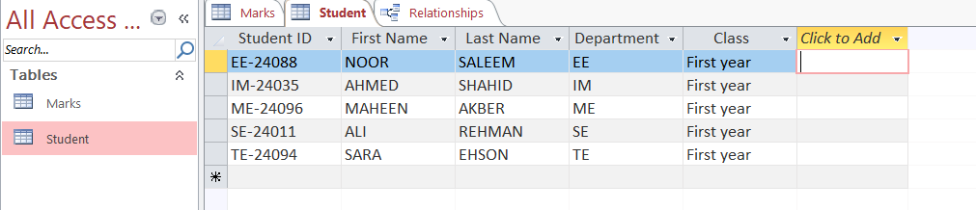

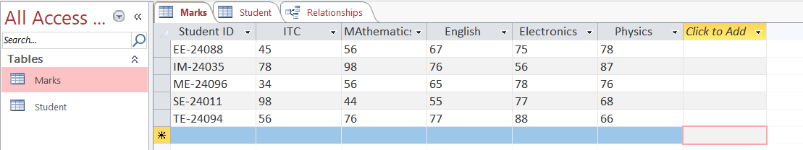

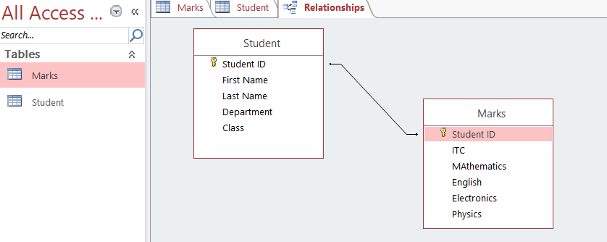

Explanation of the Relationships

- Student ID serves as a Primary Key in the Student table and as a Foreign Key in the Marks table.
- This setup establishes a one-to-many relationship, meaning each student can have multiple records in the Marks table, but each mark record is associated with only one student.

FIT Lab Session 9

NED University of Engineering & Technology – Department of Software Engineering

Lab Session 9

OBJECT

Creating queries, forms and reports in Microsoft Access

INTRODUCTION TO QUERIES
Queries select records from one or more tables in a database so they can be viewed, analyzed, and sorted on a common datasheet. The resulting collection of records, called a dynaset (short for dynamic subset), is saved as a database object and can therefore be easily used in the future. The query will be updated whenever the original tables are updated. Types of queries are select queries that extract data from tables based on specified values, find duplicate queries that display records with duplicate values for one or more of the specified fields, and find unmatched queries display records from one table that do not have corresponding values in a second table.
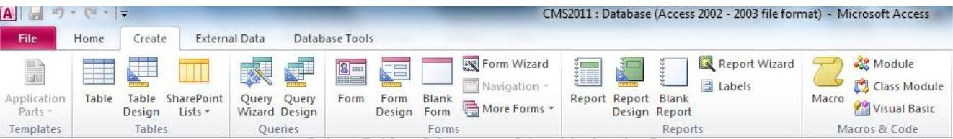
Figure 12.1 Create Menu Quick Access Toolbar

Create a Query in Design View
From the Create Main Menu as in figure 12.1, click the Query Design icon. Select tables and existing queries from the Tables and Queries tabs and click the Add button to add each one to the new query. Click Close when all of the tables and queries have been selected. Add fields from the tables to the new query by double-clicking the field name in the table boxes or selecting the field from the Field: and Table: drop-down menus on the query form. Specify sort orders if necessary.
Enter the criteria for the query in the Criteria: field. The Expression Builder can also be used to assist in writing the expressions. After you have selected all of the fields and tables, click the Run button on the toolbar. Save the query by clicking the Save button.
Query Wizard
Click the Create query by using wizard icon in the database window to have Access step you through the process of creating a query. From the first window, select fields that will be included in the query by first selecting the table from the drop-down Tables/Queries menu. Select the fields by clicking the > button to move the field from the Available Fields list to Selected Fields. Click the double arrow button >> to move all of the fields to Selected Fields. Select another table or query to choose from more fields and repeat the process of moving them to the Selected Fields box. Click Next > when all of the fields have been selected. On the next window, enter the name for the query and click Finish.

Find Duplicates Query
This query will filter out records in a single table that contain duplicate values in a field. Click the New button on the Queries database window, select Find Duplicates Query Wizard from the New Query window and click OK. Select the table or query that the find duplicates query will be applied to from the list provided and click Next >. Select the fields that may contain duplicate values by highlighting the names in the Available fields list and clicking the > button to individually move the fields to the Duplicate-value fields list or >> to move all of the fields. Click Next > when all fields have been selected. Select the fields that should appear in the new query along with the fields selected on the previous screen and click Next >. Name the new query and click Finish.
Delete a Query
To delete a query, select the required query and press the Delete key on the keyboard.

FORMS
Forms are used as an alternative way to enter data into a database table.
Create Form by Using Wizard
From the Create Main Menu as in figure 12.1, click Form wizard option in Forms section. From the Tables/Queries drop-down menu, select the table or query whose datasheet the form will modify. Then, select the fields that will be included on the form by highlighting each one the Available Fields window and clicking the single right arrow button > to move the field to the Selected Fields window. To move all of the fields to Select Fields, click the double right arrow button >>. If you make a mistake and would like to remove a field or all of the fields from the Selected Fields window, click the left arrow < or left double arrow
<< buttons. After the proper fields have been selected, click the Next > button to move on to the next screen. On the second screen, select the layout of the form.
- Columnar - A single record is displayed at one time with labels and form fields listed side-by-side in columns.
- Justified - A single record is displayed with labels and form fields are listed across the screen.
- Tabular - Multiple records are listed on the page at a time with fields in columns and records in rows.
- Datasheet - Multiple records are displayed in Datasheet View
Click the Next > button to move on to the next screen. Select a visual style for the form from the next set of options and click Next >. On the final screen, name the form in the space provided. Select "Open the form to view or enter information" to open the form in Form View or "Modify the form's design" to open it in Design View. Click Finish to create the form.
Adding Records Using A Form
Input data into the table by filling out the fields of the form. Press the Tab key to move from field to field and create a new record by clicking Tab after the last field of the last record. A new record can also be created at any time by clicking the New Record button at the bottom of the form window. Records are automatically saved as they are entered so no additional manual saving needs to be executed.
Editing Forms
The following points may be helpful when modifying forms in Design View:
Grid lines - By default, a series of lines and dots underlay the form in Design View so form elements can be easily aligned. To toggle this feature on and off right click and select Grid.
Resizing Objects - Form objects can be resized by clicking and dragging the handles on the edges and corners of the element with the mouse.
Change form object type - To easily change the type of form object without having to create a new one, right click on the object with the mouse and select Change To and select an available object type from the list.
Label/object alignment - Each form object and its corresponding label are bounded and will move together when either one is moved with the mouse. However, to change the position of the object and label in relation to each other (to move the label closer to a text box, for example), click and drag the large handle at the top, left corner of the object or label.
Tab order - Alter the tab order of the objects on the form by selecting Tab Order from design Menu when Form is active. Click the gray box before the row you would like to change in the tab order, drag it to a new location, and release the mouse button.
Form Appearance - Change the background color of the form by clicking the Shape Fill button on the format menu inside Form Design. Change the color of individual form objects by highlighting one and selecting a color from

Color palette on the formatting toolbar. The font and size, font effect, font alignment, border around each object, the border width, and a special effect can also be modified using the formatting toolbar buttons inside Form Design Tools.

Form Controls
This section explains the uses for other types of form controls including lists, combo boxes, checkboxes, option groups, and command buttons.
- List and Combo Boxes: If there are small, finite number of values for a certain field on a form, using combo or list boxes may be a quicker and easier way of entering data. These two control types differ in the number of values they display. List values are all displayed while the combo box values are not displayed until the arrow button is clicked to open.
- Check Boxes and Option Buttons: Use check boxes and option buttons to display yes/no, true/false, or on/off values. Only one value from a group of option buttons can be selected while any or all values from a check box group can be chosen. Typically, these controls should be used when five or fewer options are available. Combo boxes or lists should be used for long lists of options.

- Command Buttons: Command buttons provide you with a way of performing action(s) by simply clicking them. When you choose the button, it not only carries out the appropriate action, it also looks as if it's being pushed in and released.

Reports
Reports will organize and group the information in a table or query and provide a way to print the data in a database.
Using the Wizard
From the Create Main Menu as in figure 12.1, click Report Wizard option in the Reports section. Select the information source for the report by selecting a table or query from the Tables/Queries drop-down menu. Then, select the fields that should be displayed in the report by transferring them from the Available Fields menu to the Selected Fields window using the single right arrow button > to move fields one at a time or the double arrow button >> to move all of the fields at once. Click the Next > button to move to the next screen.
Select fields from the list that the records should be grouped by and click the right arrow button > to add those fields to the diagram. Use the Priority buttons to change the order of the grouped fields if more than one field is selected. Click Next > to continue. If the records should be sorted, identify a sort order here. Select the first field that records should be sorted by and click the A-Z sort button to choose from ascending or descending order. Click Next > to continue. Select a layout and page orientation for the report and click Next
Select a color and graphics style for the report and click Next >. On the final screen, name the report and select to open it in either Print Preview or Design View mode. Click the Finish button to create the report.
Create in Design View
Click Report Design button in the Reports section of create access toolbar and you will be presented with a blank grid. Automatically properties window will open for this newly being created report. Click on Record Source property combo box and you will be presented with the list of available tables and queries. Choose the data source of the report from the drop-down menu and click OK. Design the report in much the same way you would create a form. For example, double-click the title bar of the Field Box to add all of the fields to the report at once. Then, use the handles on the elements to resize or move them to different locations, and modify the look of the report as per your requirements.

OBJECT

Lab Session 9

OPEN ENDED LAB
Creating queries, forms and reports in Microsoft Access

LAB TASK:
- Create the following tables in a Database named Job Details and add at least 5 records.
- Employees(employeeID, employeeName, hiringDate, deptID, jobID)

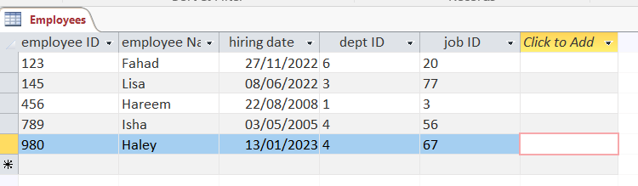

- Departments(deptID, deptName, locationID)

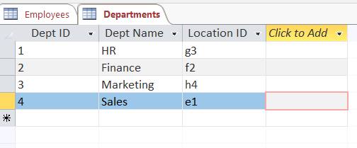
- Jobs(jobID, jobTitle, salary)

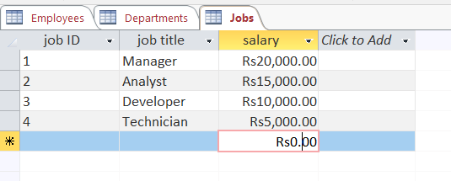



- Locations(locationID, city, country)

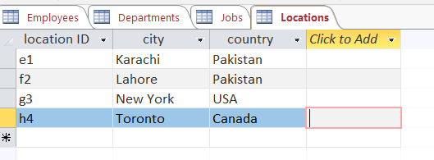

- Create appropriate relations between the newly created tables. Ensure referential integrity.

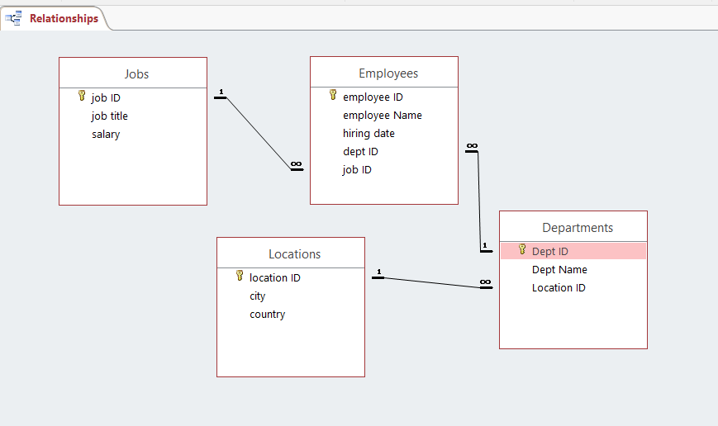

- Write suitable queries for each of the following statements.

- Display all the records from the Jobs table.
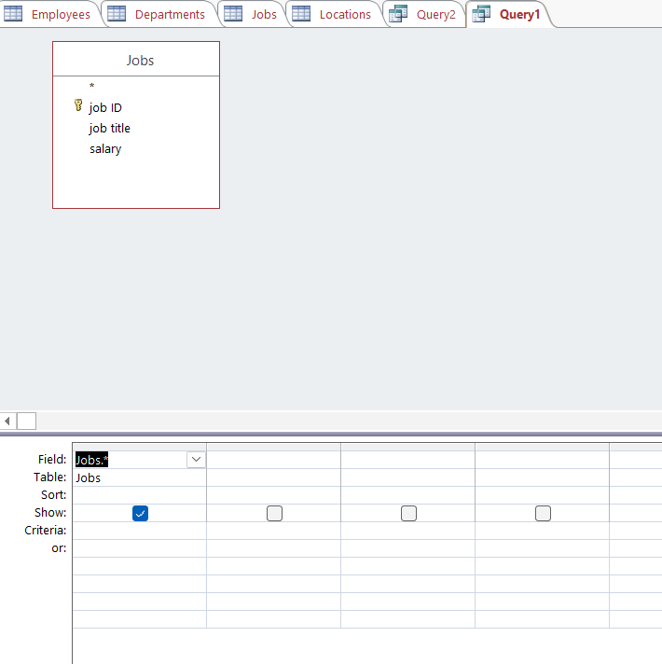

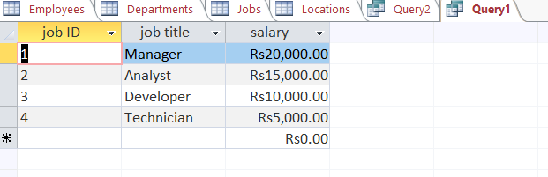

- Display the hiring date of the employees with department ID = “4”.

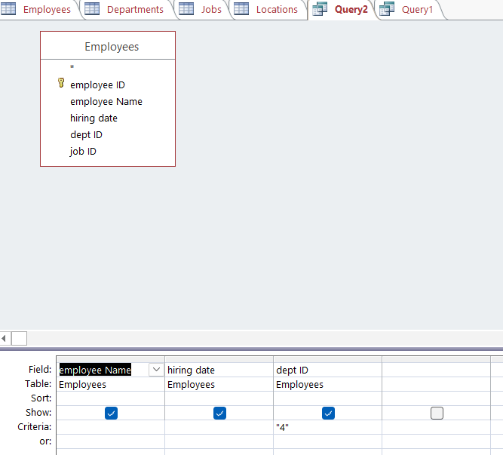

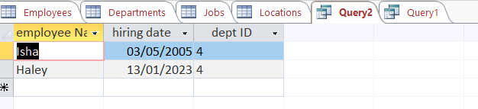



- Display job IDs for which the salary is greater than “$1000” or Title is “Manager”.

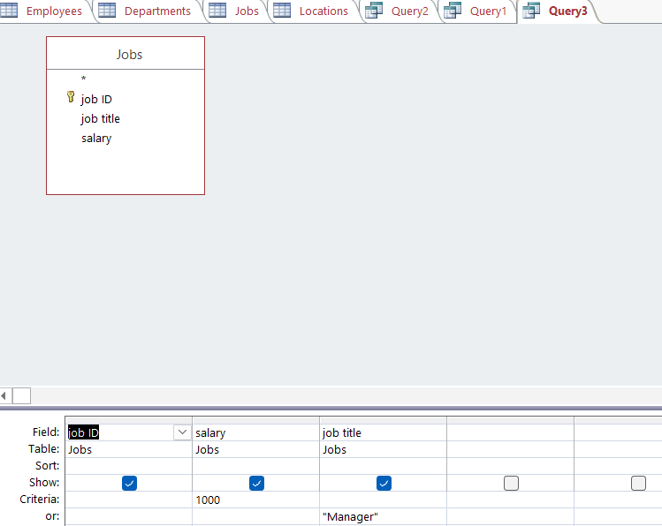

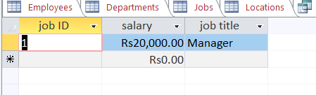

- Display the location IDs and cities of the departments that operate in Country of Pakistan.

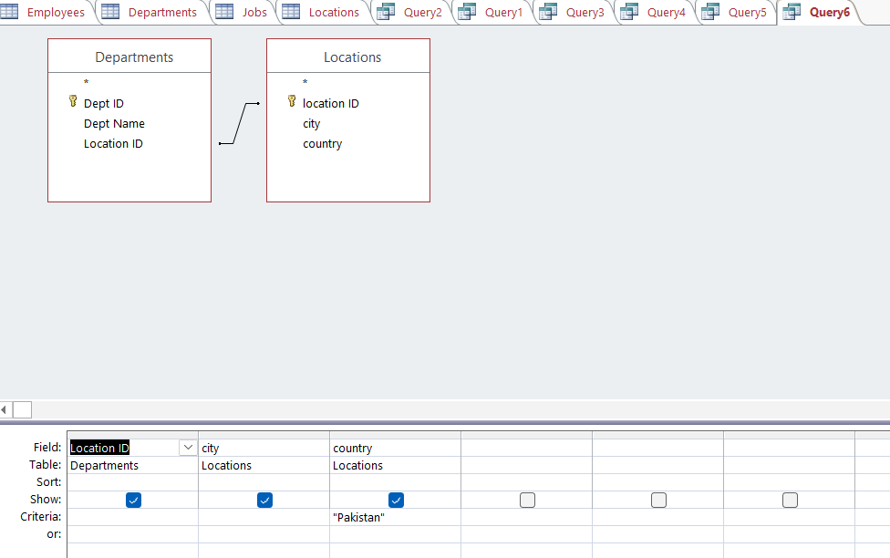

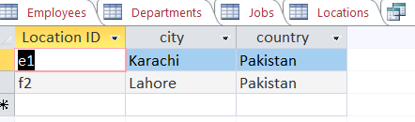

- Display the highest paid salary.

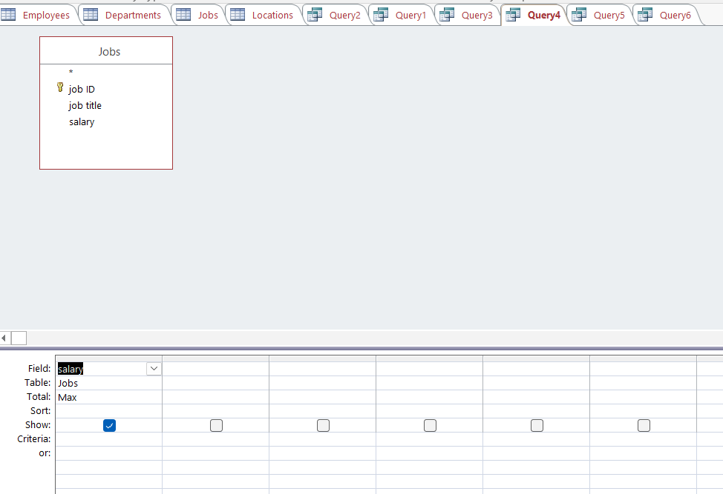

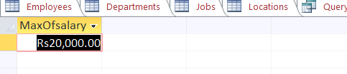

- Display the names of the employees in reverse alphabetical order.

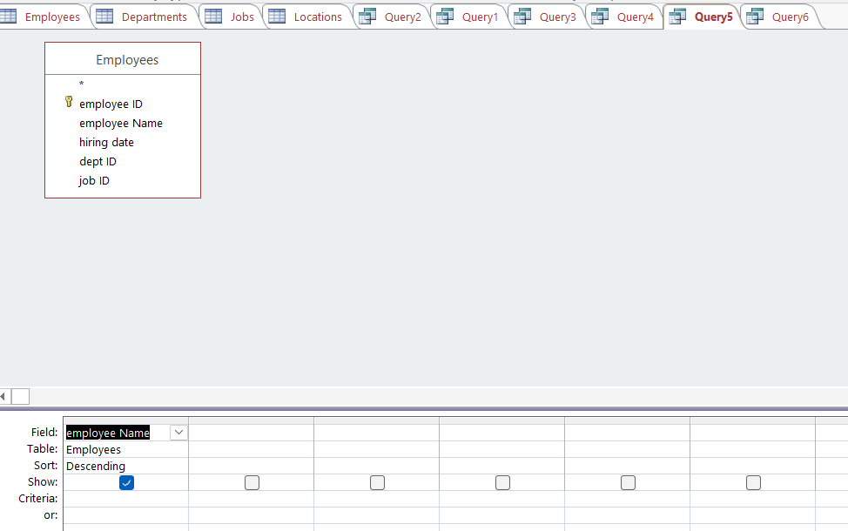

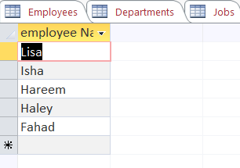
SUBMISSION GUIDELINES
- Take a screenshot of each task.
- Place all the screenshots in a single word file labeled with Roll No and Lab No. e.g. ‘SE202xxx_Lab09’.
- Convert the file into PDF.
- Place all the related files along with the PDF file in a folder labeled with Roll No and Lab No. e.g. ‘SE 202xxx_Lab09’.
- Submit the folder at GCR
- -100% policies for plagiarism.

NED University of Engineering & Technology
Department of Software Engineering
Course Code & Title: CT-174 FIT Assessment Rubric for Psychomotor (P2-PLO-3)

Instructor: Batch: 2024 Class: FESE Semester: Fall 2024. Student’s Name: Roll No.:
Laboratory Session No. Date:

Psychomotor Domain Assessment Rubric-Level P2-PLO3
Skill Sets | Extent of Achievement
 | Below Average (0--1) | Average (2) | Good (3) | Very Good (4) | Excellent (5)
Problem Definition and Understanding | Unable to define and understand the problem clearly. | Struggles to define the problem clearly, with significant gaps in understanding | Defines the problem, but with gaps or a limited understanding of key components, impacting the overall quality of definition. | Effectively defines the problem with a good understanding of its components, showcasing proficiency in problem definition. | Demonstrates an exceptional understanding of the problem, identifying all key components and challenges with insightful depth.
Technical Implementation Proficient use of tools to complete  the problem | Struggles to use tools effectively, requiring significant improvement. | Uses tools with noticeable inefficiencies. | Demonstrates basic proficiency in utilizing tool, with some room for improvement. | Effectively uses tools to support the task. | Integrates use of tools seamlessly to enhance the design and development process
Solution Design& Accuracy | Struggles to relate the implemented solutions to the design and development goals, requiring significant improvement. | Shows limited connection between the implemented solutions and the design and development context. | Demonstrates a basic understanding of how the solutions align with design and development requirements. | Effectively relates the implemented solutions to the overall design and development objectives | Maps the implemented solutions seamlessly to the overarching design and development goals, demonstrating a comprehensive understanding.
Trouble Shooting Skills  Issue resolution skills | Unable to trouble shoot | Limited troubleshooting | Adequate troubleshooting, minor errors remaining | Good troubleshooting, no errors remaining | Excellent trouble shooting no errors remain without delay.
Document Organization and on time submission | Poor Unclear disorganized document late submission | Somewhat clear with lack of organization and structuring late submission | Somewhat clear with lack of organization and structuring on time submission | Reasonably clear and organized with adequate structuring on time submission | Highly clear and well- structured document, On time submit

Weighted CLO (Psychomotor Score)
Instructor’s Signature with Date

LAB 10 – MS PowerPoint

OBJECTIVE(S)

- Learn how to use Microsoft PowerPoint
- Create a presentation
- Use drawing tools in PowerPoint
- Add animation to your presentation

Introducing Microsoft PowerPoint

Microsoft PowerPoint is an application used to create presentations. Instead of the older method of using overhead slides and projectors, PowerPoint is a flexible, fast way to create professional-looking visuals for many different types of presentations. If you haven't already used PowerPoint for school projects, you will very likely need to use it soon.
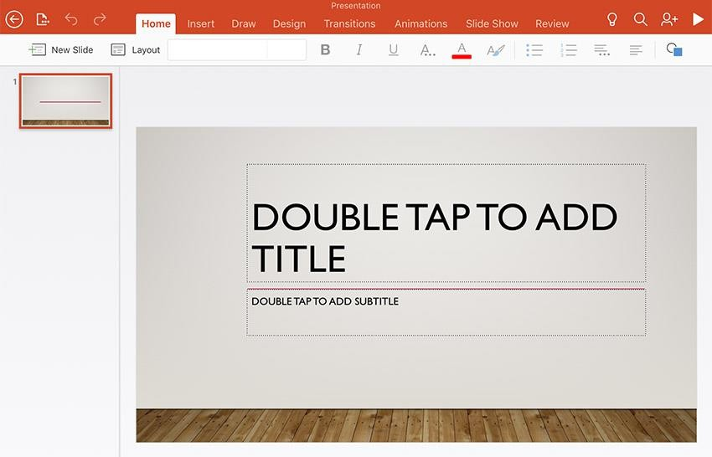

Slide Layout and Style

Start with a blank template. The first slide will be your title slide. You can pick any layout you want. Just click in the boxes to add text. To add a new slide, go to Insert → New Slide. Again you will be asked to select a layout. Pick anything you want. If you ever want to change the layout of your slide, go to Format → Slide Layout. You can now select a new slide layout.
In addition to layout, you can set the style of your slides. Go to Format → Apply Design Template or Format → Slide Layout (it depends on what version of PowerPoint you're using). By clicking on the different styles in the left list, you should see a preview of the style on the right. Select whatever style you like. You can always change it later.

MS PowerPoint PPT Templates

PowerPoint Templates (frequently also called "themes") are the quickest way to add style to your Microsoft PowerPoint presentation and one of the reasons that PowerPoint is so popular.

The easiest way to add a design to your slide is to use a template, which you'll find on PowerPoint's ribbon on the Design tab. Click on one of the template thumbnails to apply it to your presentation.

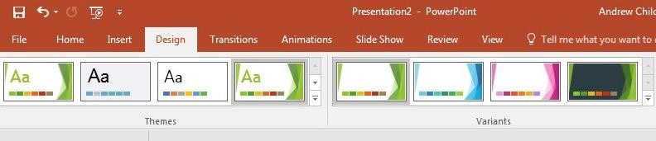

Inserting a Picture

From within PowerPoint: To insert an image from the files that PowerPoint already has, go to Insert → Picture. You can then select "Clip Art", which is provided by Microsoft. Other options for graphics and images inside of PowerPoint are also on the Insert menu. Some examples are Word Art, Autoshapes, Organization Chart, and Word Table.
From the Internet: Many images, graphs, and charts on the Internet are available for use. First they must be saved onto your computer. For Windows, you do that by left-clicking on the image, selecting "Save Picture As", and then putting the picture onto one of your disks. For Macs, you hold down the apple button, click, and then choose the "Download Image to Disk" option. Once the graphic is on your computer, go to Insert → Picture → From File and then select the image.

Animating the Presentation

You can animate your text, inserted objects (like pictures and graphs) or slide transition. We'll show you a few basics.

Animating Text
The most common animation effect for text is to have each line or bullet appoint appear one at a time. Select a slide with bulleted text. Go to Tools → Build Slide Text. This will present you with several animation choices. First try "Fly from Left". Now let's see what it looks like. Go to View → Slide Show. Each time you hit the space bar or click with your mouse, another bullet point will fly in. A more subtle and probably more professional choice is Dissolve. Go to Tools → Build Slide Text → Dissolve. View the slide show again.

Select a slide with bulleted text. Go to Slide Show → Animation Schemes. The Animation Schemes task pane will appear on the right side of your PowerPoint window. First try "Unfold" in the Moderate section. A preview of the animation shows immediately, and you can "run" the slide show again by going to Slide Show → View Show. If you don't see it on the menu right away, hover your mouse over the menu for a moment and it will appear.

Animating Pictures
This will be similar to animating text. Find a slide with pictures or graphs on it. Click on the picture/graph to select it. Go to Tools → Animation Settings. A pop up window should appear. If the Build Option is set to No Build, change it to Build. Under Effects, there will be a pulldown option with different animations for how you want the picture to appear. You can test the different animations styles by going to Slide Show view.

Slide Transition
You can also animate the way the next slide appears. Go to Tools → Slide Transition for your options. Go to Slide Show view to see what it looks like.

LAB 10 – MS PowerPoint

OBJECTIVE(S)

- Learn how to use Microsoft PowerPoint
- Create a presentation
- Use drawing tools in PowerPoint
- Add animation to your presentation

EXERCISES
- Create a Power Point presentation on a topic of your own choice of 2 slides. Add appropriate animation effects and clip arts, smart art, graphs, photos videos, etc to make a powerful presentation.

Attach the colored printout here.



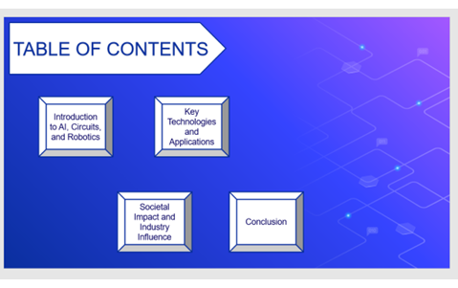













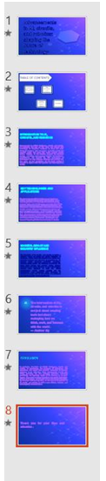
NED University of Engineering & Technology Department of Software Engineering
Course Code & Title: CT-174 FIT Assessment Rubric for Psychomotor (P2-PLO-3)

Instructor: Batch: 2024 Class: FESE Semester: Fall 2024. Student’s Name: Roll No.:
Laboratory Session No. Date:

Psychomotor Domain Assessment Rubric-Level P2-PLO3
Skill Sets | Extent of Achievement
 | Below Average (0--1) | Average (2) | Good (3) | Very Good (4) | Excellent (5)
Problem Definition and Understanding | Unable to define and understand the problem clearly. | Struggles to define the problem clearly, with significant gaps in understanding | Defines the problem, but with gaps or a limited understanding of key components, impacting the overall quality of definition. | Effectively defines the problem with a good understanding of its components, showcasing proficiency in problem definition. | Demonstrates an exceptional understanding of the problem, identifying all key components and challenges with insightful depth.
Technical Implementation Proficient use of tools to complete the problem | Struggles to use tools effectively, requiring significant improvement. | Uses tools with noticeable inefficiencies. | Demonstrates basic proficiency in utilizing tool, with some room for improvement. | Effectively uses tools to support the task. | Integrates use of tools seamlessly to enhance the design and development process
Solution Design& Accuracy | Struggles to relate the implemented solutions to the design and development goals, requiring significant improvement. | Shows limited connection between the implemented solutions and the design and development context. | Demonstrates a basic understanding of how the solutions align with design and development requirements. | Effectively relates the implemented solutions to the overall design and development objectives | Maps the implemented solutions seamlessly to the overarching design and development goals, demonstrating a comprehensive understanding.
Trouble Shooting Skills  Issue resolution skills | Unable to trouble shoot | Limited troubleshooting | Adequate troubleshooting, minor errors remaining | Good troubleshooting, no errors remaining | Excellent trouble shooting no errors remain without delay.
Document Organization and on time submission | Poor Unclear disorganized document late submission | Somewhat clear with lack of organization and structuring late submission | Somewhat clear with lack of organization and structuring on time submission | Reasonably clear and organized with adequate structuring on time submission | Highly clear and well- structured document, On time submit

Weighted CLO (Psychomotor Score)
Instructor’s Signature with Date

Lab # 11

Introduction to Assembly Language Tools Number System & Flags

Introduction to Assembly Language Tools
Software tools are used for editing, assembling, linking, and debugging assembly language programming. You will need an assembler, a linker, a debugger, and an editor. These tools are briefly explained below.

Assembler
An assembler is a program that converts source-code programs written in assembly language into object files in machine language. Popular assemblers have emerged over the years for the Intel family of processors. These include MASM (Macro Assembler from Microsoft), TASM (Turbo Assembler from Borland), NASM (Netwide Assembler for both Windows and Linux), and GNU assembler distributed by the free software foundation.

Linker
A linker is a program that combines your program's object file created by the assembler with other object files and link libraries, and produces a single executable program.

Debugger
A debugger is a program that allows you to trace the execution of a program and examine the content of registers and memory.

Editor
You need a text editor to create assembly language source files. You can use NotePad , or any other editor that produces plain ASCII text files.
Emu8086
Emu8086 combines an advanced source editor, assembler, disassemble and software emulator (Virtual PC) with debugger. It compiles the source code and executes it on emulator step by step.
Visual interface is very easy to work with. You can watch registers, flags and memory while your program executes.
Arithmetic & Logical Unit (ALU) shows the internal work of the central processor unit (CPU).
Emulator runs programs on a Virtual PC, this completely blocks your program from accessing real hardware, such as hard-drives and memory, since your assembly code runs on a virtual machine, this makes debugging much easier. 8086 machine code is fully compatible with all next generations of Intel's microprocessors, including Pentium II and Pentium 4. This makes 8086 code very portable, since it runs both on ancient and on the modern computer systems. Another advantage of 8086 instruction set is that it is much smaller, and thus easier to learn.

EMU8086 Source Editor
The source editor of EMU86 is a special purpose editor which identifies the 8086 mnemonics, hexadecimal numbers and labels by different colors as seen in Figure 1.

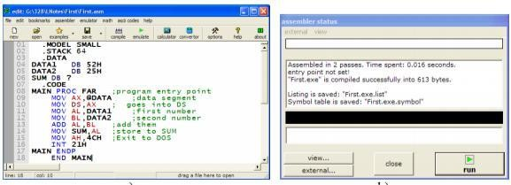
Figure:1
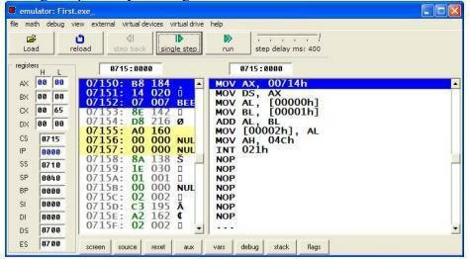
The compile button on the taskbar starts assembling and linking of the source file. A report window is opened after the assembling process is completed. Figure 2 shows the emulator of 8086 which gets opened by clicking on emulate button.
Figure 2

Data Representation in EMU8086 Binary System
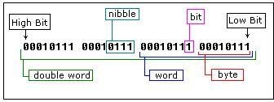
Computers are not as smart as humans are (or not yet), it's easy to make an electronic machine with two states: on and off, or 1 and 0. Computers use binary system, binary system uses 2 digits: 0, 1And thus the base is 2. Each digit in a binary number is called a BIT, 4 bits form a NIBBLE, 8 bits form a BYTE, two bytes form WORD, two words form a DOUBLE WORD (rarely used)
In emu8086, There is a convention to add "b" in the end of a binary number, this way we can determine that 101b is a binary number with decimal value of 5.

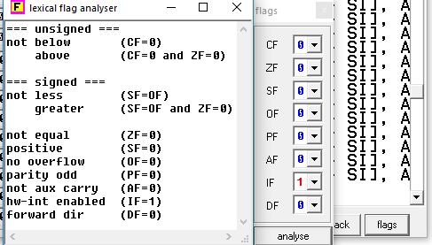
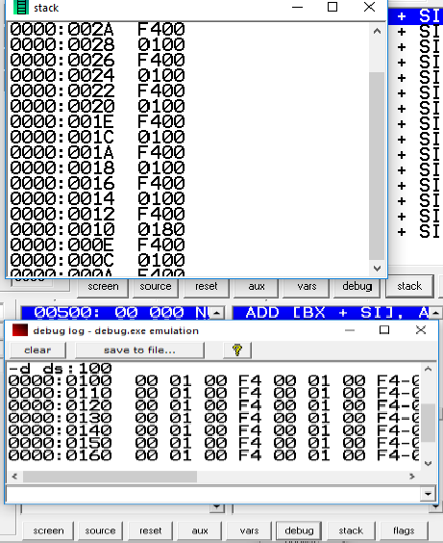
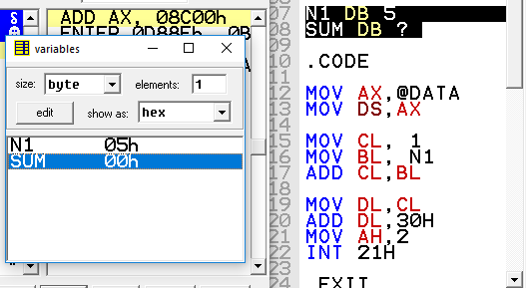
Decimal System
Most people today use decimal representation to count. In the decimal system there are 10 digits:
0, 1, 2, 3, 4, 5, 6, 7, 8, 9. These digits can represent any value, for example: 754.

Hexadecimal System
Hexadecimal System uses 16 digits:
0, 1, 2, 3, 4, 5, 6, 7, 8, 9, A, B, C, D, E, F and thus the base is 16. Hexadecimal numbers are compact and easy to read. There is a convention to add "h" in the end of a hexadecimal number.

Base Converter
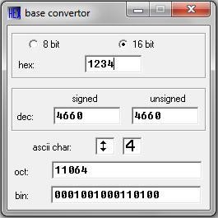
Emulator 8086 provides base converter facility which can convert any number (signed/unsigned) into octal, hexadecimal, decimal and binary number systems.

Example: Use Emu8086 to make the following calculations: 10100101b = ? d
1234h = ? d
39d = ? h

1. Start Emu8086 by selecting its icon from the start menu, or by running Emu8086.exe
- Choose “Math” and specify “Base Convertor” in emu8086.
- Enter one of the numbers like in the Figure .

Emulator 8086 Environment
  - Flags : By pressing “flags” in the bottom-right corner of the window(figure 3)you can observe flag values at the execution of instruction written in a program ,

  - Stack: stack segment window is popup by pressing “stack”. Stack is directly affected when call and return instructions used in the program.

  - Debug: emulator86 also provide debug environment where you can view and also edit the contents of memory segments , register values through debug commands.

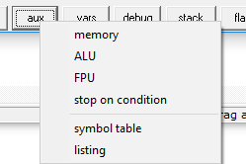
  - Variables: Variable/constants declare in the program can also be viewed through “vars” .
  - Aux: you can view various options(listing
,memory, ALU and FPU) under this tab as mention in the figure below.

Flags Register

EFLAGS register is never accessed as a whole. Rather, individual bits of this register either control the CPU operation (control flags) or reflect the outcome of a CPU operation (status flag). Table below gives some of the commonly used control and status flags.

BIT | Name | Type | Description
0 | Carry Flag (CF) | Status | Contains carry from a high-order (leftmost) bit following
 |  |  | an arithmetic operation; also, contains the contents of the
 |  |  | last bit of a shift or rotate operation.
2 | Parity Flag (PF) | Status | It indicates the parity of result i.e. if lower order 8 bits
 |  |  | of the result contains eve number of 1‟s the parity flag
 |  |  | is set to 1.0 otherwise.
4 |  | Status | If an operation performed in ALU generates a
 | Auxiliary Carry |  | carry/borrow from lower nibble (D0-D3) to upper nibble
 | (AF)
 |  |  | (D4-D7), the AF is set to1, 0 otherwise.
6 | Zero Flag (ZF) | Status | Indicates the result of an arithmetic or comparison
 |  |  | operation (0 = nonzero and 1 = zero result)
7 | Sign Flag (SF) | Status | Contains the resulting sign of an arithmetic operation (0 =
 |  |  | positive and 1 = negative).
8 | Trap Flag (TF) | Control | Permits operation of the processor in single-step mode.
9 | Interrupt Flag (IF) | Control | Indicates that all external interrupts, such as keyboard
 |  |  | entry, are to be processed or ignored.
10 | Direction Flag | Control | Determines left or right direction for moving or
 | (DF) |  | comparing string (character) data.
11 | Overflow Flag | Status | Indicates overflow resulting from some arithmetic
 | (OF) |  | operation
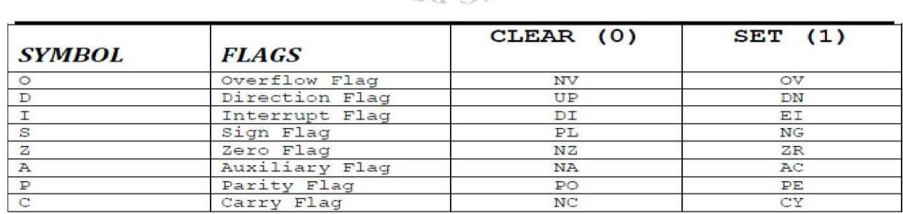
Table below gives the clear understanding that how these registers can be view and use in
programming.

LAB 11 EXERCISE:
- Name four software tools used for assembly language programming.

- Convert the following numbers using Base Converter:
  - 10110011b (binary to hexadecimal)
  - 455d (decimal to binary)
  - 2AFh (hexadecimal to binary)
  - 0A1h (hexadecimal to binary)
Do all the calculations manually and compare with the results obtained using base

converter.

3 . Write each of the following 8-bit Signed Binary Integers in Decimal:
a) 11011100 = | b) 10010001 =
c) 10001111 = | d) 10000000 =

- For each given instruction in this exercise, update the flags accordingly assume that AX contains the given contents before the instruction is executed. Give the contents of AX as well as the values and update the flags CF, OF, SF, PF, AF and ZF after the instruction is executed. All numbers are in hex. (Hint: add ax, 45 adds 45 to the contents of register ax and stores the result back in ax)

Contents of AX | Instruction | Contents of AX | CF | OF | SF | PF | AF | ZF
(Before) |  | (After)
0045 | Add ax,45
FF45 | Add ax,45
0045 | sub ax , 46
FF45 | Sub ax, 9A
FFFF | Add ax, 1

NED University of Engineering & Technology
Department of Software Engineering
Course Code & Title: CT-174 FIT Assessment Rubric for Psychomotor (P2-PLO-3)

Instructor: Batch: 2024 Class: FESE Semester: Fall 2024. Student’s Name: Roll No.:
Laboratory Session No. Date:

Psychomotor Domain Assessment Rubric-Level P2-PLO3
Skill Sets | Extent of Achievement
 | Below Average  (0--  1) | Average (2) | Good (3) | Very Good (4) | Excellent (5)
Problem Definition and Understanding | Unable to define and understand the problem clearly. | Struggles to define the problem clearly, with significant gaps in understanding | Defines the problem, but with gaps or a limited understanding of key components, impacting the overall quality of definition. | Effectively defines the problem with a good understanding of its components, showcasing proficiency in problem definition. | Demonstrates an exceptional understanding of the problem, identifying all key components and challenges with insightful depth.
Technical Implementation Proficient use of tools to complete the problem | Struggles to use tools effectively, requiring significant improvement. | Uses tools with noticeable inefficiencies. | Demonstrates basic proficiency in utilizing tool, with some room for improvement. | Effectively uses tools to support the task. | Integrates use of tools seamlessly to enhance the design and development process
Solution Design& Accuracy | Struggles to relate the implemented solutions to the design and development goals, requiring significant improvement. | Shows limited connection between the implemented solutions and the design and development context. | Demonstrates a basic understanding of how the solutions align with design and development requirements. | Effectively relates the implemented solutions to the overall design and development objectives | Maps the implemented solutions seamlessly to the overarching design and development goals, demonstrating a comprehensive understanding.
Trouble Shooting Skills  Issue resolution skills | Unable to trouble shoot | Limited troubleshooting | Adequate troubleshooting, minor errors remaining | Good troubleshooting, no errors remaining | Excellent trouble shooting no errors remain without delay.
Document Organization and on time submission | Poor Unclear disorganized document late submission | Somewhat clear with lack of organization and structuring late submission | Somewhat clear with lack of organization and structuring on time submission | Reasonably clear and organized with adequate structuring on time submission | Highly clear and well- structured document, On time submit

Weighted CLO (Psychomotor Score)
Instructor’s Signature with Date

OBJECT

Lab Session 12

Demonstrating various components of a PC and their interconnection.

COMPONENTS OF A DESKTOP/LAPTOP
System Unit
It is the main computer system cabinet in a PC, which usually houses the power supply, motherboard, and some storage devices.

Mother Board
It is the main circuit board in a microprocessor system. It normally includes the microprocessor chip (or CPU), main memory (RAM) chips, all related support circuitry, and the expansion slots for plugging in additional components. It is also known as system board.

Read Only Memory (ROM)
It is a type of memory in which instructions to perform operations critical to a computer are stored on integrated (chips) in permanent, non-volatile form. The instructions are normally recorded on the chips by the manufacturer.

Main Memory (RAM)
It is the name given to the integrated circuits (chips) commonly known as RAM(Random Access Memory) that make up main memory, which provides volatile temporary storage of data and program instructions that the CPU is using; data and instructions can be retrieved at random, no matter where they are located in main memory. RAM is used for storing operating system software instructions and for temporary storage of applications software instructions, input data, and output data.

On the basis of pin configuration, two types of RAM chips are available in the market:
- SIMM – Single Inline Memory Module, all pins are aligned on one side of the chip.
- DIMM – Dual Inline Memory Module, pins are aligned on both sides of the chip.
On the basis of internal cell design, two types of RAM are there:
- DRAM – Dynamic Random Access Memory, made of capacitors, used for most main memories.
- SRAM – Static Random Access Memory, made of flip flops, used for some specialized purposes within the main memory.
- SDRAM (synchronous DRAM) is a generic name for various kinds of dynamic random access memory (DRAM) that are synchronized with the clock speed that the microprocessor is optimized for. This tends to increase the number of instructions that the processor can perform in a given time.
It is a special high-speed memory area that the CPU can quickly access. It comprises a small area of RAM created in addition to the computer’s main memory (RAM); a copy of the most frequently used data and instructions is kept in the cache so the CPU can look in the cache first, which makes the computer run faster. Cache memory is usually located right on the microprocessor chip.

Hard Disk
It is a direct access secondary storage device consisting of a rigid metal platter connected to a control spindle; the entire unit, including the read/write heads, is enclosed in a permanently sealed container. Hard disks store much more data than diskettes do.

Compact Disk
It is an optical disk whose data is laser-recorded by the disk manufacturer. The user cannot change it or write on the disk, he can only read the data.

Processor Chip
It is an integrated circuit (chip) containing the CPU circuitry for a microprocessor. CPU is the brain of the computer; the part of the computer composed of electrical circuitry directing most of the computer system’s activities. It consists of the control unit and the arithmetic/logic unit (ALU) connected by a bus.

Parallel Ports
A parallel port is a socket on the system unit for attaching peripheral devices that transmit 8 bits simultaneously; used mainly for connecting printers.
Devices: printers, computers and other devices that need relatively high bandwidth

Figure 12.1

Serial Ports
A serial port is a socket on the system unit for connecting peripheral devices, such as a modem or a mouse, that transmit data serially, one bit after the other.
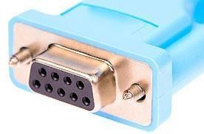
Figure 12.2
Devices Mouse with no PS2 and USB port computers & Modems.

VGA Port
A Video Graphics Array (VGA) connector is a three-row 15-pin DE-15 connector. The 15-pin VGA connector was provided on many video cards, computer monitors, laptop computers, projectors, and high definition television sets.
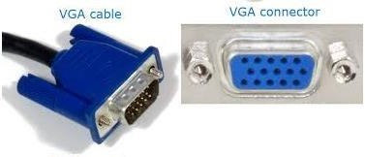

HDMI Port
Figure 12.3

HDMI (High-Definition Multimedia Interface) is a proprietary audio/video interface for transmitting uncompressed video data and compressed or uncompressed digital audio data from an HDMI-compliant source device, such as a display controller, to a compatible computer monitor, video projector, digital television, or digital audio device.[4] HDMI is a digital replacement for analog video standards.
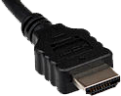
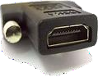
Figure 12.4

USB PORTS:
USB, short for Universal Serial Bus, is an industry standard that defines cables, connectors and communications protocols for connection, communication, and power supply between computers and devices.
Devices All type of connectors ,Mouse ,cell phones etc.

System Clock/Timer
Every microprocessor contains a system clock. It controls how fast all the operations within a computer take place. The faster the clock the faster the processing; clock speed in measured in megahertz.

Power Supply
It is the source of electrical power to components housed in the system unit of a PC.

Data Cables
It is the communication path linking several devices to the microprocessor for transferring data.

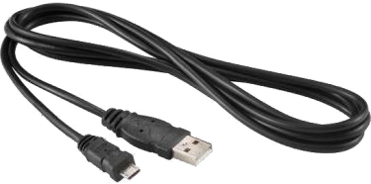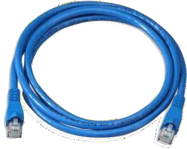

Power Cables
Figure 12.5

It is the communication path linking several devices, including the microprocessor, to the power supply for provision of electrical power.

Expansion Slot
In a PC, an area within the system cabinet where expansion cards, such as color graphic adapter cards and expanded memory cards, can be inserted and plugged into the computer’s circuitry.

Figure 12.6

Display Screens
Color display screen is one that can display up to 16.7 million colors, depending on the type of display screen and graphics adapter cards used.
Screens
Video display screen is a device for viewing computer output. Two main types are:
- Cathode ray tube (CRT) - also called monitor or screen.
- Flat panel display - a type of display screen used on portable computers. They are much thinner, weigh less and use less power than CRTs.
- An LED display is a flat panel display, which uses an array of light-emitting diodes as pixels for a video display. Their brightness allows them to be used outdoors where they are visible in the sun store signs and billboards.
- LCD (liquid crystal display) is the technology used for displays in notebook and other smaller computers. Like light-emitting diode (LED) and gas-plasma technologies, LCD allow displays to be much thinner than cathode ray tube (CRT) technology.

Graphic Adapter Cards
Graphics adapter card, also known as video display adapter is a circuit board in the system unit that determines the display screen’s resolution, number of colors, and how fast images appear. The card and the monitor must be compatible models. These cards are the expansion cards plugged into expansion slot in system cabinet that allows compatible monitor to display bit-mapped graphics. They must be used with appropriate software.

Commonly use types of adapter cards are:
- Color graphics adapter (CGA) - displays 4 colors as well as monochrome images.
- Video graphics array (VGA) - displays 16 colors.
- Super video graphics array (SVGA) - displays up to 256 colors at a very high resolution.
- Extended graphics array (XGA) - supports up to 16.7 million colors at a very high resolution.

Sound Cards
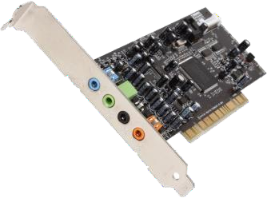
Sound card is a circuit board in the system unit which helps producing sounds at the output devices. It plugs in to an expansion slot in the PC.
Figure 12.7

Network Cards : A network interface card, which is inserted into an expansion slot in a PC, enables the computer to send and receive messages on a LAN.

Modem Cards : Modem is a device for translating digital signals from a computer into analog signals for transmission over telephone lines and then back into digital signals again for processing, that is a modem must be hooked up at each end of the transmission. Modem stands for Modulator/Demodulator

Math Coprocessor
It is a specialized processor chip installed on the motherboard that helps the CPU process the mathematical calculations more quickly.

Lab 12:
Demonstrating various components of a PC and their interconnection
EXERCISE
- Find and list various hardware and their configuration attached to your system.

_

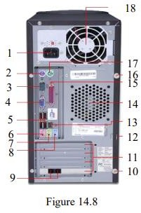
- Label the diagrams properly 1.
2.
3.
4.
5.
6.
7.
8.
9.
10.

11.

12.

13.

14.

15.

16.

17.

18.

Lab Session 13

OBJECT
Experimenting with the AND, OR, NAND, NOR and NOT integrated circuits.

COMPONENTS REQUIRED

- Bread board, 5 V - power supply, multimeter, logic probe (or LEDs with resistors), wires and the following ICs:
- 7408 quad 2 input AND gate
- 7432 quad 2 input OR gate
- 7404 hex inverter
- 7400 quad 2 input NAND gate
- 7402 quad 2 input NOR gate

THEORY

Logic Gates
Logic gates are the fundamental building blocks of digital systems. These devices are able to make decisions, in the sense that they produce one output level when some combinations of input levels are present and a different output when other combinations are applied; hence given the name Logic Gates.

The two levels produced by digital circuitry are referred to variously as HIGH and LOW, TRUE and FALSE, ON and OFF, or simply 1 and 0.

There are only three basic gates: AND, OR and NOT. The other gates are merely combinations of these basic gates.
- The AND Gate – An AND gate’s output is 1 if and only if all its inputs are 1. If A and B are two inputs to an AND gate then output, F of the gate is given as: F = A.B

- The OR Gate - An OR gate’s output is 1 if at least one of its input is 1. If A and B are two inputs to an OR gate then output, F of the gate is given as: F = A+B


- The NOT Gate (Inverter) – Its output is 1 when its input is 0 and its output is 0 when the input is 1; i.e. it complements a digital variable. If A is the input to a NOT gate then output, F of the gate is given as: F =
A

- The NAND Gate – Its output is 1 if at least one of its inputs is 0. This gate performs the same logic as an AND gate followed by an inverter. If A and B are two inputs to a NAND gate then output, F of the gate is given as: F = A.B

- The NOR Gate - The output of a NOR gate is 1 if and only if all its inputs are 0. This gate performs the same logic function as an OR gate followed by an inverter. If A and B are two inputs to a NAND gate then output, F of the gate is given as: F = A+B

All the above gates have one output and two or more inputs except the NOT gate, which has only one input.

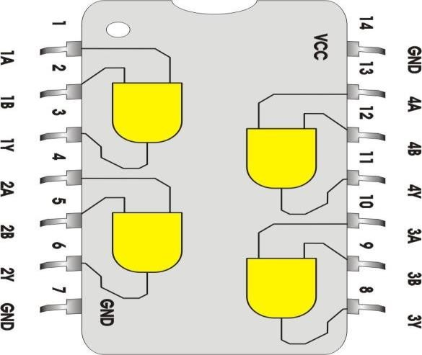
INTERNAL IC DIAGRAMS

740 8 ( AND IC)

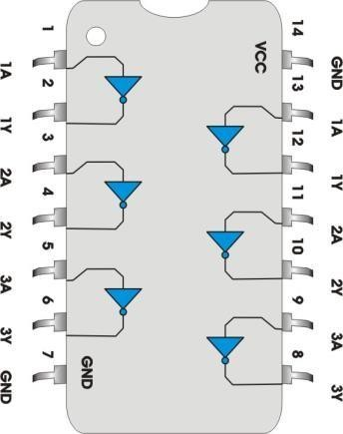
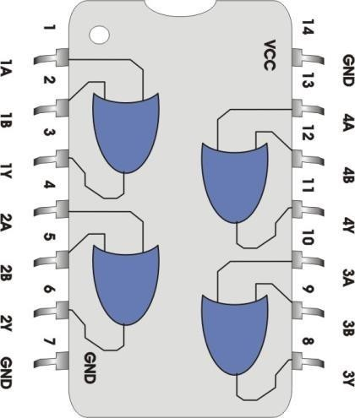
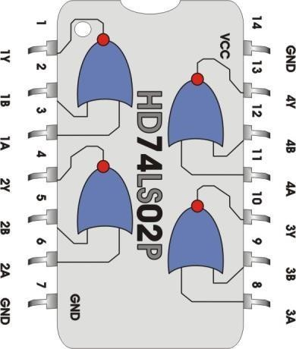

74 02 ( NOR IC)

7404 ( Inverter IC )

74 32 ( OR IC)

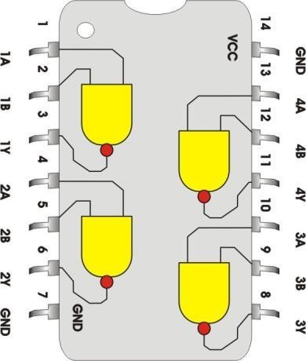
Figure 13.1 ICs Internal Diagrams

740 0 ( NAND IC)

PROCEDURE
- Set the power supply to 5V. With the help of a multimeter check the voltage at the output knobs of the power supply.
- Connect wires, long enough to reach the bread board, with the two knobs of the power supply. Again using multimeter, check the voltage at the non-connected end of the wires.
- Insert the 7408 quad 2 input AND gate IC on to the bread board and make supply and ground connections by joining 5V wire to pin # 14 and 0V wire to pin # 7.
- Consult IC’s internal connection diagram for input and output pins of the first AND gate. Connect input pins to logic 0 (0V) and observe the output using LED or logic probe.
- Try different combinations of logic levels at the two inputs. Again observe the output.
- Repeat the last two steps for all other gates of the same IC. Record the observations.
- Repeat this procedure for all other ICs.

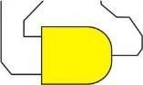
OBSERVATIONS

AND Gate

A | B | Expected Output | Observed Output
0 | 0 | 0 | 0
0 | 1 | 0 | 0
1 | 0 | 0 | 0
1 | 1 | 1 | 1

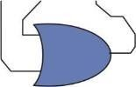
OR GATE
A | B | Expected Output | Observed Output
0 | 0 | 0 | 0
0 | 1 | 1 | 1
1 | 0 | 1 | 1
1 | 1 | 1 | 1


NOT Gate
A | Expected Output | Observed Output
0 | 1 | 1
1 | 0 | 0
NAND Gate 

A | B | Expected Output | Observed Output
0 | 0 | 1 | 1
0 | 1 | 1 | 1
1 | 0 | 1 | 1
1 | 1 | 0 | 0


NOR Gate

A | B | Expected Output | Observed Output
0 | 0 | 1 | 1
0 | 1 | 0 | 0
1 | 0 | 0 | 0
1 | 1 | 0 | 0

FINDING EXPRESSION FOR GIVEN LOGIC DIAGRAM

LOGIC DIAGRAM

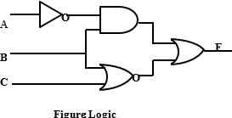

PROCEDURE
Set the power supply to 5V. With the help of a multimeter check the voltage at the output knobs of the power supply.
- Connect wires, long enough to reach the bread board, with the two knobs of the power supply. Again using millimeter, check the voltage at the non-connected end of the wires.
- Insert ICs on the bread board and make their supply and ground connections.
- As given in the logic diagram, make connections using wires and gates in the ICs.
- Apply different combinations at the three inputs and observe the output

OBSERVATIONS

Logic Expression of Given Logic Diagram

A | B | C | Expected  Output | Observed Output
0 | 0 | 0 | 1 | 1
0 | 0 | 1 | 0 | 0
0 | 1 | 0 | 1 | 1
0 | 1 | 1 | 1 | 1
1 | 0 | 0 | 1 | 1
1 | 0 | 1 | 0 | 0
1 | 1 | 0 | 0 | 0
1 | 1 | 1 | 0 | 0

NED University of Engineering & Technology
Department of Software Engineering
Course Code & Title: CT-174 FIT Assessment Rubric for Psychomotor (P2-PLO-3)

Instructor: Batch: 2024 Class: FESE Semester: Fall 2024 Student’s Name: Roll No.:
Laboratory Session No. Date:

Psychomotor Domain Assessment Rubric-Level P2-PLO3
Skill Sets | Extent of Achievement
 | Below Average (0--1) | Average (2) | Good (3) | Very Good (4) | Excellent (5)
Problem Definition and Understanding | Unable to define and understand the problem clearly. | Struggles to define the problem clearly, with significant gaps in understanding | Defines the problem, but with gaps or a limited understanding of key components, impacting the overall quality of definition. | Effectively defines the problem with a good understanding of its components, showcasing proficiency in problem definition. | Demonstrates an exceptional understanding of the problem, identifying all key components and challenges with insightful depth.
Technical Implementation Proficient use of tools to complete  the problem | Struggles to use tools effectively, requiring significant improvement. | Uses tools with noticeable inefficiencies. | Demonstrates basic proficiency in utilizing tool, with some room for improvement. | Effectively uses tools to support the task. | Integrates use of tools seamlessly to enhance the design and development process
Solution Design& Accuracy | Struggles to relate the implemented solutions to the design and development goals, requiring significant improvement. | Shows limited connection between the implemented solutions and the design and development context. | Demonstrates a basic understanding of how the solutions align with design and development requirements. | Effectively relates the implemented solutions to the overall design and development objectives | Maps the implemented solutions seamlessly to the overarching design and development goals, demonstrating a comprehensive understanding.
Trouble Shooting Skills  Issue resolution skills | Unable to trouble shoot | Limited troubleshooting | Adequate troubleshooting, minor errors remaining | Good troubleshooting, no errors remaining | Excellent trouble shooting no errors remain without delay.
Document Organization and on time submission | Poor Unclear disorganized document late submission | Somewhat clear with lack of organization and structuring late submission | Somewhat clear with lack of organization and structuring on time submission | Reasonably clear and organized with adequate structuring on time submission | Highly clear and well- structured document, On time submit

Weighted CLO (Psychomotor Score)
Instructor’s Signature with Date

OBJECT

Lab Session 14

Experimenting with the AND, OR, NAND, NOR and NOT integrated circuits.
Use any digital design software to simulate hardware circuit behavior according to a logic expression. By employing gates like AND, OR, and NOT, virtually implement the logic expression. This simulation offers a practical opportunity to grasp how digital circuits work and how different logic gates interact.

Key Tasks:
  - Logic Expression Analysis:
    - Analyze the logic expression and understand its fundamental components.
    - Identify the required logic gates (AND, OR, NOT) necessary for implementing the expression.
  - Circuit Simulation:
    - Utilize a digital design software tool to create a virtual circuit based on the identified logic gates.
    - Connect the gates in accordance with the logic expression to simulate the overall behavior of the circuit.
  - Truth Table Verification:
    - Construct a truth table for the logic expression and compare it with the simulated results.
    - Validate the accuracy of the simulation by ensuring that the output corresponds to the expected truth table values.
  - Software Tools Proficiency:
    - Develop proficiency in using the chosen digital design software for circuit simulation.
    - Explore additional features of the software that enhance the understanding of digital circuit design.
  - Excel Report Preparation:
    - Create an Excel spreadsheet to document the truth table, input values, and corresponding output results.
    - Utilize Excel functions for logical operations and demonstrate the correlation between the simulated and expected results.
  - Word and PowerPoint Documentation:
    - Prepare a comprehensive Word document that includes an introduction, methodology, circuit design explanation, and simulation results analysis.
    - Use PowerPoint to create a visually engaging presentation summarizing key findings, challenges faced, and lessons learned during the simulation.
  - Critical Analysis:
    - Conduct a critical analysis of the simulation results, identifying any discrepancies between the expected and simulated outcomes.
    - Propose improvements or modifications to the circuit design to address any identified issues.
By the end of this lab, students should have a thorough understanding of digital circuit simulation, proficiency in using digital design software, and the ability to communicate their findings effectively through a well-documented report and presentation.

NED University of Engineering & Technology Department of Software Engineering
Course Code & Title: CT-174 FIT Assessment Rubrics for Open Ended Lab (P2-PLO-3)

Instructor: Batch: 2024 Class: FESE Semester: Fall 2024 Student’s Name: Roll No.:
Laboratory Session No. Date: _

Psychomotor Domain Assessment Rubric-Level P2-PLO3
Skill Sets | Extent of Achievement
 | Below Average (0--1) | Average (2) | Good (3) | Very Good (4) | Excellent (5)
Software Handling | Unable to use software features or commands accurately | Rarely uses Software menus features correctly. | Able to use software with its Standard features with assistance | Able to use software with its  Standard features with minor assistance | Able to use software with its  Advanced features without assistance
Task Accuracy | Incorrect task | Frequent Errors &inaccuracies | Several Errors & significant inaccuracies | Few Errors &minor inaccuracies | No errors highly accurate task
Trouble Shooting  Issue resolution skills | Unable to trouble shoot | Limited troubleshooting | Adequate troubleshooting, minor errors remaining | Good troubleshooting, no errors remaining | Excellent trouble shooting no errors remain without delay.
Task Completion Time | Unable to understand the task | Incomplete task | Task takes longer than expected | Task completed in reasonable time | Task completed efficiently ahead of schedule
Document Organization and on time submission | Poor Unclear disorganized document late submission | Somewhat clear with lack of organization and structuring late submission | Somewhat clear with lack of organization and structuring ontime submission | Reasonably clear and organized with adequate structuring ontime submission | Highly clear and well- structured document,On time submit

Weighted CLO (Psychomotor Score)
Instructor’s Signature with Date

